Fishery Manuscript Series No. YY-XX

Review of Salmon Escapement Goals in Southeast Alaska, 2020

by

Steven C. Heinl,

Edgar L. Jones III,

Andrew W. Piston,

Philip J. Richards,

Justin T. Priest,

Julie A. Bednarski,

Brian W. Elliott,

Sara E. Miller,

Richard E. Brenner,

and

Jeff V. Nichols

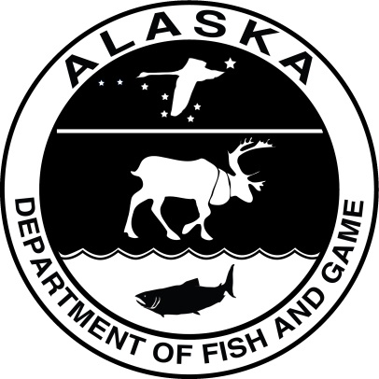

Month Year

Alaska Department of Fish and Game Divisions of Sport Fish and Commercial Fisheries

Symbols and Abbreviations

The following symbols and abbreviations, and others approved for the Système International d'Unités (SI), are used without definition in the following reports by the Divisions of Sport Fish and of Commercial Fisheries: Fishery Manuscripts, Fishery Data Series Reports, Fishery Management Reports, and Special Publications. All others, including deviations from definitions listed below, are noted in the text at first mention, as well as in the titles or footnotes of tables, and in figure or figure captions.

**Weights and measures (metric)**

centimeter cm

deciliter dL

gram g

hectare ha

kilogram kg

kilometer km

liter L

meter m

milliliter mL

millimeter mm

**Weights and measures (English)**

cubic feet per second ft3/s

foot ft

gallon gal

inch in

mile mi

nautical mile nmi

ounce oz

pound lb

quart qt

yard yd

**Time and temperature**

day d

degrees Celsius °C

degrees Fahrenheit °F

degrees kelvin K

hour h

minute min

second s

**Physics and chemistry**

all atomic symbols

alternating current AC

ampere A

calorie cal

direct current DC

hertz Hz

horsepower hp

hydrogen ion activity pH

(negative log of)

parts per million ppm

parts per thousand ppt,

‰

volts V

watts W

**General**

Alaska Administrative

Code AAC

all commonly accepted

abbreviations e.g., Mr., Mrs., AM, PM, etc.

all commonly accepted

professional titles e.g., Dr., Ph.D.,

R.N., etc.

at @

compass directions:

east E

north N

south S

west W

copyright ©

corporate suffixes:

Company Co.

Corporation Corp.

Incorporated Inc.

Limited Ltd.

District of Columbia D.C.

et alii (and others) et al.

et cetera (and so forth) etc.

exempli gratia

(for example) e.g.

Federal Information

Code FIC

id est (that is) i.e.

latitude or longitude lat or long

monetary symbols

(U.S.) $, ¢

months (tables and

figures): first three

letters Jan,...,Dec

registered trademark ®

trademark ™

United States

(adjective) U.S.

United States of

America (noun) USA

U.S.C. United States Code

U.S. state use two-letter abbreviations (e.g., AK, WA)

**Mathematics, statistics**

*all standard mathematical*

*signs, symbols and*

*abbreviations*

alternate hypothesis HA

base of natural logarithm *e*

catch per unit effort CPUE

coefficient of variation CV

common test statistics (F, t, χ2, etc.)

confidence interval CI

correlation coefficient

(multiple) R

correlation coefficient

(simple) r

covariance cov

degree (angular ) °

degrees of freedom df

expected value *E*

greater than >

greater than or equal to ≥

harvest per unit effort HPUE

less than <

less than or equal to ≤

logarithm (natural) ln

logarithm (base 10) log

logarithm (specify base) log2, etc.

minute (angular) '

not significant NS

null hypothesis HO

percent %

probability P

probability of a type I error

(rejection of the null

hypothesis when true) α

probability of a type II error

(acceptance of the null

hypothesis when false) β

second (angular) "

standard deviation SD

standard error SE

variance

population Var

sample var

fishery manuscript series no. yy-xx

Review of Salmon Escapement Goals in Southeast Alaska, 2020

by

Steven C. Heinl and Andrew W. Piston

Alaska Department of Fish and Game, Division of Commercial Fisheries, Ketchikan

Philip J. Richards, and Jeff V. Nichols

Alaska Department of Fish and Game, Division of Sport Fish, Douglas

Edgar L. Jones III

Alaska Department of Fish and Game, Division of Sport Fish, Juneau

Brian W. Elliott

Alaska Department of Fish and Game, Division of Sport Fish, Haines

Julie A. Bednarski

Alaska Department of Fish and Game, Division of Commercial Fisheries, Douglas

Justin T. Priest

Alaska Department of Fish and Game, Division of Commercial Fisheries, Sitka

and

Sara E. Miller and Richard E. Brenner

Alaska Department of Fish and Game, Division of Commercial Fisheries, Juneau

Alaska Department of Fish and Game  
Division of Sport Fish, Research and Technical Services  
333 Raspberry Road, Anchorage, Alaska, 99518-1565

Month Year

The Fishery Manuscript Series was established in 1987 by the Division of Sport Fish for the publication of technically‑oriented results of several years' work undertaken on a project to address common objectives, provide an overview of work undertaken through multiple projects to address specific research or management goal(s), or new and/or highly technical methods, and became a joint divisional series in 2004 with the Division of Commercial Fisheries. Fishery Manuscripts are intended for fishery and other technical professionals. Fishery Manuscripts are available through the Alaska State Library and on the Internet: <http://www.adfg.alaska.gov/sf/publications/>. This publication has undergone editorial and peer review.

Steven C. Heinl and Andrew W. Piston,

Alaska Department of Fish and Game, Division of Commercial Fisheries,

2030 Sea Level Drive, Suite 205, Ketchikan, Alaska 99901, USA

Philip J. Richards, and Jeff V. Nichols

Alaska Department of Fish and Game, Division of Sport Fish

802 Third Street, Douglas, Alaska 99824, USA

Alaska Department of Fish and Game, Division of Sport Fish,

1255 W. 8th Street, Juneau, Alaska 99801, US

Brian W. Elliott

Alaska Department of Fish and Game, Division of Sport Fish

Mile 1 Haines Highway, P.O. Box 330, Haines, AK 99827-0330

Julie A. Bednarski

Alaska Department of Fish and Game, Division of Commercial Fisheries,

802 Third Street, Douglas, Alaska 99824, USA

Justin T. Priest

Alaska Department of Fish and Game, Division of Commercial Fisheries,

304 Lake Street, Room 103, Sitka, Alaska 99835, USA

and

Sara E. Miller and Richard E. Brenner,

Alaska Department of Fish and Game, Division of Commercial Fisheries,

1255 W. 8th Street, Juneau, Alaska 99801, USA

This document should be cited as follows:

Heinl, S. C., E. L. Jones III, A. W. Piston, P. J. Richards, J. T. Priest, J. A. Bednarski, B. W. Elliott, S. E. Miller, R. E. Brenner, and J. V. Nichols. 2020. Review of salmon escapement goals in Southeast Alaska, 2020. Alaska Department of Fish and Game, Fishery Manuscript Series No. xx-xx, Anchorage.

The Alaska Department of Fish and Game (ADF&G) administers all programs and activities free from discrimination based on race, color, national origin, age, sex, religion, marital status, pregnancy, parenthood, or disability. The department administers all programs and activities in compliance with Title VI of the Civil Rights Act of 1964, Section 504 of the Rehabilitation Act of 1973, Title II of the Americans with Disabilities Act (ADA) of 1990, the Age Discrimination Act of 1975, and Title IX of the Education Amendments of 1972.

**If you believe you have been discriminated against in any program, activity, or facility please write:**

ADF&G ADA Coordinator, P.O. Box 115526, Juneau, AK 99811-5526

U.S. Fish and Wildlife Service, 4401 N. Fairfax Drive, MS 2042, Arlington, VA 22203

Office of Equal Opportunity, U.S. Department of the Interior, 1849 C Street NW MS 5230, Washington DC 20240

**The department’s ADA Coordinator can be reached via phone at the following numbers:**

(VOICE) 907-465-6077, (Statewide Telecommunication Device for the Deaf) 1-800-478-3648,

(Juneau TDD) 907-465-3646, or (FAX) 907-465-6078

**For information on alternative formats and questions on this publication, please contact:**

ADF&G Division of Sport Fish, Research and Technical Services, 333 Raspberry Road, Anchorage AK 99518 (907) 267-2375

TABLE OF CONTENTS

Page

LIST OF TABLES ii

LIST OF Figures ii

LIST OF APPENDICES iv

ABSTRACT 1

INTRODUCTION 1

Methods 2

Escapement Goal Development 7

Stock Assessment Overview 8

Chinook Salmon 8

Sockeye Salmon 10

Coho Salmon 10

Pink Salmon 11

Chum Salmon 11

Escapement Goal Recommendations 12

Taku River Sockeye Salmon: 12

Chilkoot Lake Sockeye Salmon 15

Speel Lake Sockeye Salmon 18

Redoubt Lake Sockeye Salmon 24

Situk River Coho Salmon 27

Summary 29

acknowledgments 29

references Cited 30

Appendix A. Chinook Salmon Escapement Goal Performance 38

Appendix B. Sockeye Salmon Escapement Goal Performance 50

Appendix C. Coho Salmon Escapement Goal Performance 65

Appendix D. Pink Salmon Escapement Goal Performance 77

Appendix E. Chum Salmon Escapement Goal Performance 81

# LIST OF TABLES

Table Page

Table 1.–Southeast Alaska Chinook salmon escapement goals, 2014–2019 escapements, and escapement goal recommendations. 3

Table 2.–Southeast Alaska sockeye salmon escapement goals, 2014–2019 escapements, and escapement goal recommendations. 4

Table 3.–Southeast Alaska coho salmon escapement goals, 2014–2019 escapements, and escapement goal recommendations. 5

Table 4.–Southeast Alaska pink salmon escapement goals, 2014–2019 escapements, and escapement goal recommendations. 6

Table 5.–Southeast Alaska chum salmon escapement goals, 2014–2019 escapements, and escapement goal recommendations. 6

Table 6.–Three tiers recommended by Clark et al. (2014) to set sustainable escapement goals based on percentiles of observed escapement counts for stocks that experience low to moderate (<0.40) harvest rates. 8

Table 7.–Parameter estimates from the state-space model fitted to the Speel Lake sockeye salmon data for calendar years 1983–2019. Posterior medians are point estimates; the 2.5th and 97.5th percentiles define 95% credible intervals for the parameters. 19

Table 8.–Parameter and management reference point estimates from simple linear spawner-recruit models fitted to Redoubt Lake sockeye salmon brood years 1982–2013 compared to estimates reported by Geiger (2003). 26

Table 9.–Escapement survey data for Situk River coho salmon, 1972–2019. 28

# LIST OF Figures

Figure Page

Figure 1.–Overfishing profiles (OFPs), optimal recruitment profiles (ORPs), and optimal yield profiles (OYPs) for Taku River sockeye salmon. OYPs and ORPs show probability that a specified spawning abundance will result in specified fractions (70%, 80%, and 90% line) of maximum sustained yield or maximum recruitment. OFPs show the probability that reducing escapement to a specified spawning abundance will result in less than specified fractions of maximum sustained yield. The shaded region shows the bilaterally approved biological escapement goal range of 40,000 to 75,000 spawners. 14

Figure 2.–Overfishing profiles (OFPs), optimal recruitment profiles (ORPs), and optimal yield profiles (OYPs) for Chilkoot Lake sockeye salmon. OYPs and ORPs show probability that a specified spawning abundance will result in specified fractions (70%, 80%, and 90% line) of maximum sustained yield or maximum recruitment. OFPs show the probability that reducing escapement to a specified spawning abundance will result in less than specified fractions of maximum sustained yield. The shaded region shows the current sustainable escapement goal range of 38,000 to 86,000 spawners. 17

Figure 3.–Point estimates (posterior medians; circles with solid lines) and 95% credible intervals (gray shading) of (a) spawning escapement, (b) harvest rate, and (c) run abundance from the state-space spawner-recruit model of Speel Lake sockeye salmon, 1983–2019. Posterior medians of optimal escapement, *S*MSY, and harvest rate, *U*MSY, are plotted as dashed horizontal reference lines in (a) and (b), respectively. 20

Figure 4.–Posterior medians of escapement estimates (spawners *S*) and 95% credible intervals (vertical lines) obtained by fitting a Bayesian state-space model to Speel Lake sockeye salmon data, 1983–2019. The grey shaded region represents the current sustainable escapement goal range of 4,000–9,000 fish. 21

Figure 5.–Plausible spawner-recruit relationships (shaded regions around the dashed line) for Speel Lake sockeye salmon as derived from a Bayesian state-space model fitted to abundance, harvest, and age data for calendar years 1983–2019. Posterior medians of recruits and spawners are plotted as brood year labels with 95% credible intervals (grey lines). The heavy dashed line is the Ricker relationship constructed from ln(**’) and ** posterior medians with 90% and 95% credible intervals (shaded areas). Recruits replace spawners on the solid diagonal line. 22

Figure 6.–Natural logarithm of recruits per spawner vs spawners for Speel Lake sockeye salmon, brood years 1983–2015. 22

Figure 7.–Point estimates (posterior medians; circles with solid lines) and 95% credible intervals (shaded areas) of (a) recruitment and (b) productivity residuals by brood year from the Bayesian state-space model for Speel lake sockeye salmon. A 5-year rolling mean is shown as a solid black line in (b). 23

Figure 8.–Overfishing profiles (OFPs), optimal recruitment profiles (ORPs), and optimal yield profiles (OYPs) for Speel Lake sockeye salmon. OYPs and ORPs show probability that a specified spawning abundance will result in specified fractions (70%, 80%, and 90% line) of maximum sustained yield or maximum recruitment. OFPs show the probability that reducing escapement to a specified spawning abundance will result in less than specified fractions of maximum sustained yield. The shaded region shows the current sustainable escapement goal range of 4,000 to 9,000 spawners. 24

Figure 9.–Optimal yield profiles (OYPs) for Redoubt Lake sockeye salmon. OYPs show probability that a specified spawning abundance will result in specified fractions (80%, and 90% lines) of maximum sustained yield, based on updated brood year escapement and return data, 1982–2013 (Model 1). The shaded region shows the current biological escapement goal range of 10,000 to 25,000 spawners and the solid vertical line is the estimate of spawning abundance at maximum sustained yield (*S*MSY). 27

# LIST OF APPENDICES

Appendix Page

Appendix A1.–Blossom River Chinook salmon. 39

Appendix A2.–Keta River Chinook salmon. 40

Appendix A3.–Unuk River Chinook salmon. 41

Appendix A4.–Chickamin River Chinook salmon. 42

Appendix A5.–Andrew Creek Chinook salmon. 43

Appendix A6.–Stikine River Chinook salmon. 44

Appendix A7.–King Salmon River Chinook salmon. 45

Appendix A8.–Taku River Chinook salmon. 46

Appendix A9.–Chilkat River Chinook salmon. 47

Appendix A10.–Alsek and Klukshu river Chinook salmon. 48

Appendix A11.–Situk River Chinook salmon. 49

Appendix B1.–Situk River sockeye salmon. 51

Appendix B2.–Klukshu (Alsek) River sockeye salmon. 52

Appendix B3.–East Alsek River sockeye salmon. 53

Appendix B4.–Chilkoot Lake sockeye salmon. 54

Appendix B5.–Chilkat Lake sockeye salmon. 55

Appendix B6.–Redoubt Lake sockeye salmon. 57

Appendix B7.–Taku River sockeye salmon. 58

Appendix B8.–Speel Lake sockeye salmon. 59

Appendix B9.–Mainstem Stikine River sockeye salmon. 60

Appendix B10.–Tahltan Lake sockeye salmon. 61

Appendix B11.–Hugh Smith Lake sockeye salmon. 62

Appendix B12.–McDonald Lake sockeye salmon. 63

Appendix C1.–Chilkat River coho salmon. 66

Appendix C2.–Berners River coho salmon. 67

Appendix C3.–Taku River coho salmon. 68

Appendix C4.–Auke Creek coho salmon. 69

Appendix C5.–Hugh Smith Lake coho salmon. 70

Appendix C6.–Montana and Peterson creeks coho salmon. 71

Appendix C7.–Sitka Area coho salmon survey index. 72

Appendix C8.–Ketchikan Area coho salmon survey index. 73

Appendix C9.–Klawock River coho salmon. 74

Appendix C10.–Yakutat Area coho salmon. 75

Appendix D1.–Southern Southeast Subregion pink salmon. 78

Appendix D2.–Northern Southeast Inside Subregion pink salmon. 79

Appendix D3.–Northern Southeast Outside Subregion pink salmon. 80

Appendix E1.–Southern Southeast Subregion summer-run chum salmon. 82

Appendix E2.–Northern Southeast Inside Subregion summer-run chum salmon. 83

Appendix E3.–Northern Southeast Outside Subregion summer-run chum salmon. 84

Appendix E4.–Cholmondeley Sound fall-run chum salmon. 85

Appendix E5.–Port Camden fall-run chum salmon. 86

Appendix E6.–Security Bay fall-run chum salmon. 87

Appendix E7.–Excursion River fall-run chum salmon. 88

Appendix E8.–Chilkat River fall-run chum salmon. 89

# ABSTRACT

The Alaska Department of Fish and Game interdivisional escapement goal review committee reviewed Pacific salmon *Oncorhynchus* spp. escapement goals for Southeast Alaska in August of 2019 and again early in 2020. Escapement goals were reviewed based on the *Policy for the Management of Sustainable Salmon Fisheries* (5 AAC 39.222) and the *Policy for Statewide Escapement Goals* (5 AAC 39.223) adopted by the Alaska Board of Fisheries into regulation in 2001. There is a total of 47 escapement goals in Southeast Alaska for 11 Chinook, 12 sockeye, 13 coho, 3 pink, and 8 chum salmon stocks. The Southeast escapement goal review committee recommended changes to these goals to the directors of the divisions of Commercial Fisheries and Sport Fish as follows: (1) change the Taku River sockeye salmon sustainable escapement goal range of 71,000–80,000 fish (based on a historical dataset) to a biological escapement goal range of 40,000–75,000 fish based on a revised dataset; and (2) change the Situk River coho salmon biological escapement goal range of 3,300–9,800 fish to a sustainable escapement goal range of 3,800–9,600 fish based on percentiles of historical survey counts. Detailed analyses of Chilkoot, Speel, and Redoubt lake sockeye salmon escapement goals are also documented here, although the committee did not recommend changes to those goals.

Key words: Southeast Alaska, Yakutat, escapement goal, transboundary river, biological escapement goal, sustainable escapement goal, sockeye salmon, *Oncorhynchus nerka*, Chinook salmon, *O. tshawytscha*, coho salmon, *O. kisutch*, chum salmon, *O. keta*, pink salmon, *O. gorbuscha*, Alaska Board of Fisheries

# INTRODUCTION

In 2000 and 2001, the Alaska Board of Fisheries (board) adopted the *Policy for the Management of Sustainable Salmon Fisheries* (5 AAC 39.222) and the *Policy for Statewide Salmon Escapement Goals* (5 AAC 39.223) into state regulation to ensure that the state’s salmon stocks would be conserved, managed, and developed using the sustained yield principle. These policies require the Alaska Department of Fish and Game (ADF&G) to report on salmon stock status and escapement goals to the board on a regular basis, document and review existing salmon escapement goals, establish goals for stocks for which escapement can be reliably measured, and prepare scientific analyses with supporting data when goals are created, modified, or recommended for elimination.

Southeast Alaska salmon stock status and escapement goals have been reviewed and summarized in comprehensive reports on a three-year cycle, beginning with the 2002/2003 board cycle. Geiger and McPherson (2004) produced ADF&G’s first report for the Southeast Region, which included chapters on all five species of Pacific salmon. That report was updated by Der Hovanisian and Geiger (2005) for the 2005/2006 board cycle. Stock status was reported in individual reports for each species for the 2008/2009 and 2011/2012 board cycles: Chinook salmon *Oncorhynchus tshawytscha* (McPherson et al. 2008; Der Hovanisian et al. 2011), sockeye salmon *O. nerka* (Eggers et al. 2008; Heinl et al. 2011), coho salmon *O. kisutch* (Shaul et al. 2008, 2011), pink salmon *O. gorbuscha* (Heinl et al. 2008; Piston and Heinl 2011a), and chum salmon *O. keta* (Eggers and Heinl 2008; Piston and Heinl 2011b). Southeast Alaska escapement goal reviews for the 2014/2015 and 2017/2018 board cycles were summarized by Heinl et al. (2014a) and Heinl et al. (2017), respectively.

In August 2019, ADF&G established a committee to review Southeast Alaska escapement goals in preparation for the 2020/2021 Alaska Board of Fisheries meetings; the committee convened again in January 2020. The Southeast escapement goal review committee consisted of regional management, research, and biometric staff from the divisions of Sport Fish and Commercial Fisheries, as well as statewide fisheries scientists from both divisions. Here we report the results of our review and provide a summary of recommended changes. We also provide brief overviews of stock assessment for each species and updates on escapement goal performance from 2014 to 2019 for all stocks with formal escapement goals.

# Methods

During this review, the Southeast escapement goal review committee evaluated 47 existing escapement goals for 11 Chinook, 12 sockeye, 13 coho, 3 pink, and 8 chum salmon stocks (Tables 1–5). The committee considered primarily those goals with recent information that could potentially result in a substantially different escapement goal, those goals with changes in stock assessment that required recalculation of existing goals, as well as consideration for goals that should be eliminated or established. The committee also considered management needs—how the goal was integrated into fisheries management and how well the goal performed. The committee determined the appropriate goal type (biological or sustainable) for each escapement goal that was reviewed and evaluated the type, quality, and quantity of available data for each stock to determine the appropriate type of escapement goal as defined in regulation.

Generally speaking, an escapement goal for a stock should provide escapement that produces sustainable yields. Escapement goals for salmon are typically based on stock-recruit relationships (e.g., Ricker 1954, Beverton and Holt 1957), representing the productivity of the stock and estimated carrying capacity. In this review, the information sources for stock-recruit models were spawner-return data. However, specific methods to determine escapement goals vary in their technical complexity and are largely determined by the quality and quantity of the available data. Thus, escapement goals are evaluated and revised over time as improved methods of assessment and goal setting are developed, and when new and better information becomes available.

Table 1.–Southeast Alaska Chinook salmon escapement goals, 2014–2019 escapements, and escapement goal recommendations.

|  |  |  |  |  |  |  |  |  |  |  |  |
| --- | --- | --- | --- | --- | --- | --- | --- | --- | --- | --- | --- |
| **System** | **Assessment**  **method** | **Goal**  **type** | **Escapement**  **goala** | **Year**  **established** | **Escapement** | | | | | | **Escapement goal**  **recommendation** |
| **2014** | **2015** | **2016** | **2017** | **2018** | **2019** |
| Keta River | HS expansion | BEG | 550–1,300 | 2018 | 1,321 | 915 | 1,342 | 903 | 1,662b | 1,041b | No change |
| Blossom River | HS expansion | BEG | 500–1,400 | 2018 | 840 | 642 | 522 | 341 | 1,087b | 557b | No change |
| Chickamin River | HS expansion | BEG | 2,150–4,300 | 2018 | 3,097 | 2,760 | 964 | 722 | 2,052b | 1,610b | No change |
| Unuk River | HS/FS expansion | BEG | 1,800–3,800 | 2009 | 1,691 | 2,623 | 1,463 | 1,203 | 1,971b | 3,115b | No change |
| Stikine River | MR | BEG | 14,000–28,000 | 2000 | 24,374b | 21,597b | 10,554b | 7,335b | 8,603b | 13,817b | No change |
| Andrew Creek | FS expansion | BEG | 650–1,500 | 1998 | 1,261 | 796 | 402 | 349 | 482b | 698b | No change |
| King Salmon River | FS expansion | BEG | 120–240 | 1997 | 68 | 50 | 149 | 85 | 30b | 27b | No change |
| Taku River | MR | BEG | 19,000–36,000 | 2009 | 23,532b | 23,567b | 9,177b | 8,214b | 7,271b | 11,558b | No change |
| Chilkat River | MR | Inriverc | 1,850–3,600 | 2003 | 1,534b | 2,456b | 1,386b | 1,173b | 873b | 2,028b | No change |
|  | MR | BEG | 1,750–3,500 | 2003 | 1,529b | 2,452b | 1,380b | 1,173b | 873b | 2,028b | No change |
| Alsek River | Weir expansion | BEG | 3,500–5,300 | 2013 | 3,357 | 5,697 | 2,514 | 1,741 | 4,348b | 6,319b | No change |
| Situk River | Weir | BEG | 450–1,050 | 2003 | 475 | 174 | 329 | 1,187b | 420b | 623b | No change |

*Note:* AS = aerial survey, FS = foot survey, HS = helicopter survey, MR = mark-recapture, BEG= biological escapement goal; gray cells indicate lower bound of the escapement goal not met.

a Goals and escapement numbers for Chinook salmon are for large fish (≥660 mm mid eye to fork length, or fish age 1.3 and older), except Alsek River goal which is germane to fish age 1.2 and older and can include fish <660 mm mid eye to fork length.

b Preliminary estimate pending publication of final report.

c The Chilkat River Chinook salmon escapement is the mark–recapture estimate of inriver run minus reported subsistence harvest. The inriver goal of 1,850–3,600 fish (5 AAC 33.384) is directly measured through mark–recapture and is not discounted for inriver subsistence harvests that average <100 fish.

Table 2.–Southeast Alaska sockeye salmon escapement goals, 2014–2019 escapements, and escapement goal recommendations.

|  |  |  |  |  |  |  |  |  |  |  |  |
| --- | --- | --- | --- | --- | --- | --- | --- | --- | --- | --- | --- |
| **System** | **Assessment**  **method** | **Goal**  **type** | **Escapement**  **goal** | **Year**  **established** | **Escapement** | | | | | | **Escapement goal**  **recommendation** |
| **2014** | **2015** | **2016** | **2017** | **2018** | **2019** |
| Hugh Smith Lake | Weir | OEGa | 8,000–18,000 | 2003 | 10,397 | 21,296 | 12,865 | 14,748 | 2,039 | 2,240 | No change |
| McDonald Lake | FS expansion | SEG | 55,000–120,000 | 2009 | 43,400 | 70,200 | 15,600 | 24,000 | 11,000 | 24,200 | No change |
| Mainstem Stikine River | Run  reconstruction | SEG | 20,000–40,000 | 1987 | 16,197 | 26,432 | 28,646 | 11,678 | 10,232b | 23,226b | No change |
| Tahltan Lake | Weir | BEG | 18,000–30,000 | 1993 | 39,745 | 33,159 | 38,458 | 19,241 | 19,001b | 36,787b | No change |
| Speel Lake | Weir | SEG | 4,000–9,000 | 2015 | 5,062 | 4,888 | 5,538 | 3,435 | 4,244 | 6,447 | No change |
| Taku Riverc | MR (historical) | SEG | 71,000–80,000 | 1986 | 92,189 | 132,523 | 179,103 | 108,416 | 119,033 | --- |  |
|  | MR (revised) | BEG | 40,000–75,000 |  | 50,738b | 82,657b | 108,860b | 60,785b | 66,845b | 82,571b | **Revised dataset**  **40,000–75,000** |
| Redoubt Lake | Weir | OEGd | 7,000–25,000 | 2003 | 18,694 | 12,540 | 22,553 | 55,397 | 72,409 | 59,106 | No change |
|  |  | BEG | 10,000–25,000 | 2003 | 18,694 | 12,540 | 22,553 | 55,397 | 72,409 | 59,106 | No change |
| Chilkat Lake | Sonar | BEG | 70,000–150,000 | 2009 | 70,470 | 175,874 | 88,513 | 88,197 | 108,092 | 134,958 | No change |
| Chilkoot Lake | Weir | SEG | 38,000–86,000 | 2009 | 105,713 | 71,515 | 86,721 | 43,098 | 85,453 | 140,378 | No change |
| East Alsek River | AS, IE | SEG | 9,000–24,000 | 2018 | 9,800 | 12,000 | 19,200 | 20,500 | 10,500 | 27,300 | No change |
| Klukshu (Alsek) River | Weir | BEG | 7,500–11,000 | 2013 | 12,148 | 11,363 | 7,391 | 3,711 | 7,143 | 18,749 | No change |
| Situk River | Weir | BEG | 30,000–70,000 | 2003 | 102,318 | 95,093 | 57,693 | 92,168 | 26,704 | 72,561 | No change |

*Note:* AS = aerial survey, FS = foot survey, IE = index escapement, MR = mark–recapture, BEG = biological escapement goal, SEG = sustainable escapement goal, OEG = optimal escapement goal, gray cells indicate lower bound of the escapement goal not met.

a Hugh Smith Lake sockeye salmon OEG was set by the Alaska Board of Fisheries (5 AAC 33.390); the OEG is the same as the BEG (8,000–18,000 fish) but includes wild *and* hatchery-produced fish. No lake stocking has occurred since 2003.

b Preliminary estimate pending publication of final report.

c In 2019, a revised “interim” Taku River escapement objective of 55,000–62,000 sockeye salmon was agreed to by the Pacific Salmon Commission Transboundary River Panel for the 2019 fishing season, based on a 22% adjustment of historical mark–recapture abundance estimates (TTC 2019). A new BEG of 40,000–75,000 sockeye salmon was adopted by the PSC prior to the 2020 fishing season based on a reanalysis and updating of the mark-recapture data and spawner-recruit analysis (TTC 2020).

d Redoubt Lake sockeye salmon OEG was set by the Alaska Board of Fisheries (5 AAC 01.760).

Table 3.–Southeast Alaska coho salmon escapement goals, 2014–2019 escapements, and escapement goal recommendations.

|  |  |  |  |  |  |  |  |  |  |  |  |  |
| --- | --- | --- | --- | --- | --- | --- | --- | --- | --- | --- | --- | --- |
| **System** | | **Assessment**  **method** | **Goal**  **type** | **Escapement**  **goal** | **Year**  **established** | **Escapement** | | | | | | **Escapement goal**  **recommendation** |
| **2014** | **2015** | **2016** | **2017** | **2018** | **2019** |
| Hugh Smith Lake | | Weir | BEG | 500–1,600 | 2009 | 4,110 | 956 | 948 | 1,266 | 619 | 1,235 | No change |
| Klawock Rivera | | Weir | SEG | 4,000–9,000 | 2013 | 7,698 | 12,780 | 24,242 | 7,412 | 13,643 | 5,287 | No change |
| Taku River | | MR | BEG | 50,000–90,000 | 2015 | 124,171b | 60,178b | 87,704b | 57,868b | 51,173b | 82,759b | No change |
| Auke Creek | | Weir | BEG | 200–500 | 1994 | 1,533 | 517 | 204 | 283 | 146 | 345 | No change |
| Juneau  Roadside  Index | Montana Creek | FS, IE | SEG | 400–1,200 | 2006 | 911 | 1,204 | 717 | 634 | 1,161 | 203 | No change |
| Peterson Creek | FS, IE | SEG | 100–250 | 2006 | 284 | 202 | 52 | 20 | 172 | NCc | No change |
| Ketchikan Survey Index | | HS, IE | BEG | 4,250–8,500 | 2006 | 16,675 | 10,128 | 13,420 | 11,557 | 13,764 | 7,916 | No change |
| Sitka Survey Index | | FS, IE | BEG | 400–800 | 2006 | 2,161 | 2,244 | 2,943 | 1,280 | 1,502 | 1,480 | No change |
| Berners River | | FS, HS, IE | BEG | 3,600–8,100 | 2018 | 15,480 | 9,940 | 6,733 | 7,040 | 3,550 | 9,405 | No change |
| Chilkat River | | AS/FS, MR, IE | BEG | 30,000–70,000 | 2006 | 130,200 | 47,930 | 26,280 | 34,742 | 66,085 | 34,779 | No change |
| Tawah Creek (Lost River) | | BS, IE | SEG | 1,400–4,200 | 2015 | 3,555 | 2,015 | 746 | 1,455 | 2,211 | 1,866 | No change |
| Situk River | | BS, IE | BEG | 3,300–9,800 | 1994 | 8,226 | 7,062 | 6,177 | 4,122 | 6,198 | 10,381 | **Change to SEG**  **3,800–9,600** |
| Tsiu-Tsivat rivers | | AS, IE | SEG | 10,000–29,000 | 2018 | 27,000 | 19,500 | 31,000 | 38,000 | 48,600 | NSd | No change |

*Note:* AS = aerial survey, FS = foot survey, BS = boat survey, HS = helicopter survey, IE = index escapement, MR = mark–recapture, BEG = biological escapement goal,

SEG = sustainable escapement goal, NC = no count; NS = no survey; gray cells indicate lower bound of the escapement goal not met.

a Klawock coho salmon escapement goal was officially adopted in 2013, but escapement was managed for this goal beginning in 2007.

b Preliminary estimate pending publication of final report.

c In 2019, a coho salmon survey was conducted at Peterson Creek; however, river conditions precluded a valid count (index of escapement) from being obtained.

d In 2019, no peak index survey available for Tsiu/Tsivat river coho salmon due to lack of available aircraft.

Table 4.–Southeast Alaska pink salmon escapement goals, 2014–2019 escapements, and escapement goal recommendations.

|  |  |  |  |  |  |  |  |  |  |  |  |
| --- | --- | --- | --- | --- | --- | --- | --- | --- | --- | --- | --- |
| **System** | **Assessment**  **method** | **Goal**  **type** | **Escapement**  **goal** | **Year**  **established** | **Escapement** | | | | | | **Escapement goal**  **recommendation** |
| **2014** | **2015** | **2016** | **2017** | **2018** | **2019** |
| Southern Southeast | AS, IE | BEG | 3.0–8.0  million | 2009 | 9.7 million | 4.3 million | 6.6 million | 6.4 million | 4.9 million | 5.6 million | No change |
| Northern Southeast Inside | AS, IE | BEG | 2.5–6.0  million | 2009 | 1.4 million | 5.2 million | 1.8 million | 4.7 million | 1.4 million | 1.7 million | No change |
| Northern Southeast Outside | AS, IE | BEG | 0.75–2.5  million | 2009 | 2.8 million | 2.8 million | 1.7 million | 2.8 million | 1.9 million | 1.5 million | No change |

*Note:* AS = aerial survey, IE = index escapement, BEG = biological escapement goal, gray cells indicate lower bound of the escapement goal not met.

Table 5.–Southeast Alaska chum salmon escapement goals, 2014–2019 escapements, and escapement goal recommendations.

|  |  |  |  |  |  |  |  |  |  |  |  |
| --- | --- | --- | --- | --- | --- | --- | --- | --- | --- | --- | --- |
| **System** | **Assessment**  **method** | **Goal**  **type** | **Escapement**  **goal** | **Year**  **established** | **Escapement** | | | | | | **Escapement goal**  **recommendation** |
| **2014** | **2015** | **2016** | **2017** | **2018** | **2019** |
| **Chum salmon (summer run)** |  |  |  |  |  |  |  |  |  |  |  |
| Southern Southeast | AS/FS/HS, IE | LB SEG | 62,000 | 2015 | 47,000 | 115,000 | 90,000 | 84,000 | 127,000 | 105,000 | No change |
| Northern Southeast Inside | AS/FS, IE | LB SEG | 107,000 | 2018 | 93,000 | 166,000 | 66,000 | 277,000 | 109,000 | 123,000 | No change |
| Northern Southeast Outside | AS/FS, IE | LB SEG | 25,000 | 2015 | 27,600 | 26,300 | 26,000 | 24,800 | 19,400 | 25,500 | No change |
| **Chum salmon (fall run)** |  |  |  |  |  |  |  |  |  |  |  |
| Cholmondeley Sound | AS, IE | SEG | 30,000–48,000 | 2009 | 48,000 | 73,000 | 30,000 | 52,000 | 70,000 | 20,000 | No change |
| Port Camden | AS, IE | SEG | 2,000–7,000 | 2009 | 4,300 | 7,300 | 4,700 | 4,200 | 1,000 | 4,800 | No change |
| Security Bay | AS, IE | SEG | 5,000–15,000 | 2009 | 6,300 | 21,500 | 14,300 | 15,500 | 5,600 | 14,300 | No change |
| Excursion River | AS, IE | SEG | 4,000–18,000 | 2009 | 10,800 | 12,000 | 1,400 | 14,500 | 6,200 | 3,600 | No change |
| Chilkat River | FW expansion | SEG | 75,000–250,000 | 2015 | 142,000 | 207,000 | 218,000 | 130,000 | NAa | 224,000 | No change |

*Note*: AS = aerial survey, FS = foot survey, HS = helicopter survey, IE = index escapement, FW = fish wheel index, SEG = sustainable escapement goal,

LB SEG = lower bound SEG; gray cells indicate lower bound of the escapement goal not met.

a In 2018, Chilkat River fish wheel counts unreliable due to extremely low water; fall chum salmon escapement estimate not available.

## Escapement Goal Development

Escapement goals were classified by the escapement goal review committee as either biological or sustainable escapement goals as defined in the *Policy for the Management of Sustainable Salmon Fisheries* (5 AAC 39.222) under section (f) as follows:

“(3) ‘biological escapement goal’ or ‘(BEG)’ means the escapement that provides the greatest potential for maximum sustained yield; …” and

“(36) ‘sustainable escapement goal’ or ‘(SEG)'’ means a level of escapement, indicated by an index or an escapement estimate, that is known to provide for sustained yield over a 5 to 10 year period, used in situations where a BEG cannot be estimated or managed for; …the SEG will be determined by the department and will take into account data uncertainty and be stated as either a ‘SEG range’ or ‘lower bound SEG’;…”

A wide variety of analytical methods have been used to establish escapement goals for Southeast Alaska salmon stocks. The following methods were used during the current escapement goal review:

***Stock-recruit Analysis***—Analysis of the relationship between escapement (number of spawners) and subsequent production of recruits (i.e., adults) in the next generation determines levels of spawning abundance that maximize sustained yield over time. The Ricker production model (Ricker 1954) is the most widely used method to estimate these levels of spawning abundance. Stock-recruit models that better fit coho salmon production include Beverton-Holt (Beverton and Holt 1957) and hockey-stick (Barrowman and Myers 2000; Bradford et al. 2000; Shaul et al. 2013) models. Bayesian age-structured state-space models (Fleischman et al. 2013) have also been used recently to better account for observation and measurement error, process variation or natural fluctuations in the actual quantities, and missing data, which are common to salmon data sets. State-space models provide less biased estimates of population parameters and reference points than traditional stock-recruit methods (Su and Peterman 2012).

***Percentile Method***—The percentile approach for establishing sustainable escapement goals was developed by Bue and Hasbrouck (*unpublished*[1]) in 2001, and it has since been used extensively throughout Alaska (Munro 2019) to develop sustainable escapement goals in situations where stock assessment data are insufficient to estimate the escapement that produces maximum sustained yield, *S*MSY. The percentile approach is based on the principle that a range of observed escapements, or indices of escapements, that have been sustained over a period of time represents a sustainable escapement goal for a stock that has been fished and has likely sustained an unknown level of harvest over that same period. Maintaining escapements within a specified range of percentiles of those observed escapements provides a proxy for the range of escapements that encompasses *S*MSY (Clark et al. 2014).

Clark et al. (2014) evaluated the Bue and Hasbrouck (*unpublished*) 4-tier percentile approach and recommended changes to the approach because the tiers are probably sub-optimal as proxies for determining a range of escapements around *SMSY*. Clark et al. (2014) recommended 3 tiers of percentile ranges (Table 6) that performed well with respect to *S*MSY across a wide range of productivities, serial correlation in escapements, and measurement error in escapements for stocks that experience low to moderate (<0.40) average harvest rates. Clark et al. (2014) further cautioned that the percentile approach is not recommended for stocks that have both very low escapement contrast (≤4) and high measurement error or those stocks that experience average harvest rates ≥0.40; however, it was recommended that if the percentile approach must be used for stocks that experience higher harvest rates, the lower bound of the escapement goal range should be set no lower than the 25th percentile of observed escapements as a precautionary approach to prevent overfishing and the upper bound should be set at the 75th percentile or greater, regardless of the level of measurement error.

Table 6.–Three tiers recommended by Clark et al. (2014) to set sustainable escapement goals based on percentiles of observed escapement counts for stocks that experience low to moderate (<0.40) harvest rates.

|  |  |  |
| --- | --- | --- |
| Tier | Escapement Contrasta and Measurement Error | Sustainable Escapement Goal Range |
| Tier 1 | High contrast (>8); high error (aerial and foot surveys) | 20th to 60th percentiles |
| Tier 2 | High contrast (>8); low error (weirs, towers) | 15th to 65th percentiles |
| Tier 3 | Low contrast (≤8) | 5th to 65th percentiles |

a Contrast is the relative range of the entire time series of escapement data calculated by dividing the maximum observed escapement by the minimum observed escapement.

***Yield Analysis***—Graphical or tabular examination of yields produced from observed escapements or escapement indices from which the escapement range with the greatest yields is identified (Hilborn and Walters 1992). In Southeast Alaska, this method has only been used to establish escapement goals for pink salmon. Yield analysis is useful for setting escapement goals when the form of the stock-recruit relationship is not known. In the case of Southeast Alaska pink salmon, total spawning escapement cannot be accurately estimated from available escapement indices, as they represent an unknown fraction of the total escapement. Thus, a Ricker analysis of Southeast Alaska pink salmon data is not possible without making unproven and possibly ill-advised assumptions (Zadina et al. 2004). Hilborn and Walters (1992) cautioned that the tabular approach should not be used without very large sample sizes (30–50 data points), which we have for Southeast Alaska pink salmon.

## Stock Assessment Overview

The Southeast Alaska region encompasses all coastal waters and inland drainages entering the Gulf of Alaska from Dixon Entrance north and west to Cape Suckling. Stock assessment and escapement goal development for transboundary Alsek, Taku, and Stikine river salmon runs is conducted jointly by ADF&G, Fisheries and Oceans Canada, and several Canadian First Nations groups, and work is approved by the Transboundary Technical Committee (TTC) of the Pacific Salmon Commission. These projects include estimation of stock-specific harvests and drainagewide escapement estimates based on mark–recapture studies, weir counts of some tributary stocks, and postseason run-reconstruction analyses of fishery data. Detailed overviews of transboundary river escapement estimation projects are outlined in annual management plans (e.g., TTC 2020). Stock assessment and escapement goal development for other non-transboundary stocks of salmon is conducted by ADF&G, reviewed by the BOF, and in some cases, additionally reviewed by the PSC.

### Chinook Salmon

In Southeast Alaska, Chinook salmon are known to occur in 34 rivers (Kissner 1978). Assessment programs are currently in place to estimate spawning escapements in 11 of these rivers (Situk, Alsek, Chilkat, Taku, King Salmon, Stikine, Unuk, Chickamin, Blossom, and Keta rivers and Andrew Creek) that serve as indicator stocks for Southeast Alaska Chinook salmon production. Stock specific information for these indicator stocks, including current and historical escapements, escapement goals, and stock status can be found in Appendix A.

In the mid-1970s it became apparent that many Chinook salmon stocks in Southeast Alaska were depressed relative to historical levels of production (Kissner 1978), and a management plan was implemented that closed commercial and recreational fisheries in terminal and near-terminal areas in U.S. waters. A 15-year (roughly three life-cycles) Chinook salmon rebuilding program was formally established by ADF&G in 1981 (ADF&G 1981). The program used regionwide, all-gear catch ceilings for Chinook salmon, designed to rebuild spawning escapements by 1995. This rebuilding program was incorporated into a comprehensive coastwide rebuilding program for all wild stocks of Chinook salmon, under the auspices of the U.S./Canada Pacific Salmon Treaty (treaty).

During the rebuilding program, ADF&G established interim point escapement goals for the 11 indicator stocks in Southeast Alaska, based on the highest observed escapement count prior to 1981. Biological escapement goal ranges based on more rigorous analyses have subsequently been established for all indicator stocks (Table 1). Escapement goals for the three transboundary river stocks (Taku, Stikine, and Alsek rivers) have additionally been reviewed and accepted by the Chinook Technical Committee (CTC) and the Transboundary Panel of the Pacific Salmon Commission, and Fisheries and Oceans Canada, Centre for Science Advice Pacific. Revised escapement goals for the other eight stocks have also been reviewed and accepted by the CTC; some goals have been revised after initial acceptance.

Escapements to the 11 indicator systems are monitored and estimated using river-specific approaches, which are described here. Escapements are enumerated annually using weirs operated on the Klukshu River (in the Alsek River drainage) and the Situk River. Escapements are estimated using mark–recapture studies on the Chilkat, Taku, and Stikine rivers, and using survey counts on the King Salmon, Chickamin, Unuk, Blossom, and Keta rivers and Andrew Creek. Escapement estimates in the Alsek River include fish age-1.2 and older, and escapement estimates for the other 10 indicator stocks are germane to large fish (Chinook salmon ≥660 mm mid-eye to fork of tail length), which in most systems include fish age-1.3 and older. In Southeast Alaska, nearly all female Chinook salmon are age-1.3 and older, whereas younger Chinook salmon (age-1.1 and age-1.2 fish) are predominantly precocious males or “jacks”.

Among the 11 Southeast Alaska Chinook salmon stocks that are monitored for escapement, there are 4 stocks (Chilkat, Taku, Stikine, and Unuk rivers) for which a full stock assessment is performed. This includes coded-wire-tagging juveniles and smolt, which provide estimates of smolt abundance, and estimates of harvest by gear, area, and time in mixed stock commercial and sport fisheries. These data, when paired with spawning abundance estimates, allow for estimates of marine (smolt-to-adult) survival, total return, and exploitation rates for these 4 Chinook salmon stocks.

Southeast Chinook salmon stocks can be classified into two broad categories, inside-rearing (mostly within Southeast Alaska waters) and outside-rearing (Gulf of Alaska and Bering Sea), based on ocean migrations. Outside-rearing stocks spend limited time rearing in marine waters in Southeast Alaska and are harvested primarily in Southeast Alaska during their return spawning migrations in the spring and early summer (mid-March through June). These stocks include Chinook salmon returning to the Situk, Alsek, Taku, and Stikine rivers. Inside-rearing stocks are more vulnerable to harvest in Southeast Alaska and northern British Columbia fisheries as immature fish, as well as during their ocean migrations as mature fish, and include the other seven Southeast Chinook salmon indicator stocks at the Chilkat, King Salmon, Unuk, Chickamin, Blossom, and Keta rivers and Andrew Creek. Note that there is some overlap in ocean migrations within these two broad classifications. Southeast Alaska and transboundary river indicator stocks produce primarily yearling smolt, which are fish having spent two winters in the freshwater environment. Exceptions occur in the Situk River, which produces mostly sub-yearling smolt that spend only one winter in freshwater, and in the Keta and Blossom rivers, which produce around 10% sub-yearling smolt.

### Sockeye Salmon

Sockeye salmon harvested in Southeast Alaska originate from three sources: coastal lakes and rivers, transboundary rivers that flow through Canada and into Alaska (e.g., the Alsek, Taku, and Stikine rivers), and Canadian river systems whose returning adult salmon migrate through U.S. waters (e.g., the Nass and Skeena rivers). Although there are more than 200 systems within Southeast Alaska that produce sockeye salmon, most are small and comprehensive stock assessment projects that provide detailed information on escapement and harvest are limited to the largest producers, including the Chilkat and Chilkoot systems in Lynn Canal and the transboundary Alsek, Taku, and Stikine rivers. Lack of long-term monitoring information, particularly regarding harvests, which often occur in mixed stock commercial net fisheries, greatly limits potential for development of escapement goals for the many smaller systems (Geiger et al. 2004). Long-term escapement monitoring projects have been maintained at Chilkat, Chilkoot, Redoubt, Speel, McDonald, and Hugh Smith lakes. In the Yakutat area, sockeye salmon escapements have been measured with a weir at the Situk River since 1976, but most other Yakutat area sockeye salmon systems have been assessed through survey counts. Escapement goals are currently established for two Yakutat area stocks (Situk and East Alsek), four transboundary river stocks (Klukshu, Taku, Stikine, and Tahltan), and six other Southeast stocks (Chilkat, Chilkoot, Speel, Redoubt, McDonald, and Hugh Smith) (Table 2; Appendix B).

### Coho Salmon

Excellent coho salmon habitat occurs in thousands of streams distributed throughout Southeast Alaska, many of which are small producers about which little is known. Due to the abundant and widely distributed nature of the resource, stock assessment projects occur on only a small fraction of producing streams. Assessment is further challenged by the wet coastal climate of the region, including frequent freshets during the fall months when spawners return to freshwater. The majority of the harvest is taken in mixed stock fisheries in areas distant from natal streams. In addition to wild stocks within Southeast Alaska, important contributions to the total regional harvest are made by local hatchery stocks (13 total), several transboundary rivers, and by natural systems and hatcheries on the northern British Columbia coast. Currently, 13 systems or groups of systems have escapement goals, including 8 with biological escapement goals and 3 with sustainable escapement goals (Table 3; Appendix C). Most direct stock assessment occurs at two levels: full indicator stock and escapement indicator stock.

Full indicator stocks are monitored for spawning escapement and are coded-wire-tagged as smolts, which provides estimates of total adult abundance and spawning escapement (including age, size, and sex), smolt production (abundance, age, and size), marine survival, fishery contributions (by area, gear type, and time), and exploitation rates. Over time, these parameters are used to evaluate the relationship between spawning escapement and production and to establish biological escapement goals that produce maximum sustained yield. Annual estimates for these parameters extend from the early 1980s for four systems (Auke Creek, Berners River, Hugh Smith Lake, and Ford Arm Creek, the latter of which is no longer monitored) and were later expanded to include the Taku River in 1992 and the Chilkat River in 2000.

In addition to the full indicator stocks, a systematic escapement survey program was developed to assess coho salmon spawning abundance in individual streams and aggregates of index streams. Escapement indicators have been established in the Haines, Juneau, Sitka, Ketchikan, and Yakutat areas where foot, helicopter, or boat surveys are systematically conducted. Escapement goals for surveyed streams near Sitka and Ketchikan apply to the sum of peak survey counts on aggregates of streams in each area (5 near Sitka and 14 near Ketchikan). Only peak survey counts that meet standards for timing, survey conditions, and completeness are included in the indices, and statistical interpolations are made for missing counts on individual streams to maintain comparability of the index across years. In the Juneau and Yakutat areas, survey-based escapement goals apply to individual streams (two near Juneau and three near Yakutat). In the Haines area, peak survey counts at four tributaries are expanded to estimate total escapement to the Chilkat River.

### Pink Salmon

Wild pink salmon spawn in more than 2,500 short, coastal streams in Southeast Alaska (Zadina et al. 2004). The vast majority of the pink salmon harvest takes place in mixed stock commercial fisheries in Southeast Alaska waters from Dixon Entrance, north to Cross Sound. Yakutat area pink salmon stocks are spatially segregated from the rest of Southeast Alaska and are harvested primarily in terminal, inriver commercial set gillnet fisheries (Clark 1995a). The majority (96%) of the pink salmon harvest in Southeast Alaska occurs in commercial purse seine fisheries, which are managed through extensive inseason monitoring of harvests, fishing effort, and movement of pink salmon into spawning streams (Van Alen 2000; Zadina et al. 2004).

Because pink salmon production in Southeast Alaska is broadly dispersed, assessment of escapements has been based on aerial surveys. Peak aerial survey counts of 702 streams in the region are used to generate an annual escapement measure, or index of abundance, upon which pink salmon escapement goals are based (Piston and Heinl 2020a). Southeast Alaska pink salmon are largely harvested in mixed stock fisheries, so it is not possible to allocate harvests of pink salmon to stock group of origin at any finer scale than subregion. Therefore, escapement goals for Southeast Alaska pink salmon have been established for aggregates of pink salmon runs in three broad subregions (Table 4; Appendix D; Zadina et al. 2004). The Southern Southeast Subregion includes 366 index streams from Sumner Strait south to Dixon Entrance (Districts 1–8), the Northern Southeast Inside Subregion includes 295 index streams located on inside waters north of Sumner Strait (Districts 9–12, 14–15, and District 13 subdistricts 51–59), and the Northern Southeast Outside Subregion includes 41 index streams located on the outside waters of Chichagof and Baranof islands in northern Southeast Alaska (District 13, excluding Peril Straits and Hoonah Sound subdistricts 51–59; Table 4; Piston and Heinl 2020a).

### Chum Salmon

There are more than 1,200 streams and rivers in Southeast Alaska for which ADF&G has a record of at least one annual adult chum salmon spawning count since 1960, and counts of 1,000 or more chum salmon were obtained at approximately 450 of those streams prior to 1985 (Piston and Heinl 2020b). Of the chum salmon populations that have been consistently monitored, most have been monitored through aerial surveys, though small numbers have been monitored annually by foot surveys. Inriver fish wheel counts have been used to monitor salmon escapements to the Taku and Chilkat rivers, which are large glacial, mainland river systems. Stock-specific harvest information is not available for the vast majority of wild chum salmon stocks in Southeast Alaska, which are predominantly harvested in mixed stock fisheries. Some fall chum salmon runs are harvested directly in terminal or near-terminal fisheries, which allows for some accounting of stock-specific harvest; however, in many cases these fall-run fish also migrate through mixed stock fisheries where stock composition of the harvest may not be known.

Southeast Alaska chum salmon index streams were grouped into appropriate stock groups by area and run-timing based on marine-tagging and genetic studies (Eggers and Heinl 2008). Chum salmon populations in Southeast Alaska are generally divided into two runs based on migration timing: summer-run fish spawn during the period mid-July to mid-August and fall-run fish spawn in September or later. Southeast Alaska summer-run chum salmon index streams were grouped into three stock groups that comprise aggregates of index streams across broad subregions, upon which lower bound sustainable escapement goals are based (Table 5; Appendix E; Piston and Heinl 2020b): the Southern Southeast Subregion includes 15 index streams (Districts 1–7); the Northern Southeast Inside Subregion includes 63 index streams (Districts 8–12, 14–15, and District 13 subdistricts 51–59); and the Northern Southeast Outside Subregion includes nine index streams (District 13, excluding Peril Straits and Hoonah Sound subdistricts 51–59). Southeast Alaska fall-run chum salmon index streams were grouped into stocks that support terminal commercial fisheries or have supported fisheries in the past. Fall-run stocks with sustainable escapement goals include Cholmondeley Sound, Security Bay, Port Camden, Excursion Inlet, and the Chilkat River (Table 5; Appendix E).

## Escapement Goal Recommendations

The Southeast escapement goal review committee recommended that 2 of the 47 existing escapement goals be changed or replaced (Taku River sockeye salmon and Situk River coho salmon; Tables 1−5). Summaries of these specific reviews and recommendations are provided in the accounts below. Escapement goal reviews conducted for several additional stocks (Chilkoot, Speel, and Redoubt lake sockeye salmon) are also documented below, though no changes were subsequently recommended to those escapement goals. Escapement goals not presented below remained status quo.

### Taku River Sockeye Salmon:

The Taku River is a transboundary river system that originates in the Stikine plateau of northwestern British Columbia and terminates at Taku Inlet, approximately 30 km northeast of Juneau, Alaska. The river produces one of the larger runs of sockeye salmon harvested in Southeast Alaska. Canadian-origin Taku River salmon runs are jointly managed by ADF&G, Fisheries and Oceans Canada (DFO), and the Taku River Tlingit First Nation as outlined in Chapter 1, Annex IV of the Pacific Salmon Treaty (treaty). Provisions of the treaty establish conservation and harvest sharing objectives for Canadian-origin Taku River sockeye salmon, which are managed as an aggregate run. (Hereafter, references to Taku River sockeye salmon and associated escapement goals refer specifically to fish of Canadian origin.) Based on current (2009–2018) assessment methods, the inriver run has averaged 130,700 fish over the past decade and the terminal run, which includes marine harvest (in U.S. District 111), has averaged 189,700 fish. The harvest rate has averaged 42%, resulting in average spawning escapements of 110,000 fish that spawn throughout the Canadian portions of the drainage in both river and lake habitats. An aggregate escapement goal range of 71,000 to 80,000 fish was established by the TTC of the Pacific Salmon Commission (PSC) in 1985. The goal was based on professional judgment and was long considered an “interim” goal (TTC 2014). In 2003, the department classified the goal as a sustainable escapement goal (Geiger et al. 2004).

Inriver abundance of Taku River sockeye salmon is estimated annually through a two-event mark–recapture project that takes place in the lower Taku River near the U.S./Canada border. Fish are tagged (Event 1) near Canyon Island, in the U.S. portion of the lower Taku River and, a short distance upriver, catches in the Canadian commercial fishery are sampled (Event 2) for marked and unmarked fish. Radio telemetry studies conducted in 1984, 2015, 2017, and 2018 identified that roughly 22% of the tags released in Event 1 were not available for capture and sampling in Event 2, and this loss of tags resulted in estimates of escapement that were biased high (TTC 2019). As a result, the PSC directed the TTC to account for this bias, revise historical estimates and datasets, and perform a detailed spawner-recruit analysis to facilitate development of a biologically-based escapement goal. An updated interim Taku River escapement objective of 55,000 to 62,000 fish was bilaterally approved for the 2019 fishing season, based on a 22% adjustment of the historical escapement goal range of 71,000 to 80,000 fish (TTC 2019). In addition, the most recent provisions of the treaty called for development of a bilaterally approved maximum sustainable yield escapement goal to be established prior to the 2020 fishing season, based on the revised historical estimates and datasets and updated spawner-recruit analysis.

A Taku River Sockeye Working Group (working group) consisting of representatives from DFO, the department, and the Taku River Tlingit First Nation was created to accomplish this work. Over a two-year period, the working group reviewed the stock assessment program and historical data (Pestal et al. 2020) and conducted a detailed spawner-recruit analysis using revised mark–recapture estimates of abundance (Miller and Pestal 2020). Analyses conducted by the working group were reviewed and ultimately approved by the Canadian Science Advisory Secretariat in November 2019. Results were further reviewed and approved by the TTC and two expert reviewers (Mr. Robert Clark, retired ADF&G Fisheries Scientist and consultant from the U.S., and Dr. Carl Schwarz, Professor Emeritus, Simon Fraser University, and consulting biometrician from Canada).

**Escapement goal review:** Revised Taku River sockeye salmon spawner-recruit data from run years 1980 to 2018 were analyzed using a Bayesian age-structured state-space spawner-recruit model that included a one year-lag autoregressive component as outlined by Miller and Pestal (2020). The Taku working group recommended a biological escapement goal range of 40,000 to 75,000 wild sockeye salmon. Escapements within this range are estimated to provide a 92% and 43% probability of achieving at least 80% of maximum sustained yield at the lower and upper bounds, respectively, and a 93% probability of achieving at least 80% of maximum sustained yield at the escapement estimated to provide maximum sustained yield, *S*MSY (43,857 fish; 95% CI 28,830–130,640 fish) (Figure 1; Miller and Pestal 2020). This range accounts for uncertainty in the spawner-recruit relationship and the minimal contrast observed within the time series of historical escapement estimates (the 1980–2014 maximum estimate divided by the minimum estimate = 3.8). The escapement goal range also includes the median estimate of spawner abundance that maximizes sustained yield, *S*MSY. The recommended escapement goal is consistent with Canada’s Wild Salmon Policy and the Alaska *Policy for the Management of Sustainable Salmon Fisheries*, and it meets the treaty directive for establishing a maximum sustained yield escapement goal. The escapement goal range and a management objective of 58,000 fish (representing the midpoint of the escapement goal range) was adopted by the PSC Transboundary River Panel prior to the start of the 2020 fishing season (TTC 2020). **The escapement goal committee recommended adopting the bilaterally approved biological escapement goal range of 40,000–75,000 wild sockeye salmon, assessed annually through U.S.-Canada mark–recapture and radio telemetry programs.** See Miller and Pestal (2020) for additional details regarding the escapement goal analysis for Taku River sockeye salmon.

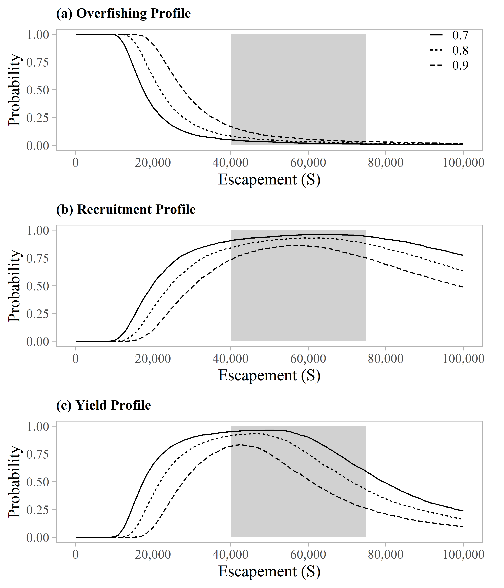

Figure 1.–Overfishing profiles (OFPs), optimal recruitment profiles (ORPs), and optimal yield profiles (OYPs) for Taku River sockeye salmon. OYPs and ORPs show probability that a specified spawning abundance will result in specified fractions (70%, 80%, and 90% line) of maximum sustained yield or maximum recruitment. OFPs show the probability that reducing escapement to a specified spawning abundance will result in less than specified fractions of maximum sustained yield. The shaded region shows the bilaterally approved biological escapement goal range of 40,000 to 75,000 spawners.

### Chilkoot Lake Sockeye Salmon

Chilkoot Lake, located on mainland Alaska approximately 13 km northeast of Haines, supports one of the largest sockeye salmon runs in Southeast Alaska (Eggers et al. 2009b). Chilkoot Lake sockeye salmon are primarily harvested in the District 15 commercial drift gillnet fishery in northern Lynn Canal. Smaller, but unknown, portions of this run are also harvested in purse seine fisheries that target pink salmon in Icy and northern Chatham straits (Ingledue 1989; Gilk-Baumer et al. 2015). In addition, several thousand Chilkoot Lake sockeye salmon are harvested in subsistence and sport fisheries each year. Escapements have been assessed annually with a weir located on the Chilkoot River since 1976. Escapements have ranged from 7,177 (1995) to 140,378 (2019) fish, with a median escapement of 73,872 fish (1976–2019). Mark–recapture studies conducted in 12 years produced escapement estimates that averaged 1.73 times greater than weir counts; there is some uncertainty, however, about the extent to which weir counts under-represent escapement or if mark–recapture methods might result in significant overestimates (Bachman et al. 2014). Stock-composition of the commercial sockeye salmon harvest in District 15 was determined from scale-pattern analysis from 1976 to 2016 (McPherson 1990; Bednarski et al. 2016) and from genetic stock identification since 2017 (Zeiser et al. 2019). Estimated annual harvests of Chilkoot Lake sockeye salmon ranged from 2,838 (1998) to 327,323 (1987) fish, with a median harvest of 60,215 fish and estimated harvest rates of 4–84% (median 46%; 1976–2019).

The current sustainable escapement goal range of 38,000–86,000 sockeye salmon was established in 2009, based on stock-recruit analysis of the 1976–2003 brood years (Eggers et al. 2009b). Eggers et al. (2009b) used an autoregressive Ricker model optimized using maximum likelihood, and the recommended escapement goal range was expected to produce at least 90% of maximum sustained yield over the long term. Eggers et al. (2009b) opted for a sustainable goal rather than a biological goal due to the uncertainty in harvest and escapement estimates and large fluctuations in the productivity of this system over time, possibly as a result of density dependence of juvenile sockeye salmon in Chilkoot Lake in association with environmental drivers.

Brenner et al. (2018) reviewed and updated Chilkoot Lake sockeye salmon stock assessment information with escapement and return data from brood years 1976–2010. Similar to the Eggers et al. (2009b) analysis, significant correlation of recruitment parameters at a lag of 1 year dictated the use of an autoregressive Ricker model (AR1) and the updated analysis was constructed in a Bayesian framework. Based on analysis results from Brenner et al. (2018), the escapement goal review committee recommended maintaining the existing sustainable escapement goal of 38,000–86,000 fish; a range of escapements estimated to provide a 57–93% probability of achieving at least 80% of maximum sustained yield, and a 39–85% probability of achieving at least 90% of maximum sustained yield, with the highest probabilities of achieving maximum yield at escapements of around 53,000 fish. Brenner et al. (2018) concluded that a somewhat narrower range of escapements would increase the probability of achieving maximum sustainable yield. For example, escapements of 36,000–72,000 fish would result in an 80% probability of achieving at least 80% of maximum sustained yield.

**Escapement Goal Review:** For this review, the AR1 Ricker model (Brenner et al. 2018) was updated to see if incorporating brood year returns from recent very large escapements in 2012 (118,166 fish) and 2014 (105,713 fish) resulted in changes to parameter estimates and management reference points, such as the escapement expected to produce maximum sustained yield, *S*MSY. This analysis produced an estimate of *S*MSY (52,739 fish) and probabilities of achieving at least 80% and 90% of MSY (Figure 2) that were nearly identical to the analysis of Brenner et al. (2018). **Based on these results, the escapement goal committee recommended maintaining the current sustainable escapement goal range of 38,000–86,000 sockeye salmon, counted annually at the Chilkoot River weir.** The current escapement goal range is consistent with management considerations and sustained yield as defined in the sustainable salmon fisheries policy. A very large escapement in 2019 (140,378 fish; the largest escapement on record) will provide additional information about the productivity of this stock once recruits are fully realized in 2025. See Brenner et al. (2018) for additional details regarding the escapement goal analysis for Chilkoot Lake sockeye salmon.

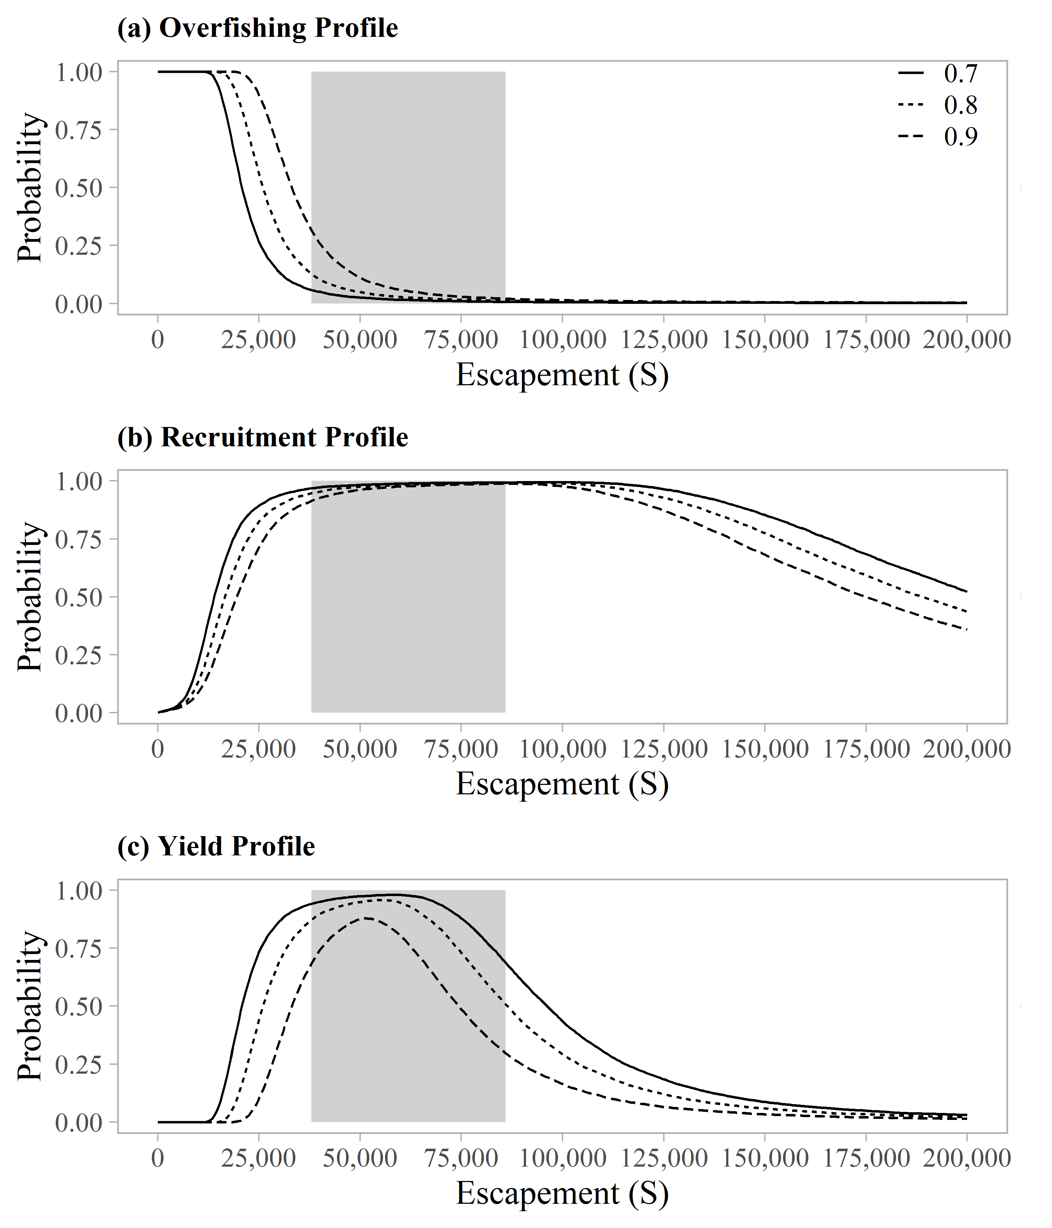

Figure 2.–Overfishing profiles (OFPs), optimal recruitment profiles (ORPs), and optimal yield profiles (OYPs) for Chilkoot Lake sockeye salmon. OYPs and ORPs show probability that a specified spawning abundance will result in specified fractions (70%, 80%, and 90% line) of maximum sustained yield or maximum recruitment. OFPs show the probability that reducing escapement to a specified spawning abundance will result in less than specified fractions of maximum sustained yield. The shaded region shows the current sustainable escapement goal range of 38,000 to 86,000 spawners.

### Speel Lake Sockeye Salmon

Speel Lake is located on the mainland in Speel Arm, Port Snettisham, approximately 50 km southeast of Juneau, Alaska. The lake supports a small run of sockeye salmon, which is harvested primarily in the District 11 commercial drift gillnet fishery in Taku Inlet, Stephens Passage, and Port Snettisham. Management of the District 11 fishery is based primarily on the abundance of wild Taku River sockeye and coho salmon, as specified in the Pacific Salmon Treaty, and the Speel Lake sockeye salmon run accounts for a very small portion of the harvest. Since the late 1990s, wild Speel Lake sockeye salmon have also been harvested in terminal hatchery fisheries conducted in Speel Arm to harvest Snettisham Hatchery sockeye salmon runs. Hatchery production is managed in accordance with the *District 11: Snettisham Hatchery Salmon Management Plan* (5 AAC 33.378), which requires ADF&G to conduct common property harvests in the Speel Arm special harvest area by limiting time and area through emergency order authority to protect and sustain production of wild sockeye salmon runs. Speel Lake sockeye salmon harvests have been estimated annually since 1986 (except 1991) in conjunction with U.S./Canada programs to identify stock-specific harvests in the District 11 drift gillnet fishery. Escapements have been enumerated annually at an adult counting weir at the outlet of the lake in all but two years since 1983 (the weir has been operated by Douglas Island Pink and Chum, Inc. since 1996). Weir counts during most of the 1980s and 1990s underestimated the escapement, however, due to early removal of the weir (Heinl et al 2014b).

The current sustainable escapement goal range of 4,000–9,000 sockeye salmon was established in 2015 based on a spawner-recruit analysis of total runs from 1983 to 2011 (Heinl et al. 2014b). A Bayesian age-structured state-space model was used to assess uncertainty introduced by serial correlation, measurement error in escapement estimates (due to expanded historical weir counts), and missing data (including two years of missing escapement data, 1993–1994; four years of missing harvest data, 1983–1985, 1991; and six years of missing age composition data, 1983–1985, 1991, 1993, 1994). The escapement expected to produce maximum sustained yield (*S*MSY) was estimated to be 6,200 spawners (95% CI: 3,900–21,000 spawners), and there was an estimated 73% probability of achieving at least 80% of MSY at the lower bound (4,000 spawners) and an estimated 60% probability of achieving at least 80% of MSY at the upper bound (9,000 spawners) of the escapement goal range.

**Escapement Goal Review:** For this review, the Bayesian age-structured state-space model was updated to include run years 2012–2019. (Note that since this review included eight additional years of data, we have provided a more detailed overview here compared to the Taku and Chilkoot sockeye salmon analyses, which were recently documented in standalone reports.) Estimated model parameters and management reference points were imprecise for this stock, as indicated by large credible intervals (Table 7), which may be a true representation of process variation and observation error in the Speel Lake data set. Years with higher uncertainty corresponded to years with missing harvest or escapement data (Figures 3 and 4). The median estimate of ln(**) was low at 1.24, corresponding to median productivity (recruits per spawner in the absence of density effects) of ** = 3.45; but, the uncertainty was high (CV = 0.39 for **) (low productivity stock is defined as ** ≤ 4; Su and Peterman 2012). The median estimate of the density dependent parameter ** was 9.38 × 10-5, and the uncertainty was also high (CV = 0.41; Table 7). Uncertainty about ** is reflected in variability in the values of *S* leading to maximum recruitment *S*MAX = 1/* *, and uncertainty about equilibrium abundance, *S*EQ, is reflected by variability in the values of *S* where the curves intersect the replacement line (Figure 5). There is high contrast in the spawner data (contrast = 9; 16,104 spawners in 1990 divided by 1,788 spawners in 2008) and a few recruits-to-spawner ratios are below 1.0 at high levels of spawning abundance (escapements > 10,000 fish; years 1983, 1990, 1992). Ricker recruitment residuals (productivity residuals) are deviations in recruitment from that predicted by the Ricker spawner-recruit relationship. After controlling for density-dependent effects, these deviations reflect time-varying changes in productivity. There does not appear to be a decrease in productivity in recent years, rather productivity seems to have fluctuated in a random manner (Figures 6 and 7b), with the exception of the very poor 2013 brood year.

Escapements over the past 10 years (2010–2019) all fell within a narrow range of 3,500–6,500 fish (Figures 3 and 4). As a result, the additional brood years appeared to have little effect in the updated stock-recruit relationship and estimated model parameter and management reference points were very similar to those reported by Heinl et al. (2014b); for example, the escapement expected to produce maximum sustained yield, *S*MSY, was estimated to be 5,900 fish (95% CI = 3,900–12,800 fish) in the updated analysis vs. 6,200 fish (95% CI = 3,900–21,000 fish) reported by Heinl et al. (2014b). The range of escapements estimated to produce at least 90% of MSY is 3,792–8,156 fish, very similar to the current escapement goal range of 4,000–9,000 fish. At the current lower bound of 4,000 fish, there is an estimated 81% probability of achieving at least 80% of MSY (Figure 8) and an estimated 56% probability of achieving at least 90% of MSY. At the current upper bound of 9,000 fish, there is an estimated 57% probability of achieving at least 80% of MSY (Figure 8) and an estimated 35% probability of achieving at least 90% of MSY. **The escapement goal committee recommended maintaining the current sustainable escapement goal range of 4,000–9,000 sockeye salmon, counted annually at the Speel Lake weir.** It could be beneficial to future assessments if escapements were allowed to reach or exceed the upper bound of the escapement goal range (> 9,000 fish) to provide additional information about the productivity of this stock.

Table 7.–Parameter estimates from the state-space model fitted to the Speel Lake sockeye salmon data for calendar years 1983–2019. Posterior medians are point estimates; the 2.5th and 97.5th percentiles define 95% credible intervals for the parameters.

|  |  |  |  |
| --- | --- | --- | --- |
| Parameter | 2.5th Percentile | Median | 97.5th percentile |
| ** | 1.95 | 3.45 | 7.31 |
| ln(**) | 0.67 | 1.24 | 1.99 |
| Ln(**)’ | 0.80 | 1.36 | 2.23 |
| ** | 3.08 × 10-5 | 9.38 × 10-5 | 1.83 × 10-4 |
| ** | -0.21 | 0.28 | 0.74 |
| ** | 0.35 | 0.46 | 0.63 |
| *S*EQ | 10,504 | 14,782 | 29,740 |
| *S*MAX | 5,452 | 10,666 | 32,515 |
| *S*MSY | 3,916 | 5,946 | 12,824 |
| *U*MSY | 0.36 | 0.55 | 0.77 |
| MSY | 4,656 | 7,725 | 16,492 |
| D | 10 | 17 | 28 |
| **4 | 0.32 | 0.37 | 0.41 |
| **5 | 0.56 | 0.60 | 0.65 |
| **6 | 0.02 | 0.03 | 0.04 |
| B | 4 | 7 | 12 |

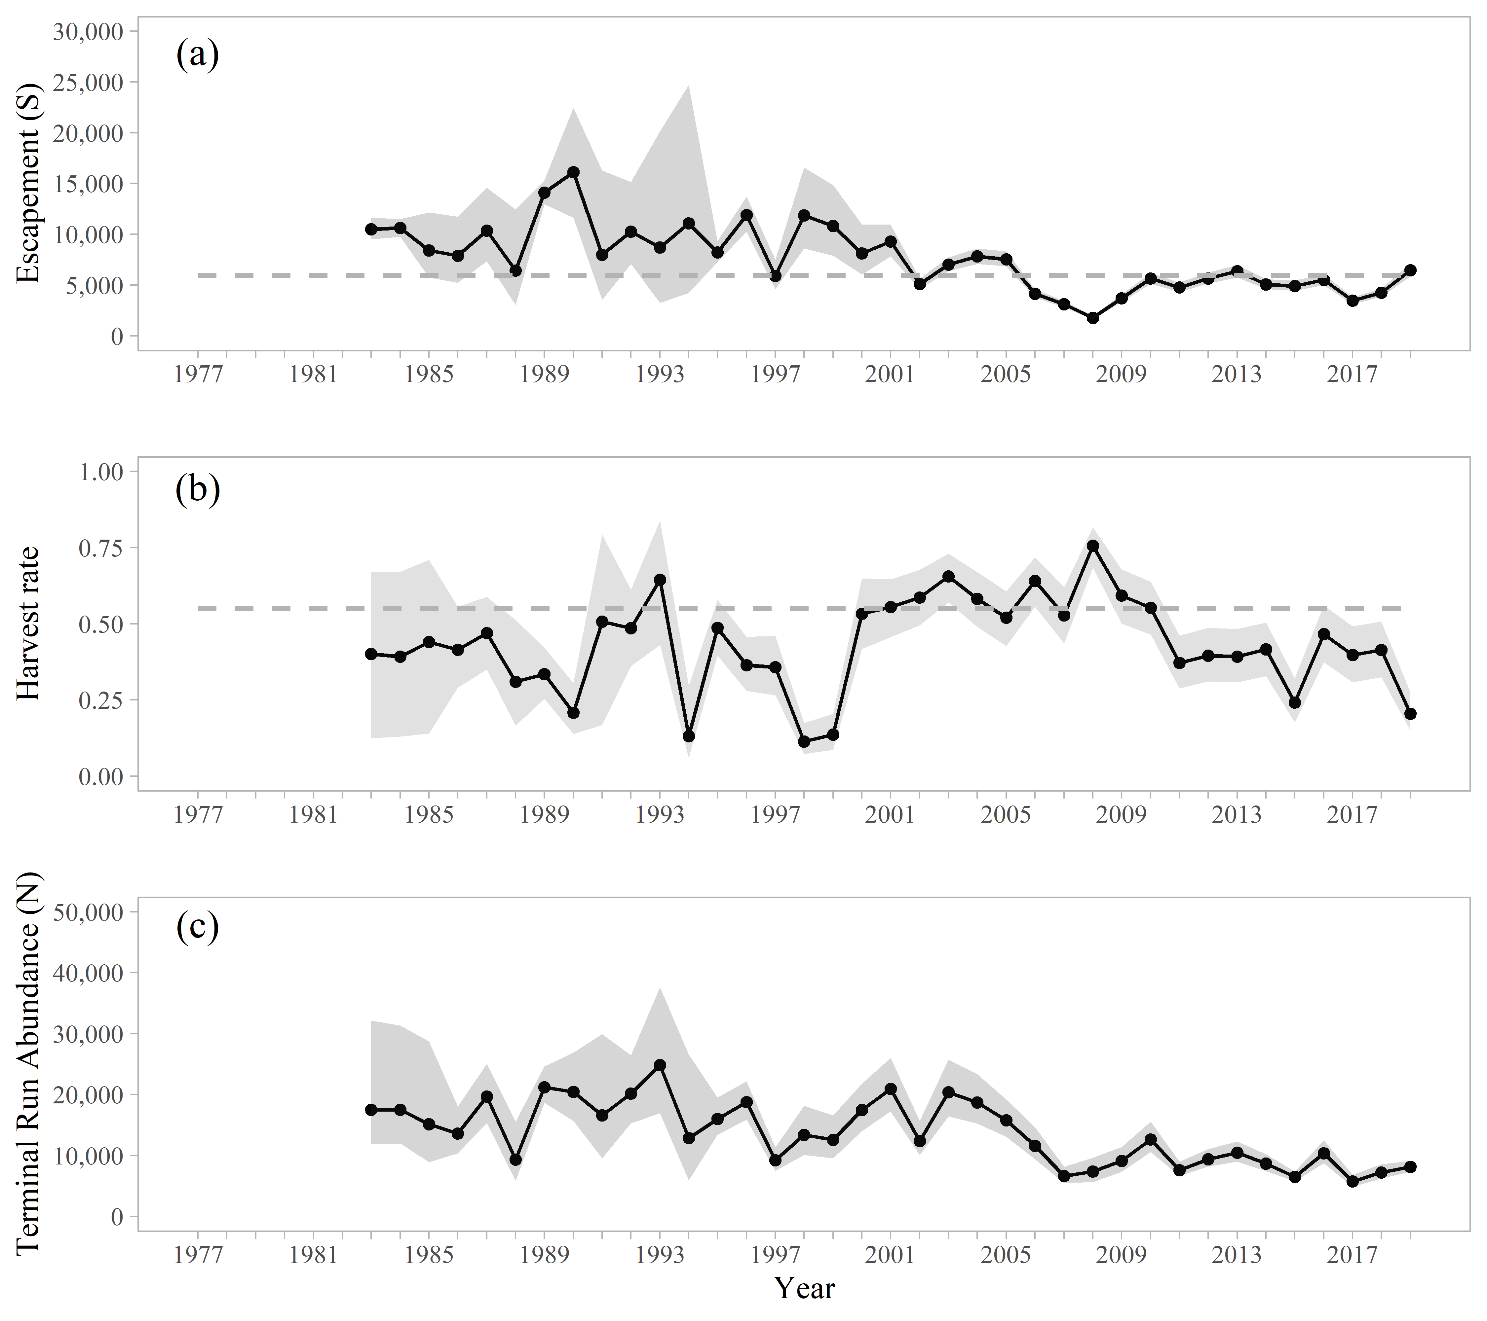

Figure 3.–Point estimates (posterior medians; circles with solid lines) and 95% credible intervals (gray shading) of (a) spawning escapement, (b) harvest rate, and (c) run abundance from the state-space spawner-recruit model of Speel Lake sockeye salmon, 1983–2019. Posterior medians of optimal escapement, *S*MSY, and harvest rate, *U*MSY, are plotted as dashed horizontal reference lines in (a) and (b), respectively.

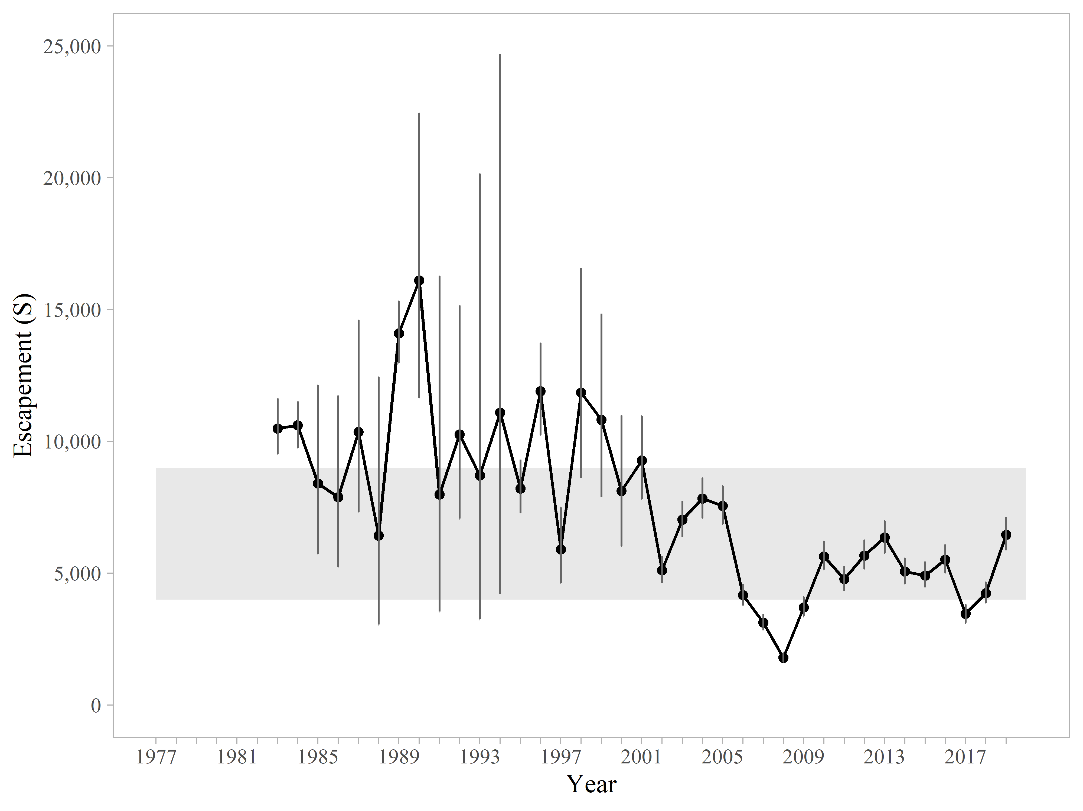

Figure 4.–Posterior medians of escapement estimates (spawners *S*) and 95% credible intervals (vertical lines) obtained by fitting a Bayesian state-space model to Speel Lake sockeye salmon data, 1983–2019. The grey shaded region represents the current sustainable escapement goal range of 4,000–9,000 fish.

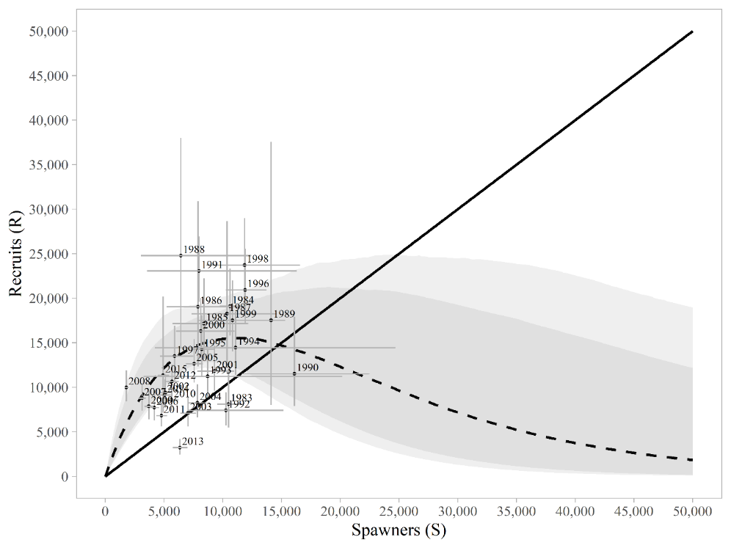

Figure 5.–Plausible spawner-recruit relationships (shaded regions around the dashed line) for Speel Lake sockeye salmon as derived from a Bayesian state-space model fitted to abundance, harvest, and age data for calendar years 1983–2019. Posterior medians of recruits and spawners are plotted as brood year labels with 95% credible intervals (grey lines). The heavy dashed line is the Ricker relationship constructed from ln(**’) and ** posterior medians with 90% and 95% credible intervals (shaded areas). Recruits replace spawners on the solid diagonal line.

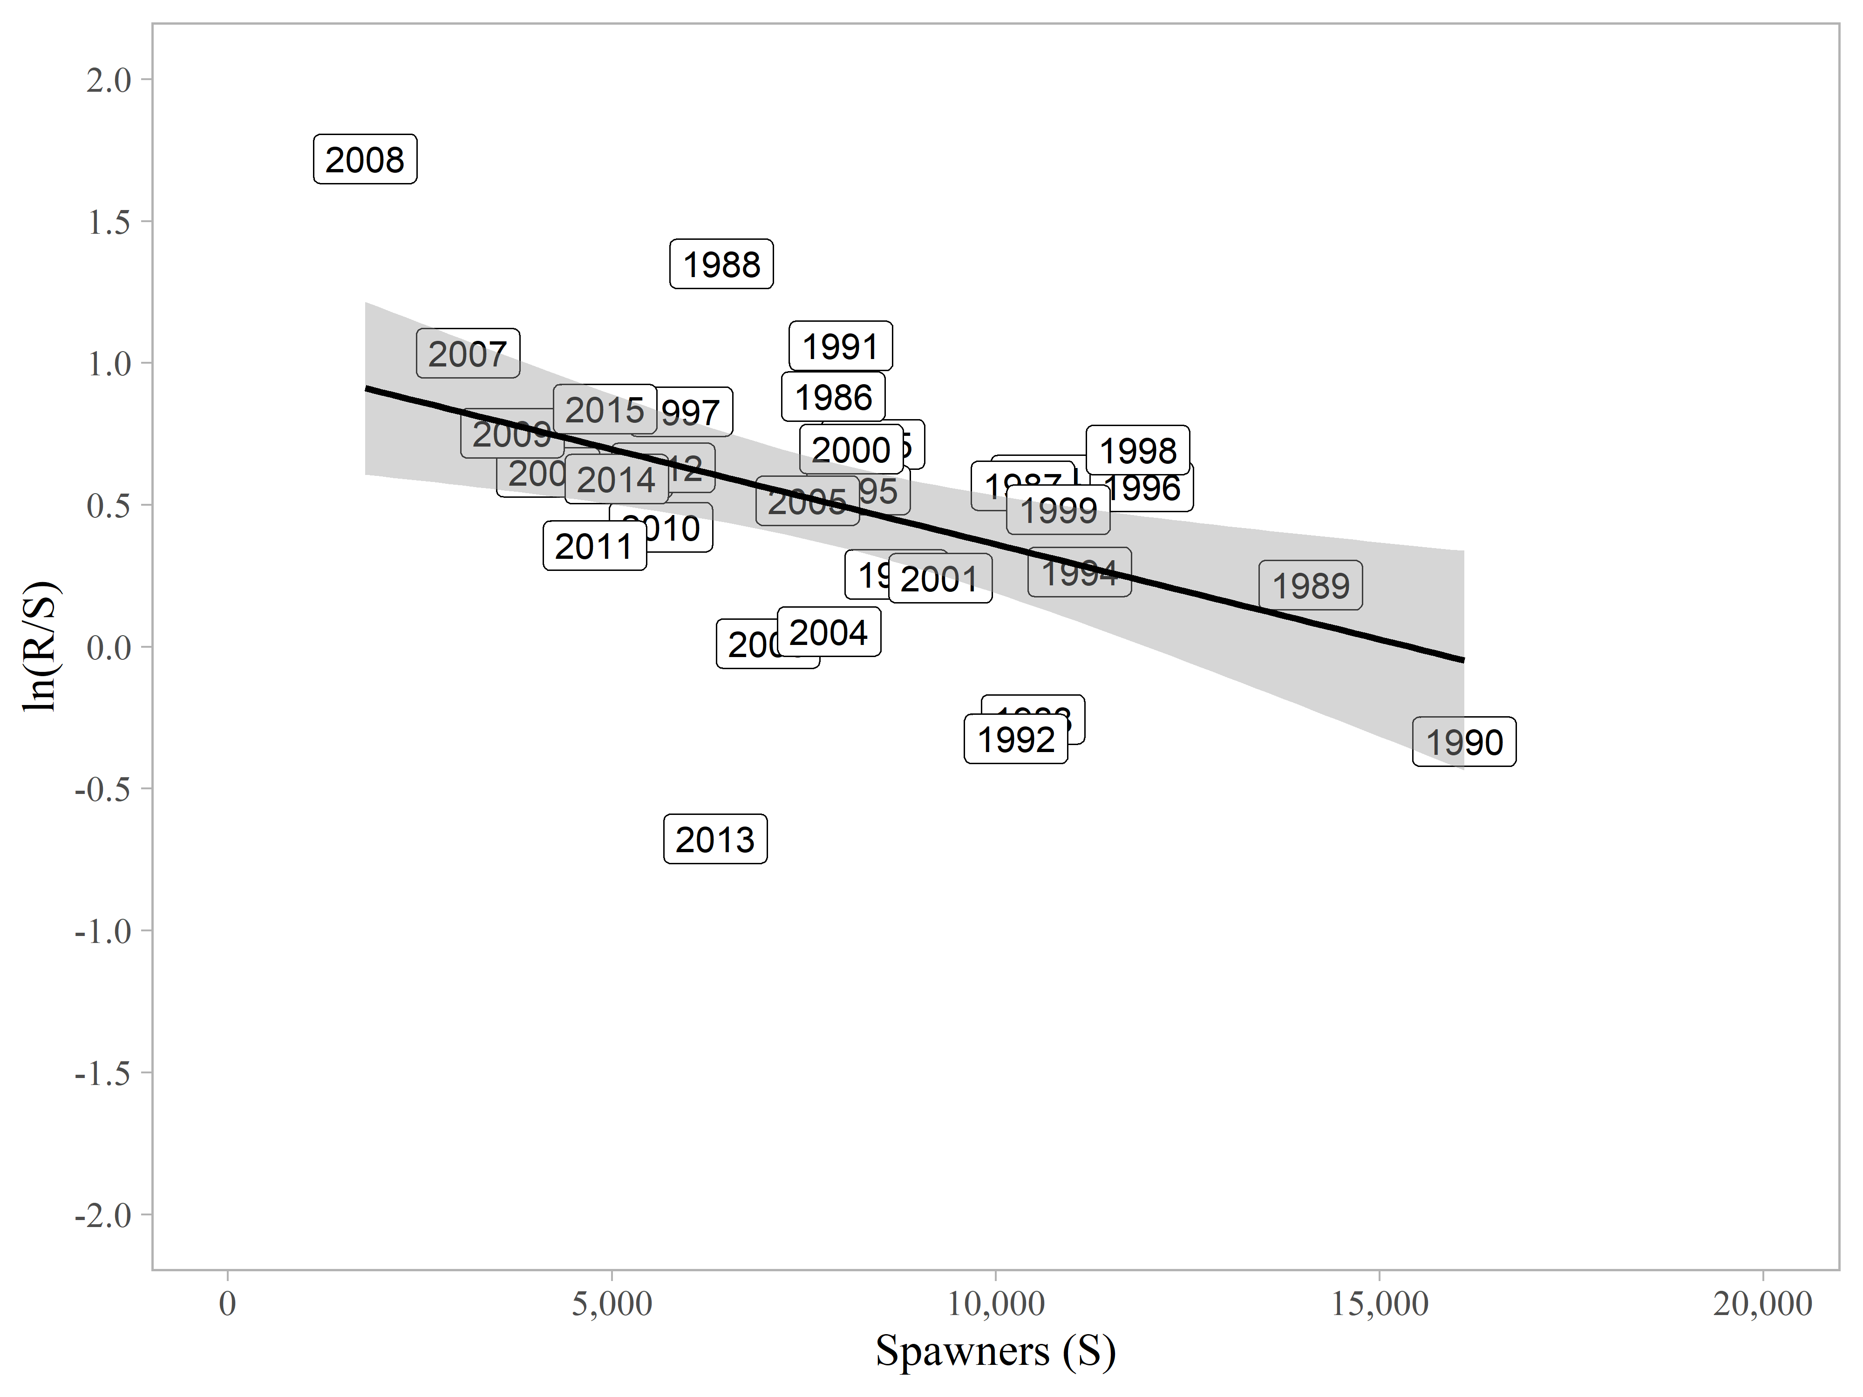

Figure 6.–Natural logarithm of recruits per spawner vs spawners for Speel Lake sockeye salmon, brood years 1983–2015.

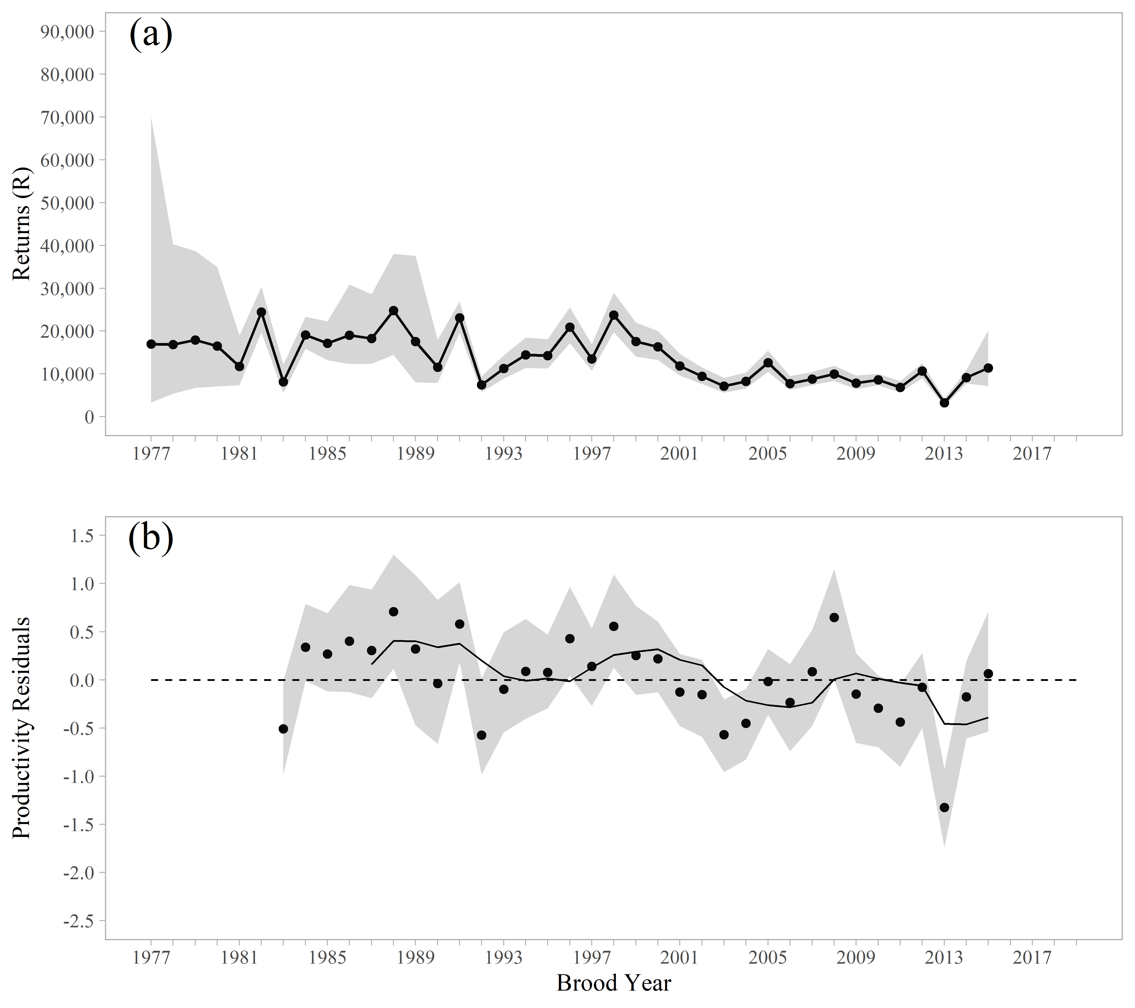

Figure 7.–Point estimates (posterior medians; circles with solid lines) and 95% credible intervals (shaded areas) of (a) recruitment and (b) productivity residuals by brood year from the Bayesian state-space model for Speel lake sockeye salmon. A 5-year rolling mean is shown as a solid black line in (b).

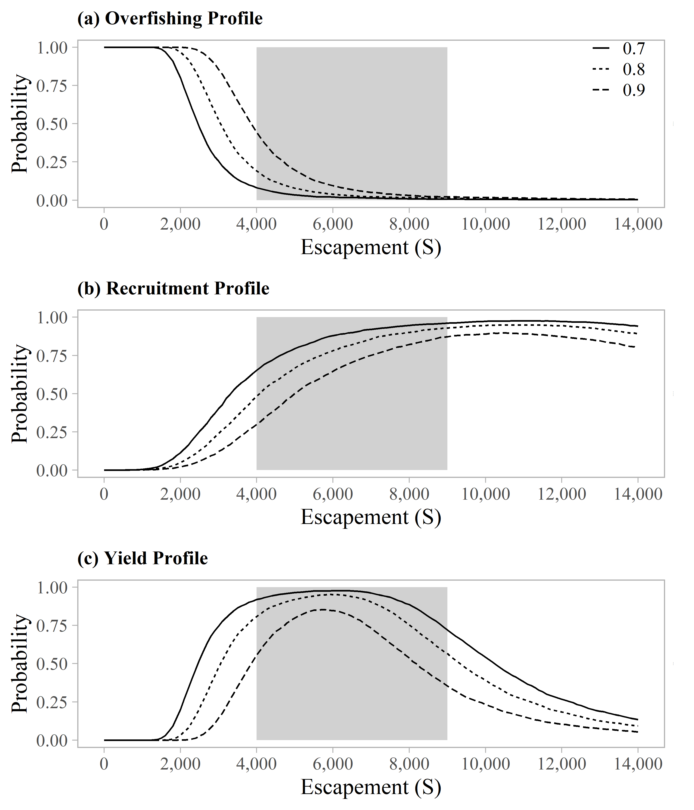

Figure 8.–Overfishing profiles (OFPs), optimal recruitment profiles (ORPs), and optimal yield profiles (OYPs) for Speel Lake sockeye salmon. OYPs and ORPs show probability that a specified spawning abundance will result in specified fractions (70%, 80%, and 90% line) of maximum sustained yield or maximum recruitment. OFPs show the probability that reducing escapement to a specified spawning abundance will result in less than specified fractions of maximum sustained yield. The shaded region shows the current sustainable escapement goal range of 4,000 to 9,000 spawners.

### Redoubt Lake Sockeye Salmon

Redoubt Lake, located on the outer coast of Baranof Island, approximately 19 km south of Sitka, Alaska, supports a run of sockeye salmon that is harvested primarily in terminal subsistence and sport fisheries and, to a much lesser extent, mixed stock commercial fisheries in Sitka Sound. Sockeye salmon escapements have been enumerated at an adult counting weir at the outlet of the lake in all but one year since 1982 (the weir has been operated by the USDA Forest Service since the mid-1990s). Cooperative ADF&G and Forest Service lake fertilization enhancement projects have been conducted nearly annually at Redoubt Lake since the mid-1980s. Liquid fertilizer was applied annually during 1984–1987 and 1990–1995, followed by a less intensive program using dry fertilizer, which has been applied annually by the Forest Service since 1999 (Geiger 2003; Koller et al. 2014). In addition, a small-scale sockeye salmon egg incubation project was conducted at Redoubt Lake in 5 years during the 1980s–1990s, and 900,000 Chinook salmon fry were stocked in the lake in 1986 (Geiger 2003). The effect of the nutrient enhancement program on freshwater production and adult recruitment of sockeye salmon is difficult to assess due to the lack of data from non-fertilized years with which to compare to fertilized years (Beauchamp and Overman 2004); all but three brood years since 1982 (1987, 1995, 1996) experienced some level of lake fertilization.

In 2003, ADF&G recommended a biological escapement goal range of 10,000–25,000 Redoubt Lake sockeye salmon based on a stock-recruit analysis of brood years 1982–1996 (Geiger 2003). In that same year, however, the Board of Fisheries set an optimal escapement goal range of 7,000–25,000 sockeye salmon and adopted a management plan (5 AAC 01.760 *Redoubt Bay and Lake Sockeye Salmon Fisheries Management Plan*) that provides guidelines for allocating harvest between subsistence, sport, and commercial fisheries based on inseason projections of total escapement. Since 2003, escapements have averaged 45,300 fish (range: 10,019–101,067 fish) and reported subsistence harvests averaged 5,400 fish (range: 599–13,683 fish). As outlined in the Redoubt fisheries management plan, directed commercial purse seine fisheries can occur only when the escapement is projected to exceed 40,000 fish. Harvest rates since 2003 averaged 22% in the 8 years when directed commercial purse seine fisheries were prosecuted and averaged 15% in all other years. In 2018 and 2019, the directed commercial fishery attracted more effort than in previous years, which resulted in estimated commercial purse seine harvests of 22,900 fish (2018) and 39,300 fish (2019) and total harvest rates of 32% (2018) and 47% (2019).

**Escapement goal review:** (Note that since this review included 22 additional years of data since the current escapement goal was adopted, we have provided a more detailed overview here compared to the Taku and Chilkoot sockeye salmon analyses, which were recently documented in standalone reports.) Available run-reconstruction data included weir counts (1982–2018; with the exception of 1998, when the weir was not operated), age composition data from the escapement (with the exception of 1998), and harvest data, including estimated commercial harvest (provided by ADF&G Sitka Area Management Biologists Eric Coonradt and Aaron Dupuis), estimated sport harvest, and reported subsistence harvest. A Bayesian approach was used to describe the spawner-recruit relationship. After log-transforming both sides of the standard Ricker equation (Ricker 1954), the Ricker model was fit to the data using a linear regression equation. This was done using two sets of data:

1. Model 1, brood years 1982–2013; following Geiger (2003), the missing 1998 escapement was estimated from regression of 1982–2018 escapements on subsistence harvests (R2 = 0.90); the age composition of the 1998 run was then estimated using the average age at return, all brood years combined (Figure 9); and
2. Model 2, brood years 1999–2013; a shorter time series that did not require imputing values and encompassed all years when the lake was fertilized only with dry fertilizer.

Parameter and management reference point estimates from Model 1 and Model 2 were very similar and, despite the addition of 17 years of escapement and return data, were similar to the values estimated by Geiger (2003), though most reference point estimates (e.g., *S*MSY) were slightly larger (Table 8). The range of escapements estimated to produce at least 90% of MSY was approximately 12,000–27,000 fish (Model 1) and 11,000–26,000 fish (Model 2), again very similar to the range of 11,000–25,000 fish reported by Geiger (2003). For simplicity, Geiger (2003) recommended the escapement goal be rounded to 10,000–25,000 fish. At a lower bound of 10,000 fish, there is an estimated 73% probability of achieving at least 80% of MSY and an estimated 7% probability of achieving at least 90% of MSY (Figure 10). At an upper bound of 25,000 fish, there is an estimated 98% probability of achieving at least 80% of MSY and an estimated 74% probability of achieving at least 90% of MSY (Figure 10). **The escapement goal committee recommended maintaining the current biological escapement goal range of 10,000–25,000 sockeye salmon, counted annually at the Redoubt Lake weir. Given this result it is likely the *optimal* escapement goal of 7,000–25,000 fish (5 AAC 01.760) developed by the Board of Fisheries will also not change.** Future escapement goal review for this stock would benefit from use of a Bayesian age-structured state-space model to better account for missing data and associated uncertainty due to the lack of weir operations and sampling in 1998.

Table 8.–Parameter and management reference point estimates from simple linear spawner-recruit models fitted to Redoubt Lake sockeye salmon brood years 1982–2013 compared to estimates reported by Geiger (2003). The 2.5th and 97.5th percentiles define 95% credible intervals for the parameters. The contrast in spawners for Model 1 is 169, the contrast in spawners for Model 2 is 34, and the contrast in spawners for Geiger (2003) is 160. The 90% lower and upper *S*MSY are point estimates and not posterior medians from the Bayesian model.

|  |  |  |  |  |  |
| --- | --- | --- | --- | --- | --- |
|  | **Model 1a** | | | **Model 2b** | **Geiger**  **(2003)c** |
| **Parameter** | 2.5th  Percentile | Median | 97.5th  Percentile | Median |
| ** | 3.15 | 5.49 | 9.59 | 7.99 | 4.50 |
| ln(**) | 1.15 | 1.70 | 2.26 | 2.08 | 1.50 |
| ln(**)' | 1.65 | 2.20 | 2.9 | 2.59 | 2.15 |
| ** | 0.00002769 | 0.00004076 | 0.00005408 | 0.000044980 | 0.000043 |
| ** | 0.78 | 0.99 | 1.31 | 1.00 | 1.14 |
| *S*EQ | 43,939 | 53,946 | 73,376 | 57,601 | 49,993 |
| *S*MAX | 18,493 | 24,536 | 36,116 | 22,232 | 23,250 |
| *S*MSY | 15,189 | 18,576 | 25,456 | 18,175 | 17,400 |
| *U*MSY | 0.64 | 0.76 | 0.87 | 0.83 | 0.75 |
| MSY | 33,628 | 60,421 | 122,352 | 89,875 | 53,266 |
| 90% MSY Lower | 11,751 | 11,345 |  |  | 11,040 |
| 90% MSY Upper | 26,845 | 26,480 |  |  | 25,200 |
| a Model 1: Brood years 1982–2013; the missing 1998 escapement was estimated by regression of escapement on subsistence harvest (Geiger 2003), and age composition of the 1998 run was based on average return by age class, all brood years combined. | | | | | |
| b Model 2: Brood years 1999–2013. | | | | | |
| c Estimates for brood years 1982–1996 were derived from Geiger (2003; page 20). | | | | | |

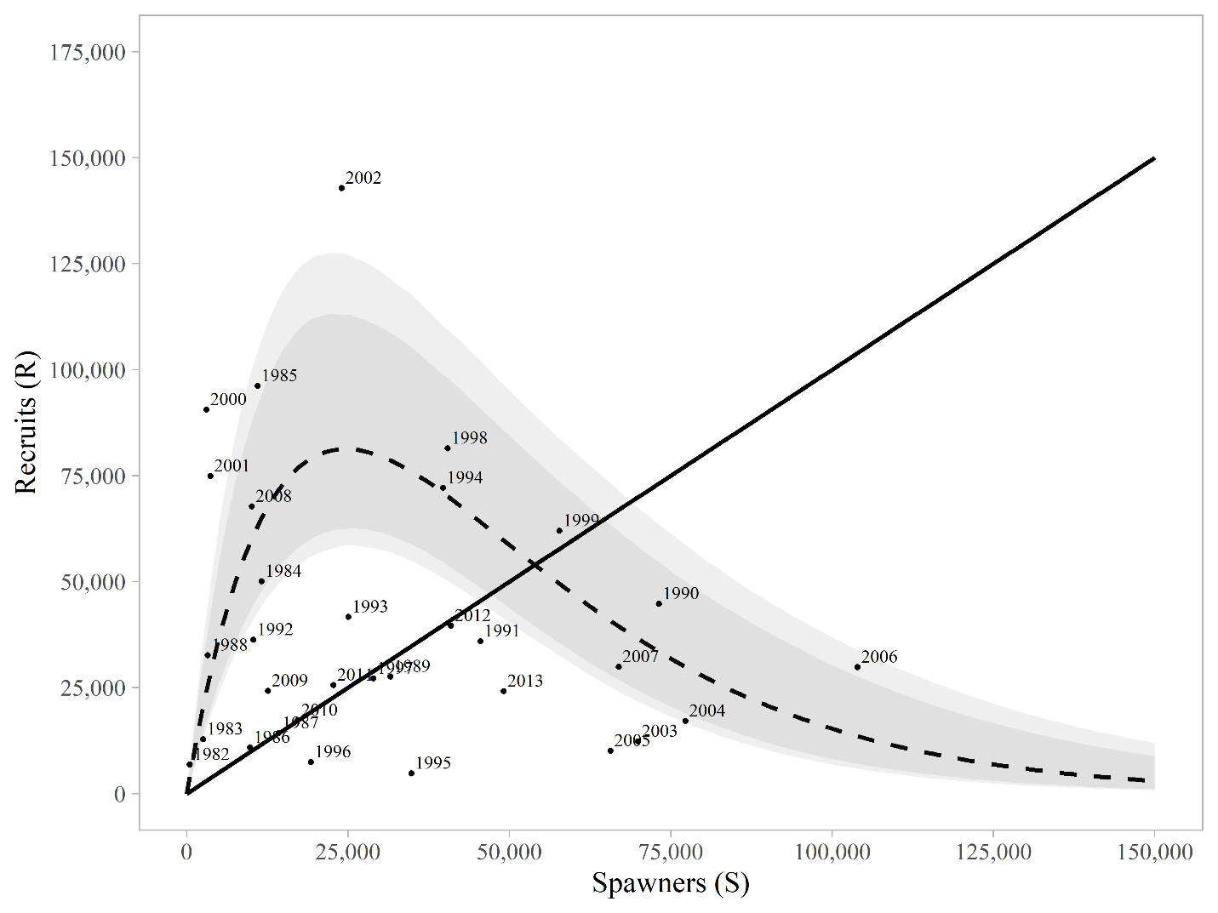

Figure 9.–Plausible spawner-recruit relationships (shaded regions around the dashed line) for Redoubt Lake sockeye salmon as derived from a Bayesian approach (brood years 1982–2013). The observed recruits and spawners are plotted as brood year labels. The heavy dashed line is the Ricker relationship constructed from ln(**’) and ** posterior medians with 90% and 95% credible intervals (shaded areas). Recruits replace spawners on the solid diagonal line.

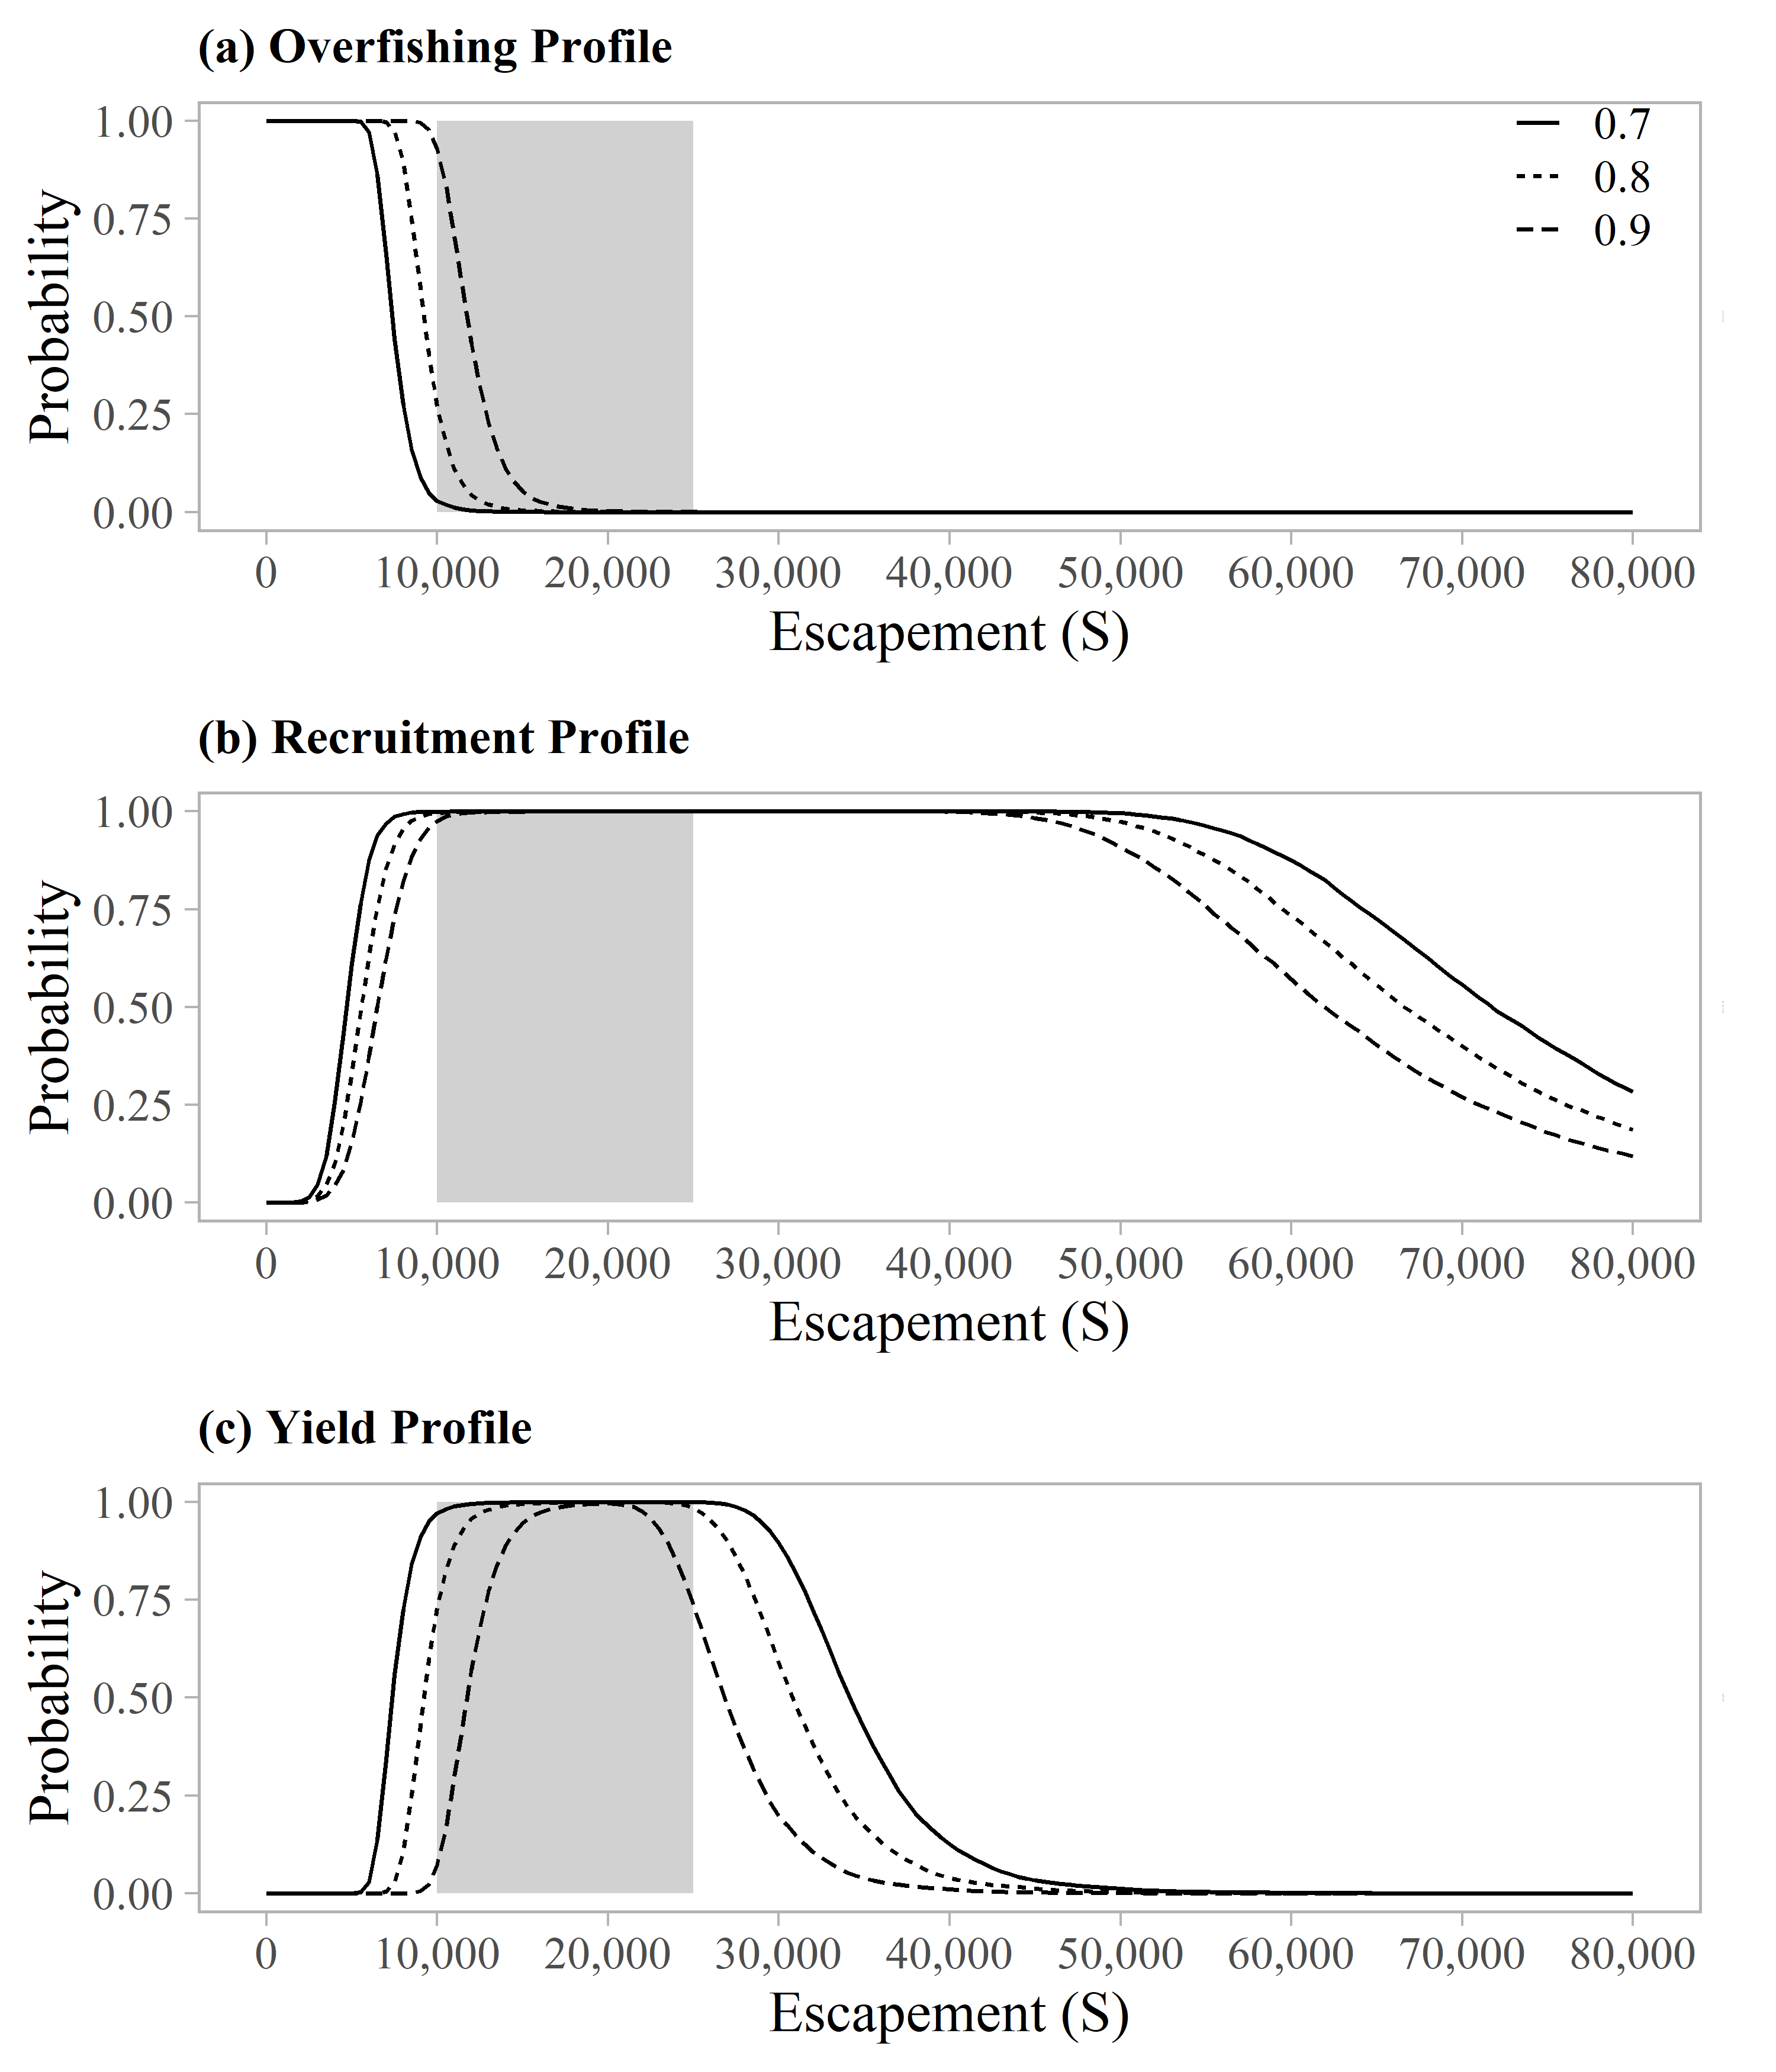

Figure 10.–Overfishing profiles (OFPs), optimal recruitment profiles (ORPs), and optimal yield profiles (OYPs) for Redoubt Lake sockeye salmon as derived from a Bayesian approach (brood years 1982–2013). OYPs and ORPs show probability that a specified spawning abundance will result in specified fractions (70%, 80%, and 90% line) of maximum sustained yield or maximum recruitment. OFPs show the probability that reducing escapement to a specified spawning abundance will result in less than specified fractions of maximum sustained yield. The shaded region shows the current biological escapement goal range of 10,000 to 25,000 spawners. The shaded region shows the current biological escapement goal range of 10,000 to 25,000 spawners and the solid vertical line is the estimate of spawning abundance at maximum sustained yield (*S*MSY).

### Situk River Coho Salmon

The Situk River is located approximately 15 km southeast of Yakutat, Alaska. Situk River coho salmon are harvested primarily in the mixed stock Situk-Ahrnklin commercial set gillnet fishery (statistical area 182-70). Commercial harvests in that fishery, which have averaged 99,700 coho salmon annually since 1985, include mixed stocks of coho salmon from the Situk, Ahrnklin and Lost rivers and other smaller systems that flow into the Situk-Ahrnklin Inlet (Shaul et al. 2010). Situk River coho salmon are also harvested in sport and subsistence fisheries, distant commercial set gillnet fisheries, and offshore commercial troll fisheries (Shaul et al. 2010). In 1994, ADF&G established a biological escapement goal range of 3,300–9,800 coho salmon (peak survey count), based on a stock-recruit analysis (Clark and Clark 1994). However, that work was complicated by a lack of escapement estimates, age composition data, and stock-specific harvest information. Shaul et al. (2010) also reviewed the Situk River escapement goal using three years of smolt estimates and assumed productivity based on literature review. They recommended the current biological escapement goal be retained until substantial additional information became available regarding stock productivity and habitat capability of the Situk River system.

Although a weir has been operated annually in the Situk River since 1976, it has been removed after the sockeye salmon run is completed, typically in early to mid-August (Hoffman 2019), due to weather and funding constraints. Historical coho salmon escapement information is limited to boat survey counts conducted weekly after the weir is removed (Table 9; Zeiser 2019). Mark–recapture and coded wire tagging studies were conducted 2004–2006 to estimate escapement, harvest, smolt production, and survival rates. In 2005 and 2006, a total of 32,400 and 18,100 Situk River coho salmon were harvested equating to total harvest rates of 41% and 44%, respectively. An average 85% of the total harvests occurred in the mixed stock Situk-Ahrnklin set gillnet fishery and the freshwater sport fishery (Shaul et al. 2010). Peak survey-to-escapement expansion factors derived from mark–recapture studies were too variable (range: 5.3–14.0) to be useful for converting historical survey counts to estimates of escapement (Eggers and Tracy 2007; Shaul et al. 2010), which are clearly far larger than survey counts.

**Escapement Goal Review:** The escapement goal review committee recommended the Situk River coho salmon escapement goal be reviewed based on percentiles of historical escapement survey counts, as lack of information on age composition, escapement, and harvest precluded escapement goal analysis based on production models. The Situk River coho salmon run could qualify as a “Tier 1” stock (Clark et al. 2014), as there is high measurement error and high contrast in escapement survey counts (the maximum count divided by the minimum count equals 26). For stocks that experience harvest rates of ≥40%, however, Clark et al. (2014) recommended sustainable escapement goal ranges should be set at the 25th and 75th percentiles as a precautionary approach to prevent overfishing. The 25th and 75th percentiles of Situk River coho salmon escapement survey counts (1972–2019) produced a range of 3,775–9,630 fish, or approximately 3,800–9,600 fish. The lower bound of the range is slightly more conservative than the current biological escapement goal range, but the percentile approach is consistent with the quality of information used to manage the stock. **The escapement goal committee recommended replacing the current biological escapement goal with a *sustainable* escapement goal range of 3,800–9,600 coho salmon counted annually on a peak survey.**

Table 9.–Escapement survey data for Situk River coho salmon, 1972–2019.

|  |  |  |  |  |
| --- | --- | --- | --- | --- |
| **Year** | **Maximum**  **Count** | **Survey**  **Date** | **Survey**  **Type** | **Number**  **of Surveys** |
| 1972 | 5,100 | 9/9/1972 | Boat | 4 |
| 1973 | 1,719 | 9/18/1973 | Boat | 1 |
| 1974 | 4,260 | 10/4/1974 | Boat | 5 |
| 1975 | 4,500 | 10/6/1975 | Aerial | 3 |
| 1976 | 3,280 | 9/7/1976 | Boat | 2 |
| 1977 | 3,750 | 10/4/1977 | Boat | 4 |
| 1978 | 3,850 | 9/5/1978 | Boat | 7 |
| 1979 | 7,000 | 9/11/1979 | Boat | 6 |
| 1980 | 8,100 | 10/15/1980 | Boat | 3 |
| 1981 | 8,430 | 10/3/1981 | Boat | 4 |
| 1982 | 9,180 | 9/19/1982 | Boat | 5 |
| 1983 | 5,300 | 9/16/1983 | Boat | 4 |
| 1984 | 14,000 | 10/18/1984 | Boat | 3 |
| 1985 | 6,490 | 9/5/1985 | Boat | 2 |
| 1986 | 3,162 | 9/24/1986 | Boat | 8 |
| 1987 | 2,000 | 8/27/1987 | Boat | 4 |
| 1988 | 11,000 | 9/27/1988 | Boat | 5 |
| 1989 | 3,900 | 9/8/1989 | Boat | 2 |
| 1990 | 1,630 | 9/7/1990 | Boat | 4 |
| 1991 | --- | --- | --- | 0 |
| 1992 | 13,820 | 9/29/1992 | Boat | 3 |
| 1993 | 10,703 | 9/23/1993 | Boat | 4 |
| 1994 | 21,960 | 9/13/1994 | Boat | 3 |
| 1995a | --- | --- | --- | 2 |
| 1996 a | --- | --- | --- | 2 |
| 1997 | 9,780 | 9/16/1997 | Boat | 4 |
| 1998 a | --- | --- | --- | 1 |
| 1999 a | --- | --- | --- | 2 |
| 2000 | 1,550 | 9/1/2000 | Boat | 3 |
| 2001 | 5,030 | 9/11/2001 | Boat | 4 |
| 2002 | 40,000 | 9/25/2002 | Boat | 3 |
| 2003 | 6,009 | 9/30/2003 | Boat | 6 |
| 2004 | 10,284 | 9/9/2004 | Boat | 4 |
| 2005 | 2,514 | 9/23/2005 | Boat | 6 |
| 2006 | 7,950 | 9/25/2006 | Boat | 4 |
| 2007 | 3,736 | 9/3/2007 | Boat | 5 |
| 2008 a | --- | --- | --- | 2 |
| 2009 | 5,814 | 10/14/2009 | Boat | 3 |
| 2010 | 11,195 | 9/17/2010 | Boat | 5 |
| 2011 | 3,652 | 10/4/2011 | Boat | 4 |
| 2012 | 3,007 | 10/11/2012 | Boat | 4 |
| 2013 | 14,853 | 8/29/2013 | Boat | 6 |
| 2014 | 8,226 | 9/5/2014 | Boat | 5 |

Table 9.–Page 2 of 2.

|  |  |  |  |  |
| --- | --- | --- | --- | --- |
| **Year** | **Maximum**  **Count** | **Survey**  **Date** | **Survey**  **Type** | **Number**  **of Surveys** |
| 2015 | 7,062 | 9/27/2015 | Boat | 5 |
| 2016 | 6,177 | 9/20/2016 | Boat | 5 |
| 2017 | 4,122 | 9/26/2017 | Boat | 5 |
| 2018 | 6,198 | 10/2/2018 | Boat | 6 |
| 2019 | 10,381 | 9/16/2019 | Boat | 6 |

a Surveys in 1995, 1996, 1998, 1999, and 2008 were conducted too early in the season to provide a valid peak count.

# Summary

The Southeast escapement goal review committee recommended that 2 of the 47 existing salmon escapement goals be changed. No new goals were established or eliminated; thus, 47 Southeast Alaska escapement goals are maintained for 11 Chinook, 12 sockeye, 13 coho, 3 pink, and 8 chum salmon stocks. Escapement goals for these 47 stocks included 27 designated as a biological escapement goal, 18 designated as a sustainable escapement goal, and two managed for an optimal escapement goal. Committee recommendations were reviewed by ADF&G regional and headquarters staff prior to adoption as escapement goals. Brief overviews of stock assessment, escapement goal history, and escapement goal performance through 2019 are provided in Appendices A–E for all stocks with formal escapement goals. Specific details regarding the escapement goals currently in place for each stock can be found in the reports cited within these appendices.

# acknowledgments

We would like to thank the members of the Southeast escapement goal review committee and all the people who provided advice and information used in this report: Bob Chadwick, Eric Coonradt, Kristin Courtney, Aaron Dupuis, Lowell Fair, Scott Forbes, Nathan Frost, Dave Harris, Jim Hasbrouck, Rick Hoffman, Judy Lum, Andrew Munro, Bill Templin, Jeff Williams, and Nicole Zeiser. We also thank James Hasbrouck and Bill Templin for their helpful reviews of the final manuscript.

# references Cited

ADF&G (Alaska Department of Fish and Game). 1981. Proposed management plan for Southeast Alaska Chinook salmon runs in 1981. Alaska Department of Fish and Game, Division of Commercial Fisheries, Regional Information Report No. 1J81-03, Douglas.

Bachman, R. L., J. A. Bednarski, and S. C. Heinl. 2014. Escapement and harvest of Chilkoot River sockeye salmon, 2007–2012. Alaska Department of Fish and Game, Fishery Data Series No. 14-07, Anchorage.

Barrowman, N. J., and R. A. Myers. 2000. Still more spawner-recruitment curves: the hockey stick and its generalizations. Canadian Journal of Fisheries and Aquatic Sciences. 57:665–676.

Beauchamp, D. A., and N. C. Overman. 2004. Evaluating the effects of fertilization on sockeye salmon production in Redoubt Lake, Alaska. Final Report to U.S. Forest Service, Washington Cooperative Fish and Wildlife Research Unit Report #WACFWRU-03-03, Seattle.

Bednarski, J. A., M. Sogge, and S. C. Heinl. 2016. Stock assessment study of Chilkoot Lake sockeye salmon, 2013–2015. Alaska Department of Fish and Game, Fishery Data Series No. 16-29, Anchorage.

Bednarski, J. A., M. Sogge, S. E. Miller, and S. C. Heinl. 2017. A comprehensive review of Chilkat River drainage sockeye salmon stock assessment studies. Alaska Department of Fish and Game, Fishery Manuscript Series No. 17-06, Anchorage.

Bergander, F. E., S. A. McPherson, and J. P. Koenings. 1988. Southeast Alaska sockeye salmon studies, 1987–1988. Technical Report for the period July 1, 1987, to June 30, 1988. Alaska Department of Fish and Game, Division of Commercial Fisheries, Regional Information Report No. 1J88-44, Juneau.

Bergmann, W. R, S. N. Forbes, S. C. Heinl, B. L. Meredith, A. W. Piston, and S. B. Walker. 2009. McDonald Lake sockeye salmon action plan, 2009. Alaska Department of Fish and Game, Regional Information Report Series No. 1J09-03, Douglas.

Bernard, D. R., and E. L. Jones III. 2010. Optimum escapement goals for Chinook salmon in the transboundary Alsek River. Alaska Department of Fish and Game, Fishery Manuscript Series No. 10-02, Anchorage.

Bernard, D. R., S. A. McPherson, K. A. Pahlke, and P. Etherton. 2000. Optimal production of Chinook salmon from the Stikine River. Alaska Department of Fish and Game, Fishery Manuscript Series No. 00-01, Anchorage.

Beverton, R. J., and S. J. Holt. 1957. On the dynamics of exploited fish populations. MAFF Fisheries Investigations Series II 19:533.

Bradford, M. J., R. A. Myers, and J. R. Irvine. 2000. Reference points for coho salmon (Oncorhynchus kisutch) harvest rates and escapement goals based on freshwater production. Canadian Journal of Fisheries and Aquatic Sciences. 57:677–686.

Brenner, R. E., S. E. Miller, S. C. Heinl, X. Zhang, J. A. Bednarski, M. M. Sogge, and S. J. Fleischman. 2018. Sockeye salmon stock status and escapement goals for Chilkoot Lake in Southeast Alaska. Alaska Department of Fish and Game, Fishery Data Series No. 18-01, Anchorage.

Burkett, R. J., Koenings, M. Haddix, and D. Barto. 1989. Cooperative ADF&G, FRED Division/U.S. Forest Service lake enrichment program for Southeast Alaska. Alaska Department of Fish and Game, Division of Fisheries Rehabilitation, Enhancement, and Development Report Series No. 98, Juneau.

Burkholder, A. 2000. Yakutat set gillnet fishery 2000 management plan. Alaska Department of Fish and Game, Division of Commercial Fisheries, Regional Information Report No. 1J00-20, Juneau.

Chadwick, B. 2016. Juneau, Sitka, and Prince of Wales Island coho salmon index escapement surveys: 2016–2018. Alaska Department of Fish and Game, Division of Sport Fish, Regional Operational Plan No. ROP.SF.1J.2016.15, Anchorage.

Clark, J. H. 1995a. Biological escapement goals for even and odd-year pink salmon returning to the Situk River and to Humpy Creek near Yakutat, Alaska. Alaska Department of Fish and Game, Division of Commercial Fisheries, Regional Information Report No. 1J95-08, Juneau.

**REFERENCES CITED (Continued)**

Clark, J. H. 1995b. Escapement goals for coho salmon stocks returning to streams located along the Juneau road system of Southeast Alaska. Alaska Department of Fish and Game, Division of Commercial Fisheries, Regional Information Report No. 1J95-02, Douglas.

Clark, R. A. 2005. Stock status and recommended escapement goals for coho salmon in selected waters along the Juneau road system, 1981–2004. Alaska Department of Fish and Game, Special Publication No. 05-21, Anchorage.

Clark, J. H., and J. E. Clark. 1994. Escapement goals for Yakutat area coho salmon stocks. Alaska Department of Fish and Game, Division of Commercial Fisheries, Regional Information Report No. 1J95-14, Douglas.

Clark, J. H., and P. Etherton. 2000. Biological escapement goal for Klukshu River system sockeye salmon. Alaska Department of Fish and Game, Division of Commercial Fisheries, Regional Informational Report No. 1J00-24, Juneau.

Clark, J. E., J. H. Clark, and L. D. Shaul. 1994. Escapement goals for coho salmon stocks returning to Berners River, Auke Creek, Ford Arm Lake, and Hugh Smith Lake in Southeast Alaska. Alaska Department of Fish and Game, Division of Commercial Fisheries Management and Development, Regional Information Report No. 1J94-26, Juneau.

Clark, J. H., S. A. McPherson, and A. Burkholder. 1995a. Biological escapement goal for Situk River sockeye salmon. Alaska Department of Fish and Game, Division of Commercial Fisheries Management and Development, Regional Informational Report No. 1J95-22, Douglas.

Clark, J. H., A. Burkholder, and J. E. Clark. 1995b. Biological escapement goals for five sockeye salmon stocks returning to streams in the Yakutat area of Alaska. Alaska Department of Fish and Game, Division of Commercial Fisheries Management and Development, Regional Informational Report No. 1J95-16, Juneau.

Clark, J. H., S. A. McPherson, and D. M. Gaudet. 1998. Biological escapement goal for Andrew Creek Chinook salmon, Alaska Department of Fish and Game, Division of Commercial Fisheries, Regional Information Report No. 5J98-08, Juneau.

Clark, J. H., S. A. McPherson, and G. F. Woods. 2002. Biological escapement goal for sockeye salmon in the Situk River, Yakutat, Alaska. Alaska Department of Fish and Game, Special Publication No. 02-03, Anchorage.

Clark, J. H., G. F. Woods, and S. Fleischman. 2003. Revised biological escapement goal for the sockeye salmon stock returning to the East Alsek-Doame river system of Yakutat, Alaska. Alaska Department of Fish and Game, Special Publication No. 03-04, Anchorage.

Clark, R. A., D. M. Eggers, A. R. Munro, S. J. Fleischman, B. G. Bue, and J. J. Hasbrouck. 2014. An evaluation of the percentile approach for establishing sustainable escapement goals in lieu of stock productivity information. Alaska Department of Fish and Game, Fishery Manuscript No. 14-06, Anchorage.

Der Hovanisian, J. 2013. Escapement goal for Klawock River coho salmon. Alaska Department of Fish and Game, Fishery Manuscript Series No. 13-09, Anchorage.

Der Hovanisian, J. A., and H. J. Geiger, editors. 2005. Stock status and escapement goals for salmon stocks in Southeast Alaska 2005. Alaska Department of Fish and Game, Special Publication No. 05-22, Anchorage.

Der Hovanisian, J., S. McPherson, E. Jones, P. Richards, R. Chapell, B. Elliott, T. Johnson, and S. Fleischman. 2011. Chinook salmon status and escapement goals for stocks in Southeast Alaska. Alaska Department of Fish and Game, Special Publication No. 11-19, Anchorage.

Eggers, D. M., and D. R. Bernard. 2011. Run reconstruction and escapement goals for Alsek River sockeye salmon. Alaska Department of Fish and Game, Fishery Manuscript Series No. 11-01, Anchorage.

Eggers, D. M., and S. C. Heinl. 2008. Chum salmon stock status and escapement goals in Southeast Alaska. Alaska Department of Fish and Game, Special Publication No. 08-19, Anchorage.

Eggers, D. M., and M. Tracy. 2007. A mark–recapture experiment to estimate the escapement of coho salmon in the Situk River, 2005, 2006. Alaska Department of Fish and Game, Fishery Data Series No. 07-70, Anchorage.

**REFERENCES CITED (Continued)**

Eggers, D. M., J. H. Clark, R. L. Bachman, and S. C. Heinl. 2008. Sockeye salmon stock status and escapement goals in Southeast Alaska. Alaska Department of Fish and Game, Divisions of Sport Fish and Commercial Fisheries, Special Publication No. 08-17, Anchorage.

Eggers, D. M., S. C. Heinl, and A. W. Piston. 2009a. McDonald Lake sockeye salmon stock status and escapement goal recommendations, 2008. Alaska Department of Fish and Game, Fishery Data Series No. 09-31, Anchorage.

Eggers, D. M., X. Zhang, R. L. Bachman, and M. M. Sogge. 2009b. Sockeye salmon stock status and escapement goals for Chilkoot Lake in Southeast Alaska. Alaska Department of Fish and Game, Fishery Data Series No. 09-63, Anchorage.

Eggers, D. M., R. L. Bachman, and J. Stahl. 2010. Stock status and escapement goals for Chilkat Lake sockeye salmon in southeast Alaska. Alaska Department of Fish and Game, Fishery Manuscript No. 10-05, Anchorage.

Elliott, B. W. 2009. Production and escapement of coho salmon from the Chilkat River, 2005–2006. Alaska Department of Fish and Game, Fishery Data Series No. 09-65, Anchorage.

Elliott, B. W. 2013. Production, harvest, and escapement of Chilkat River coho salmon, 2009–2010. Alaska Department of Fish and Game, Fishery Data Series No. 13-14, Anchorage.

Ericksen, R. P., and S. J. Fleischman. 2006. Optimal production of coho salmon from the Chilkat River. Alaska Department of Fish and Game, Fishery Manuscript No. 06-06, Anchorage.

Ericksen, R. P., and S. A. McPherson. 2004. Optimal production of Chinook salmon from the Chilkat River. Alaska Department of Fish and Game, Fishery Manuscript No. 04-01, Anchorage.

Faber, D. M. 2008. Loss of spawning habitat due to isostatic rebound and the subsequent effect on the commercial East Alsek sockeye fishery, Alaska. M. S. Thesis, University of Alaska, Fairbanks.

Fleischman, S. J., J. A. Der Hovanisian, and S. A. McPherson. 2011. Escapement goals for Chinook salmon in the Blossom and Keta rivers. Alaska Department of Fish and Game, Fishery Manuscript No. 11-05, Anchorage.

Fleischman, S. J., M. J. Catalano, R. A. Clark, and D. R. Bernard. 2013. An age-structured state-space stock-recruit model for Pacific salmon (*Oncorhynchus* spp.). Canadian Journal of Fisheries and Aquatic Sciences. 70:401–414.

Geiger, H. J. 2003. Sockeye salmon stock status and escapement goal for Redoubt Lake in Southeast Alaska. Alaska Department of Fish and Game, Division of Commercial Fisheries, Regional Information Report No. 1J03-01, Juneau.

Geiger, H. J., and S. McPherson, *editors*. 2004. Stock status and escapement goals for salmon stocks in Southeast Alaska. Alaska Department of Fish and Game, Divisions of Sport Fish and Commercial Fisheries, Special Publication No. 04-02, Anchorage.

Geiger, H. J., T. P. Zadina, and S. C. Heinl. 2003. Sockeye salmon stock status and escapement goal for Hugh Smith Lake in Southeast Alaska. Alaska Department of Fish and Game, Division of Commercial Fisheries, Regional Information Report 1J03-05, Juneau.

Geiger, H. J., M. A. Cartwright, J. H. Clark, J. Conitz, S. C. Heinl, K. Jensen, B. Lewis, A. J. McGregor, R. Riffe, G. Woods and T. P. Zadina. 2004. Sockeye salmon stock status and escapement goals in Southeast Alaska [*in*] H. J. Geiger, and S. McPherson, editors. Stock status and escapement goals for salmon stocks in Southeast Alaska. Alaska Department of Fish and Game, Special Publication No. 04-02, Anchorage.

Geiger, H. J., R.L. Bachman, S. C. Heinl, K. Jensen, B. Lewis, T. A. Johnson, A. Piston, and R. Riffe. 2005. Sockeye salmon stock status and escapement goals in Southeast Alaska [*in*] J. A. Der Hovanisian and H. J. Geiger, editors. Stock status and escapement goals for salmon in Southeast Alaska 2005. Alaska Department of Fish and Game, Special Publication No. 05-22, Anchorage.

Gilk-Baumer, S. E., S. D. Rogers Olive, D. K. Harris, S. C. Heinl, E. K. C. Fox, and W. D. Templin. 2015. Genetic mixed stock analysis of sockeye salmon harvests in selected northern Chatham Strait commercial fisheries, Southeast Alaska, 2012–2014. Alaska Department of Fish and Game, Fishery Data Series No. 15-03, Anchorage.

**REFERENCES CITED (Continued)**

Halupka, K. C., M. D. Bryant, M. F. Willson, and F. H. Everest. 2000. Biological characteristics and population status of anadromous salmon in Southeast Alaska. United States Forest Service. General Technical Report. PNW-GTR-468.

Heinl, S. C., D. M. Eggers, and A. W. Piston. 2008. Pink salmon stock status and escapement goals in Southeast Alaska and Yakutat. Alaska Department of Fish and Game, Special Publication No. 08-16, Anchorage.

Heinl, S. C., R. L. Bachman, and K. Jensen. 2011. Sockeye salmon stock status and escapement goals in Southeast Alaska. Alaska Department of Fish and Game, Divisions of Sport Fish and Commercial Fisheries, Special Publication No. 11-20, Anchorage.

Heinl, S. C., E. L. Jones III, A. W. Piston, P. J. Richards, and L. D. Shaul. 2014a. Review of salmon escapement goals in Southeast Alaska, 2014. Alaska Department of Fish and Game, Fishery Manuscript Series No. 14-07, Anchorage.

Heinl, S. C., S. E. Miller, and J. A. Bednarski. 2014b. Speel Lake sockeye salmon stock status and escapement goal review. Alaska Department of Fish and Game, Fishery Manuscript Series No. 14-04, Anchorage.

Heinl, S. C., E. L. Jones III, A. W. Piston, P. J. Richards, L. D. Shaul, B. W. Elliott, S. E. Miller, R. E. Brenner, and J. V. Nichols. 2017. Review of salmon escapement goals in Southeast Alaska, 2017. Alaska Department of Fish and Game, Fishery Manuscript Series No. 17-11, Anchorage.

Hendrich, C. F., J. L. Weller, S. A. McPherson, and D. R. Bernard. 2008. Optimal production of Chinook salmon from the Unuk River. Alaska Department of Fish and Game, Fishery Manuscript No. 08-03, Anchorage.

Hilborn, R., and C. J. Walters. 1992. Quantitative Fisheries Stock Assessment: Choice, Dynamics and Uncertainty. Chapman and Hall, New York.

Hoffman, R. A. 2019. Operational Plan: Situk River salmon enumeration and sampling procedures, 2019. Alaska Department of Fish and Game, Regional Operational Plan ROP.CF.1J.2019.08, Douglas.

Humphreys, R. D., S. M. McKinnel, D. Welch, M. Stocker, B. Turris, F. Dickson, and D. Ware, editors. 1994. Pacific Stock Assessment Review Committee (PSARC) Annual Report for 1993. Canadian Manuscript Report of Fisheries and Aquatic Sciences 2227.

Ingledue, D. 1989. Hawk Inlet shore purse seine fishery, 1989. Alaska Department of Fish and Game, Division of Commercial Fisheries, Regional Information Report No. 1J89-31, Juneau.

Johnson, T. A., S. C. Heinl, and H. J. Geiger. 2005. McDonald Lake: Stock status and escapement goal recommendations. Alaska Department of Fish and Game, Fishery Manuscript No. 05-07, Anchorage.

Kissner, P. D. 1978. Status of important native Chinook salmon stocks in Southeastern Alaska. Alaska Department of Fish and Game. Federal Aid in Fish Restoration, Annual Performance Report, 1976–1977, Project F-9-9(18) AFS 41-5, Juneau.

Koller, J., J. Serio, B. Van Alen, and C. Leeseberg. 2014. Redoubt Lake sockeye salmon monitoring and lake fertilization project: 2013 annual report and final report for study 10-611. U.S. Fish and Wildlife Service, Office of Subsistence Management, Fishery Resource Monitoring Program, Final Report (Study No. 05-601), Anchorage.

McPherson, S. A. 1990. An inseason management system for sockeye salmon returns to Lynn Canal, Southeast Alaska. M. S. Thesis, University of Alaska, Fairbanks.

McPherson, S. A., and J. K. Carlile. 1997. Spawner-recruit analysis of Behm Canal Chinook salmon stocks. Alaska Department of Fish and Game, Division of Commercial Fisheries Management and Development, Regional Information Report No. 1J97-06, Juneau.

McPherson, S. A., and J. H. Clark. 2001. Biological escapement goal for King Salmon River Chinook salmon. Alaska Department of Fish and Game, Division of Commercial Fisheries, Regional Information Report No. 1J01-40, Juneau.

McPherson, S., S. Marshall, and M. Rowse. 1987. Situk River sockeye salmon spawner-recruit analysis. Alaska Department of Fish and Game, Division of Commercial Fisheries, Southeast Region Report 87(2), Douglas.

**REFERENCES CITED (Continued)**

McPherson, S. A., P. Etherton, and J. H. Clark. 1998. Biological escapement goal for Klukshu River Chinook salmon. Alaska Department of Fish and Game, Fishery Manuscript No. 98-02, Anchorage.

McPherson, S. A., D. Bernard, J. H. Clark, K. Pahlke, E. Jones, J. Der Hovanisian, J. Weller, and R. Ericksen. 2003. Stock status and escapement goals for Chinook salmon stocks in Southeast Alaska. Alaska Department of Fish and Game, Special Publication No. 03-01, Anchorage.

McPherson, S. A., R. E. Johnson, and G. F. Woods. 2005. Optimal production of Chinook salmon from the Situk River. Alaska Department of Fish and Game, Fishery Manuscript No. 05-04, Anchorage.

McPherson, S., J. H. Clark, D. R. Bernard, J. Der Hovanisian, E. Jones, K. Pahlke, P. Richards, J. Weller, and T. Johnson. 2008. Chinook salmon status and escapement goals for stocks in Southeast Alaska. Alaska Department of Fish and Game, Special Publication No.08-18, Anchorage.

McPherson, S. A., E. L. Jones III, S. J. Fleischman, and I. M. Boyce. 2010. Optimal production of Chinook salmon from the Taku River through the 2001 year class. Alaska Department of Fish and Game, Fishery Manuscript Series No. 10-03, Anchorage.

Miller, S. E., and S. C. Heinl. 2018. Chilkat Lake sockeye salmon escapement goal review. Alaska Department of Fish and Game, Fishery Manuscript Series No. 18-05, Anchorage.

Miller, S.E., and G. Pestal. 2020. Estimates of a biologically-based spawning goal and management benchmarks for the Canadian-origin Taku River sockeye salmon stock aggregate. DFO Can. Sci. Advis. Sec. Res. Doc. 2020/035.

Munro, A. R. 2019. Summary of Pacific salmon escapement goals in Alaska with a review of escapements from 2010 to 2018. Alaska Department of Fish and Game, Fishery Manuscript Series No. 19-05, Anchorage.

Munro, A. R., and E. C. Volk. 2014. Summary of Pacific salmon escapement goals in Alaska with a review of escapements from 2005 to 2013. Alaska Department of Fish and Game, Fishery Manuscript Series No. 14-01, Anchorage.

Pestal, G., and S. Johnston. 2015. Estimates of a biologically-based spawning goal and biological benchmarks for the Canadian-origin Taku River coho stock aggregate. DFO Canadian Science Advisory Secretariat Research Document 2015/048, Ottawa.

Pestal, G., C. J. Schwarz, and R. A. Clark. 2020. Taku River sockeye salmon stock assessment review and updated 1984–2018 abundance estimates. Pacific Salmon Commission Technical Report No. 43, Vancouver.

Piston, A. W., and S. C. Heinl. 2011a. Pink salmon stock status and escapement goals in Southeast Alaska. Alaska Department of Fish and Game, Special Publication No.11-18, Anchorage.

Piston, A. W., and S. C. Heinl. 2011b. Chum salmon stock status and escapement goals in Southeast Alaska. Alaska Department of Fish and Game, Special Publication No.11-21, Anchorage.

Piston, A. W., and S. C. Heinl. 2014a. Chum salmon stock status and escapement goals in Southeast Alaska. Alaska Department of Fish and Game, Special Publication No. 14-13, Anchorage.

Piston, A. W., and S. C. Heinl. 2014b. Pink salmon stock status and escapement goals in Southeast Alaska. Alaska Department of Fish and Game, Special Publication No. 14-14, Anchorage.

Piston, A. W., and S. C. Heinl. 2017. Chum salmon stock status and escapement goals in Southeast Alaska. Alaska Department of Fish and Game, Special Publication No. 17-12, Anchorage.

Piston, A. W., and S. C. Heinl. 2018. Pink salmon stock status and escapement goals in Southeast Alaska. Alaska Department of Fish and Game, Special Publication No. 18-14, Anchorage.

Piston, A. W., and S. C. Heinl. 2020a. Pink salmon stock status and escapement goals in Southeast Alaska. Alaska Department of Fish and Game, Special Publication No. 20-09, Anchorage.

Piston, A. W., and S. C. Heinl. 2020b. Chum salmon stock status and escapement goals in Southeast Alaska. Alaska Department of Fish and Game, Special Publication No. 20-10, Anchorage.

**REFERENCES CITED (Continued)**

Ricker, W. E. 1954. Stock and recruitment. Journal of Fisheries Research Board of Canada 11:559–623.

Riffe, R., and J. H. Clark. 2003. Biological escapement goal for Speel Lake sockeye salmon. Alaska Department of Fish and Game, Division of Commercial Fisheries, Regional Information Report No. 1J03-04, Juneau.

Shaul, L. D., and T. A. Tydingco. 2006. Escapement goals for coho salmon counted in aggregate surveys in the Ketchikan and Sitka areas. Alaska Department of Fish and Game, Special Publication No. 06-11, Anchorage.

Shaul, L., E. Jones, K. Crabtree, T. Tydingco, S. McCurdy, and B. Elliott. 2008. Coho Salmon Stock Status and Escapement Goals in Southeast Alaska. Alaska Department of Fish and Game, Special Publication No. 08-20, Anchorage.

Shaul, L. D., K. F. Crabtree, M. Kemp, and N. Olmsted. 2009. Coho salmon studies at Hugh Smith Lake, 1982–2007. Alaska Department of Fish and Game, Fishery Manuscript Series No. 09-04, Anchorage.

Shaul, L. D., K. F. Crabtree, D. M. Eggers, M. Tracy, and J. H. Clark. 2010. Estimates of harvest, escapement, exploitation rate, smolt production, and marine survival for coho salmon stocks in the Situk-Ahrnklin Lagoon, 2004–2006. Alaska Department of Fish and Game, Fishery Data Series No. 10-11, Anchorage.

Shaul, L., K. Crabtree, E. Jones, S. McCurdy, and B. Elliott. 2011. Coho salmon stock status and escapement goals in Southeast Alaska. Alaska Department of Fish and Game, Special Publication No. 11-23, Anchorage.

Shaul, L. D., R. Ericksen, K. Crabtree, and J. Lum. 2013. Beyond the estuary: an extension of the nomad life history strategy in coho salmon. North Pacific Anadromous Fish Commission Technical Report No. 9:171–175.

Shaul, L. D., K. F. Crabtree, and M. Kemp. 2017. Berners River Coho Salmon Studies, 1972–2014. Alaska Department of Fish and Game, Fishery Manuscript Series No. 17-08, Anchorage.

Shaul, L. D., J. A. Bednarski, J. T. Williams, and B. W. Elliott. 2019. Stock status and review of factors affecting coho salmon returns and escapements in Southeast Alaska. Alaska Department of Fish and Game, Regional Information Report No. 1J19-12.

Smith, J. J., D. Reed, M. Tracy, and J. H. Clark. 2006. A mark-recapture experiment to estimate the escapement of sockeye salmon in the East Alsek River, 2005. Alaska Department of Fish and Game, Fishery Data Series No. 06-71, Anchorage.

Stopha, M. 2016. An evaluation of the Klawock River salmon hatchery for consistency with statewide policies and prescribed management practices. Alaska Department of Fish and Game, Division of Commercial Fisheries, Regional Information Report No. 5J16-05, Anchorage.

Su, Z., and R. M. Peterman. 2012. Performance of a Bayesian state-space model of semelparous species for stock-recruitment data subject to measurement error. Ecological Modelling 224:76–89.

TTC (Transboundary Technical Committee). 1986. Report of the Canada/United States Transboundary Technical Committee. Final Report. Pacific Salmon Commission Report TCTR 86-1, Vancouver.

TTC (Transboundary Technical Committee). 1990. Long-term research plans for the transboundary rivers. Pacific Salmon Commission Report TCTR (90)-3, Vancouver.

TTC (Transboundary Technical Committee). 1993. Salmon management and enhancement plans for the Stikine, Taku, and Alsek rivers, 1993. Pacific Salmon Commission Report TCTR (93)-2, Vancouver.

TTC (Transboundary Technical Committee). 2014. Salmon management and enhancement plans for the Stikine, Taku, and Alsek rivers, 2013. Pacific Salmon Commission Report TCTR (14)-1, Vancouver.

TTC (Transboundary Technical Committee). 2019. Salmon management and enhancement plans for the Stikine, Taku, and Alsek rivers, 2019. Pacific Salmon Commission Report TCTR (19)-3, Vancouver.

TTC (Transboundary Technical Committee). 2020. Salmon management and enhancement plans for the Stikine, Taku, and Alsek rivers, 2017. Pacific Salmon Commission Report TCTR (20)-1, Vancouver.

**REFERENCES CITED (Continued)**

Van Alen, B. W. 2000. Status and stewardship of salmon stocks in Southeast Alaska. Pages 161–194 [*in*] E. E Knudsen, C. R. Steward, D. D. McDonald, J. E. Williams, D. W. Reiser, editors. Sustainable Fisheries Management: Pacific salmon. CRC Press. Boca Raton.

Walker, S., T. Thynes, D. Gray, K. S. Reppert, A. W. Piston, and S. C. Heinl. 2018. McDonald Lake sockeye salmon stock status and action plan 2018. Alaska Department of Fish and Game, Division of Commercial Fisheries, Regional Information Report No. 1J18-03, Douglas.

Weller, J. L., D. J. Reed, and G. M. Freeman. 2007. Spawning abundance of Chinook salmon in the Chickamin River in 2005. Alaska Department of Fish and Game, Fishery Data Series No. 07-63, Anchorage.

Williams, J. T., S. Power, and E. L. Jones III. 2016. Production and escapement of coho salmon in the Taku River, 2016–2018. Alaska Department of Fish and Game, Division of Sport Fish, Regional Operational Plan No. ROP.SF.1J.2016.10, Anchorage.

Woods, G. F., and N. L. Zeiser. 2010. 2010 Yakutat set gillnet fishery management plan. Alaska Department of Fish and Game, Division of Commercial Fisheries, Regional Information Report No. 1J10-10, Douglas.

Zadina, T. P., S. C. Heinl, A. J. McGregor, and H. J. Geiger. 2004. Pink salmon stock status and escapement goals in Southeast Alaska and Yakutat [in] Stock status and escapement goals for salmon stocks in Southeast Alaska. H. J. Geiger and S. McPherson [eds]. Alaska Department of Fish and Game, Divisions of Sport and Commercial Fisheries, Special Publication No. 04-02, Anchorage.

Zeiser, N. L. 2019. Operational plan: Yakutat salmon escapement surveys, 2019–2021. Alaska Department of Fish and Game, Regional Operational Plan ROP.CF.1J.2019.01, Douglas.

Zeiser, N. L., and G. F. Woods. 2016. Annual Management Report of the 2015 Yakutat Area commercial salmon fisheries. Alaska Department of Fish and Game, Fishery Management Report No. 16-22, Anchorage.

Zeiser, N. L., S. C. Heinl, S. E. Miller, and K. R. Shedd. 2019. Operational Plan: Stock assessment studies of Chilkoot Lake sockeye salmon, 2019. Alaska Department of Fish and Game, Division of Commercial Fisheries, Regional Operational Plan ROP.CF.1J.2019.07, Douglas.

# Appendix A. Chinook Salmon Escapement Goal Performance

Appendix A1.–Blossom River Chinook salmon.

The Blossom River is a clearwater system that empties into Behm Canal, 65 km east of Ketchikan, Alaska, and supports a mostly inside-rearing stock of Chinook salmon. The waters of east Behm Canal are closed to Chinook salmon fishing year-round and there are no directed fisheries that target this stock. Immature and mature fish are harvested in marine mixed stock fisheries in Southeast Alaska and northern British Columbia (based on coded wire tag information from the nearby Unuk and Chickamin wild stocks and Whitman, Neets, and Deer Mountain hatchery stocks). Age data collected since 1998 indicate that about 10% of these fish are sub-yearling smolt. Total escapement was estimated from mark–recapture studies conducted in 1998 and from 2004 to 2006, and standardized index counts using helicopter surveys were obtained in all years since 1975. Four years of concurrent mark–recapture estimates and index counts were used to estimate the peak index count expansion factor of 3.87.

**Escapement Goals and Stock Status:** In 1994, ADF&G established a peak index escapement goal of 300 large spawners, based on a stock-recruit analysis. In 1997, the goal was revised to a range of 250 to 500 large spawners. The current biological escapement goal range of 150 to 300 large index spawners was established in 2012, based on a stock-recruit analysis by Fleischman et al. (2011). After applying the expansion factor, the escapement goal based on the index of large spawners was then converted to a total drainagewide escapement goal range of 500 to 1,400 large spawners, which was officially adopted in 2018 (Heinl et al. 2017).

Between 1976 and 1980, estimated escapements were below the current lower bound of the escapement goal; in the 6 years that followed, some of the largest escapements were observed. This was then followed by a >30-year period (1988–2019) of reduced but relatively stable escapements averaging about 870 large fish. From 2015 to 2019, escapements were above the escapement goal range every year except in 2017 (Appendix Figure A1).

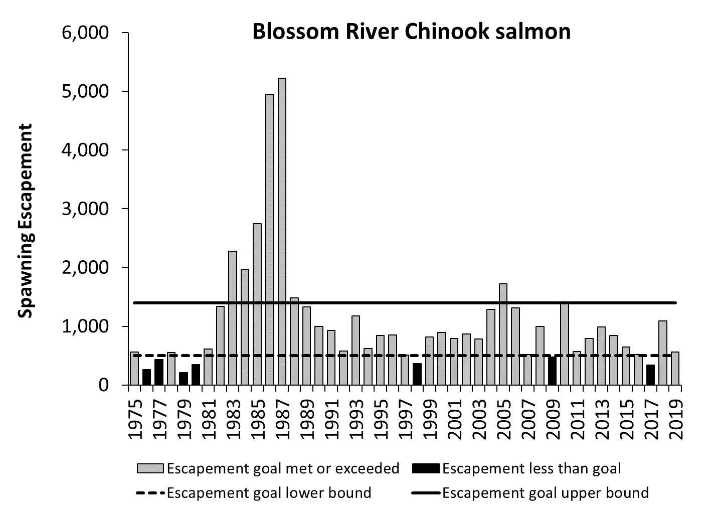

Appendix Figure A1.–Estimated Blossom River Chinook salmon escapements, 1975–2019, and biological escapement goal range of 500–1,400 large spawners.

Appendix A2.–Keta River Chinook salmon.

The Keta River is a clearwater system that empties into Behm Canal, 74 km east of Ketchikan, Alaska, and supports a mostly inside-rearing stock of Chinook salmon. The waters of east Behm Canal are closed to Chinook salmon fishing year-round and there are no directed fisheries that target this stock. Immature and mature fish are harvested in marine mixed stock fisheries in Southeast Alaska and northern British Columbia (based on coded wire tag information from the nearby Unuk and Chickamin wild stocks and Whitman, Neets, and Deer Mountain hatchery stocks). Age data collected since 1998 indicate that about 10% of these fish are sub-yearling smolt. Total escapement was estimated from mark–recapture studies conducted from 1998 to 2000. Index counts, using helicopter surveys, were performed in all other years since 1975. Three years of concurrent mark–recapture estimates and index counts were used to estimate the peak index count expansion factor of 3.01.

**Escapement Goals and Stock Status:** In 1994, ADF&G established a peak index escapement goal of 300 large spawners based on a stock-recruit analysis. In 1997, the goal was revised to a range of 250 to 500 large index spawners. The current biological escapement goal range of 175 to 400 large index spawners was established in 2012, based on a stock-recruit analysis by Fleischman et al. (2011). After applying the expansion factor, the escapement goal based on the index of large spawners was then converted to a total drainagewide escapement goal range of 550 to 1,300 large spawners, which was officially adopted in 2018 (Heinl et al. 2017).

Like the nearby Blossom River, survey counts were low in the 1970s, increased in the mid- to late 1980s, and have been relatively stable since that time. From 2015 to 2019, escapements were within or above the escapement goal range in each year (Appendix Figure A2).

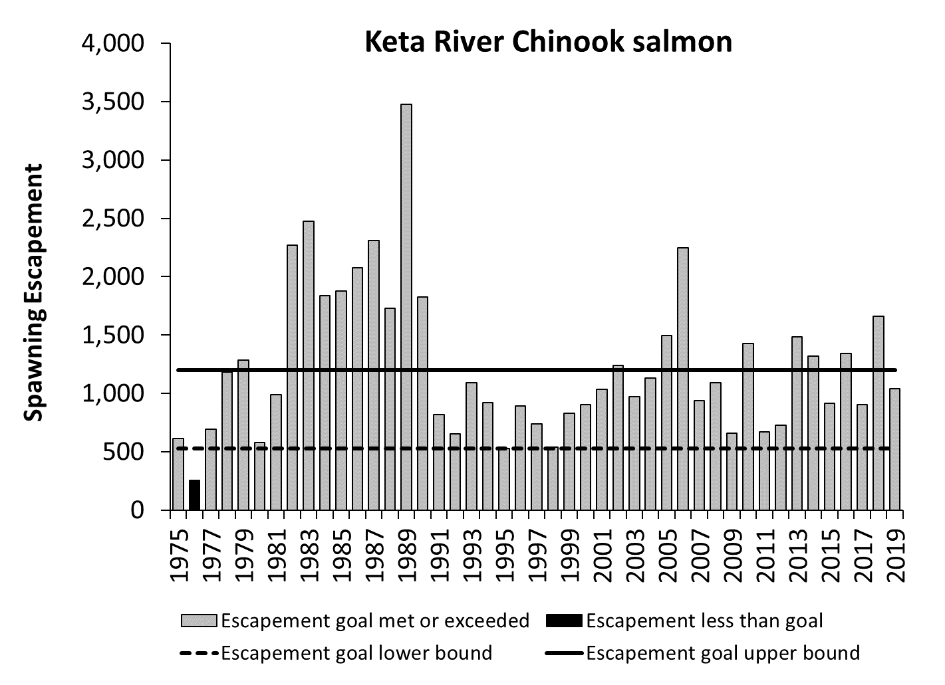

Appendix Figure A2.–Estimated Keta River Chinook salmon escapements, 1975–2019, and biological escapement goal range of 550–1,300 large spawners.

Appendix A3.–Unuk River Chinook salmon.

The Unuk River is a glacial system that flows into Behm Canal, 87 km northeast of Ketchikan, Alaska, and supports a mostly inside-rearing stock of Chinook salmon. The waters of east Behm Canal are closed to Chinook salmon fishing and there are no directed fisheries that target this stock. Immature and mature fish are harvested in marine mixed stock fisheries in Southeast Alaska and northern British Columbia. Coded-wire-tagging of this stock was conducted from 1982 to 1986 and from 1992 to present. Escapements of large spawners were based on mark–recapture estimates of total escapement from 1997 to 2009 and in 2011, and expanded index counts using helicopter and foot surveys from 1977 to 1996 and from 2010 to 2016. Radio telemetry studies conducted in 1994 and 2009 indicated that aerial and foot surveys covered 80% of the spawning area. Seven years of concurrent mark-recapture estimates and survey counts were used to estimate the peak index count expansion factor of 4.83.

**Escapement Goals and Stock Status:** In 1994, ADF&G established a peak index escapement goal of 875 large spawners. In 1997, the goal was revised to an index goal range of 650 to 1,400 large spawners (McPherson and Carlile 1997). The current biological escapement goal range of 1,800 to 3,800 large spawners was established in 2009, based on a stock-recruit analysis of the 1982–2001 brood years (Hendrich et al. 2008). The troll fishery accounts for 70% of the total harvest, followed by the sport fishery (15%), the drift gillnet and terminal hatchery fisheries (6% each), and marginal amounts in the purse seine, high seas trawl, and Canadian mixed net fisheries. On average, 95% of the harvest occurs in Southeast Alaska.

The recent abrupt decline in productivity was unexpected given escapements had exceeded the lower bound of the current escapement goal established in 2009 for 34 straight years and harvest rates averaged around 30% through 2011. However, in 2012 the escapement goal was missed for the first time on record, and the harvest rate was a record high of 72%. From 2015 to 2019, escapements were below the escapement goal range in 2 years (Appendix Figure A3) and harvest rates during 2015 to 2017 averaged 45% (range 30–56%). Harvest rates in 2018 and 2019 are pending sport fish sampling data.

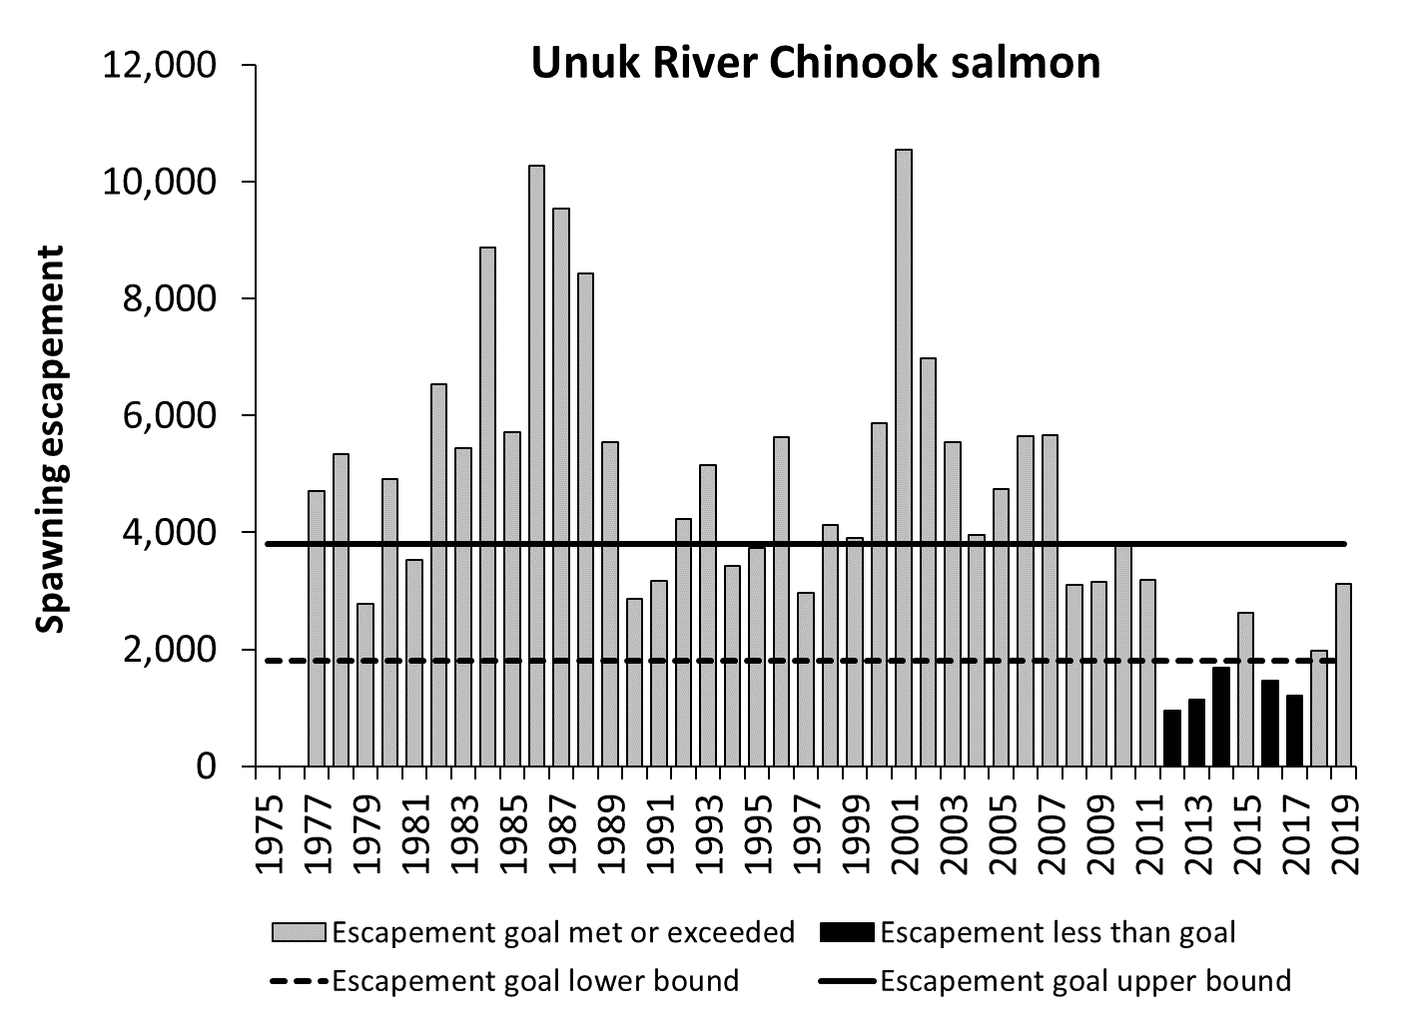

Appendix Figure A3.–Estimated Unuk River Chinook salmon escapements, 1977–2019, and biological escapement goal range of 1,800–3,800 large spawners.

Appendix A4.–Chickamin River Chinook salmon.

The Chickamin River is a glacial system that empties into Behm Canal, 67 km northeast of Ketchikan, Alaska, and supports a mostly inside-rearing stock of Chinook salmon. The waters of east Behm Canal are closed to Chinook salmon fishing year-round and there are no directed fisheries that target this stock. Immature and mature fish are harvested in marine mixed stock fisheries in Southeast Alaska and northern British Columbia. Coded-wire-tagging of this stock was conducted from 1983 to 1988 and from 2001 to 2007. Escapement is measured using index counts of large fish. Mark–recapture studies conducted in 1995, 1996, and from 2001 to 2005 showed that an average 21% of the total escapement is counted during index counts using helicopter and foot surveys (Weller et al. 2007). A radio telemetry study in 1996 also showed that index counts are conducted in stream reaches where more than 80% of all spawning occurs. Seven years of concurrent mark–recapture estimates and index counts were used to estimate the peak index count expansion factor of 4.75.

**Escapement Goals and Stock Status:** In 1994, ADF&G established a peak index escapement goal of 525 large spawners, based on a stock-recruit analysis by McPherson and Carlile (1997). The goal was revised in 1997 to the current biological escapement goal range of 450 to 900 large index spawners as recommended by McPherson and Carlile (1997). After applying the expansion factor, the escapement goal based on the index of large spawners was then converted to a total drainagewide escapement goal range of 2,150 to 4,300 large spawners, which was officially adopted in 2018 (Heinl et al. 2017).

Based on coded wire tagging studies conducted in the 2000s, it was observed that nearly all (99%) of the Chickamin River Chinook salmon harvest occurred in Southeast Alaska. During this time period, the troll fishery accounted for about half of the total harvest, followed by all net fisheries (combined 35%), and sport fisheries (15%). The Chickamin River stock shows a cyclic pattern of escapement; peak survey counts from 1975 to 1981 and 1992 to 1998 were below the current escapement goal range, and those from 1982 to 1991 and 1999 to 2011 were within or above the range. This stock, like other Chinook salmon stocks in Alaska, has recently experienced a decline in productivity. From 2015 to 2019, escapements were below the escapement goal range in 4 years (Appendix Figure A4).

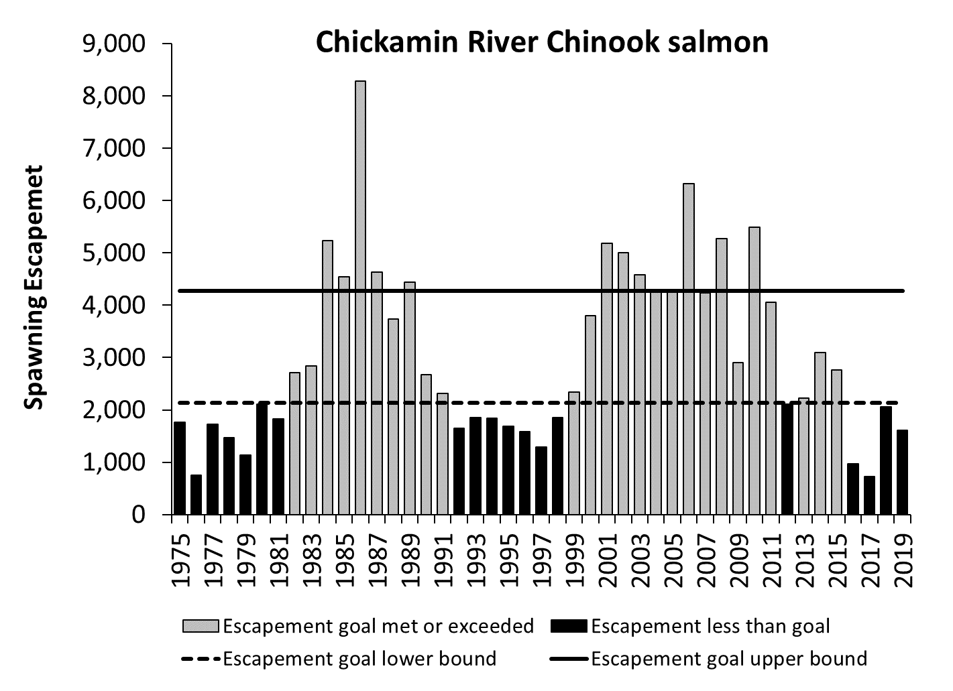

Appendix Figure A4.–Estimated Chickamin River Chinook salmon escapements, 1975–2019, and biological escapement goal range of 2,150–4,300 large spawners.

Appendix A5.–Andrew Creek Chinook salmon.

Andrew Creek is a clearwater tributary of the lower Stikine River, located on the mainland near Petersburg and Wrangell, Alaska, that supports a mostly inside-rearing stock of Chinook salmon. Harvests of immature and mature Andrew Creek fish occur primarily in Southeast Alaska and to a small extent in northern British Columbia fisheries, based on coded wire tag recoveries of Chinook salmon from Southeast Alaska hatcheries that use Andrew Creek brood stock. Escapements are based on weir counts from 1976 to 1984 and expanded index counts using a combination of helicopter, fixed-wing and foot surveys, in 1975 and from 1985 to 2011, and foot surveys since 2012. Four years of concurrent weir and index count data were used to estimate the peak index count expansion factor of 1.95.

**Escapement Goals and Stock Status:** In 1985, ADF&G established an escapement goal of 750 large fish. The current biological escapement goal range of 650 to 1,500 large spawners was established in 1998, based on a stock-recruit analysis by Clark et al. (1998). The Andrew Creek stock, like other Chinook salmon stocks in Alaska, has recently experienced a decline in productivity. A large terminal marine drift gillnet fishery occurred in the spring, near the mouth of the Stikine River, that targeted Stikine River and other nearby Chinook salmon stocks but that fishery closed in 1976. Then, beginning in 2005, in years of surplus Chinook salmon production to the Stikine River, directed Chinook salmon fisheries were allowed in the marine waters in District 8 near Petersburg and Wrangell. Directed commercial and liberalized sport fisheries were implemented between 2005 and 2009. Limited directed fisheries occurred in 2011, 2012 and 2015 and these directed fisheries likely increased harvest rates on Andrew Creek Chinook salmon. From 2015 to 2019, escapements were below the escapement goal range in 3 years (Appendix Figure A5).

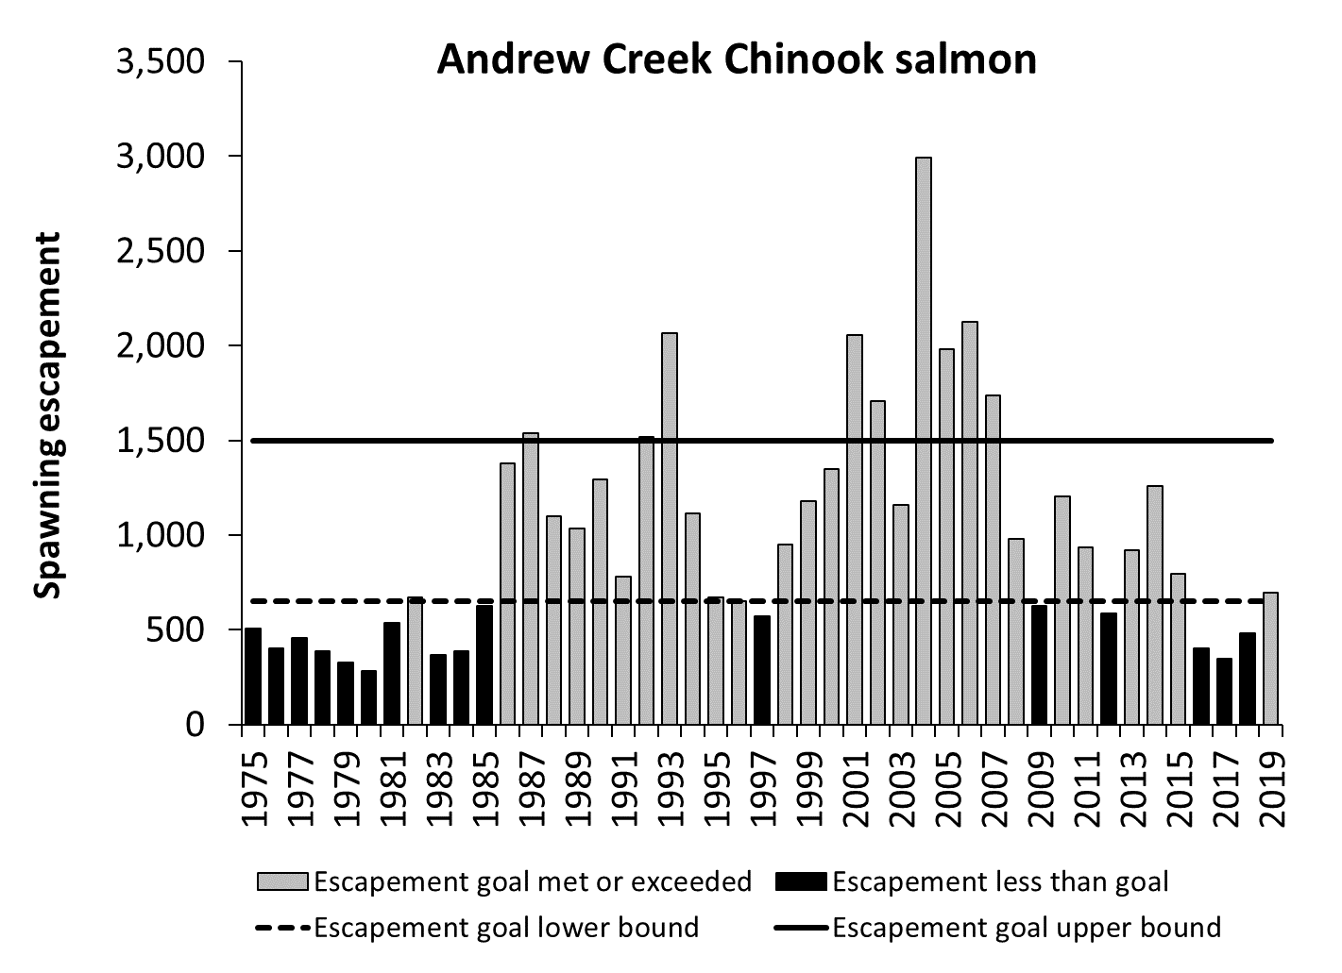

Appendix Figure A5.–Estimated Andrew Creek Chinook salmon escapements, 1975–2019, and biological escapement goal range of 650–1,500 large spawners.

Appendix A6.–Stikine River Chinook salmon.

The Stikine River is a transboundary glacial system that supports an outside-rearing stock of Chinook salmon. The Stikine River originates in British Columbia and flows into central Southeast Alaska near the towns of Petersburg and Wrangell. It is the largest river by volume flowing into Southeast Alaska. Wild smolt have been coded-wire-tagged since 2000 to estimate smolt and adult production and harvest rates. Escapements were evaluated through survey counts conducted on the Little Tahltan River, a tributary in the upper Stikine River drainage, from 1975 to 1984, and weir counts from 1985 to present. Since 1996, mark–recapture studies have been conducted to estimate total Stikine River escapement; these studies indicate the Little Tahltan River weir counts are quite variable in comparison to the total Stikine River escapement and represent 3% to 33% of the total annual escapement.

**Escapement Goals and Stock Status:** The current biological escapement goal range of 14,000 to 28,000 large spawners was established in 2000, based on a stock-recruit analysis by Bernard et al. (2000). Beginning in 2005, during years of surplus Chinook salmon production to the Stikine River, directed commercial and liberalized sport fisheries for Chinook salmon were implemented in the marine waters in District 8 near Petersburg and Wrangell and inriver in Canada. In years of directed Chinook salmon fishing, total harvest rates ranged between 50% and 70%. In other years, harvest rates average only 20%, and most harvest occurs in the late winter and spring commercial troll fisheries, commercial drift gillnet and sport fisheries in District 8 near Petersburg and Wrangell, and in Canadian inriver gillnet and Aboriginal fisheries. Due to conservation concerns fisheries known to intercept Stikine River Chinook salmon were restricted in 2018 and 2019 and the harvest rate was reduced to 2% each year.

This stock has shown a decline in productivity in recent years due to reduced marine survivals and it is unlikely that directed fisheries will be prosecuted until productivity improves. From 2015 to 2019, escapements were below the escapement goal range in 4 years (Appendix Figure A6), and the harvest rate averaged 18%.

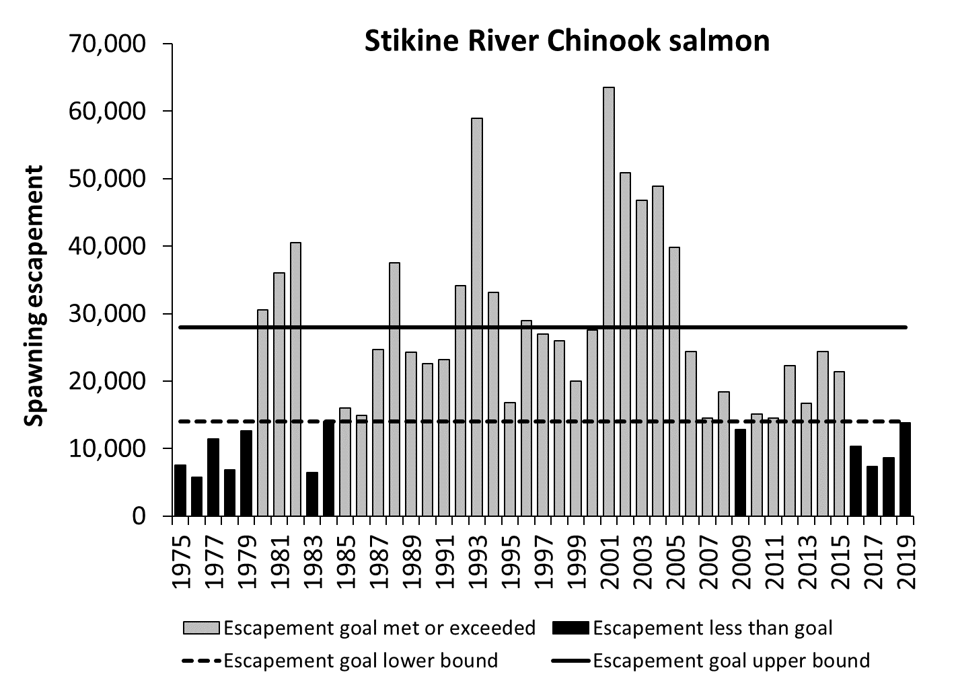

Appendix Figure A6.–Estimated Stikine River Chinook salmon escapements, 1975–2019, and biological escapement goal range of 14,000–28,000 large spawners.

Appendix A7.–King Salmon River Chinook salmon.

The King Salmon River is a clearwater system located on Admiralty Island (and thus the only monitored Chinook salmon island stock), about 30 km south of Juneau, Alaska, that supports a mostly inside-rearing stock of Chinook salmon. This stock does not support directed fisheries but is harvested incidentally in marine waters in sport and commercial fisheries. Escapements of large Chinook salmon are based on weir counts from 1983 to 1992 and expanded index counts using helicopter or foot surveys from 1971 to 1982 and 1993 to 2011 and foot surveys since 2012. Ten years of concurrent weir and index count data were used to estimate the peak index count expansion factor of 1.52.

**Escapement Goals and Stock Status:** In 1981, ADF&G established a peak index escapement goal of 200 large fish, based on maximum counts of 200 spawners in 1957 and 211 spawners in 1973. In the mid-1980s, the goal was revised to 250 large spawners counted through the weir that was operated at the time. The current biological escapement goal range of 120 to 240 large spawners was established in 1997, based on a stock-recruit analysis of the 1971–1991 brood years (McPherson and Clark 2001). From 2015 to 2019, escapements were below the escapement goal range in 5 years (Appendix Figure A7).

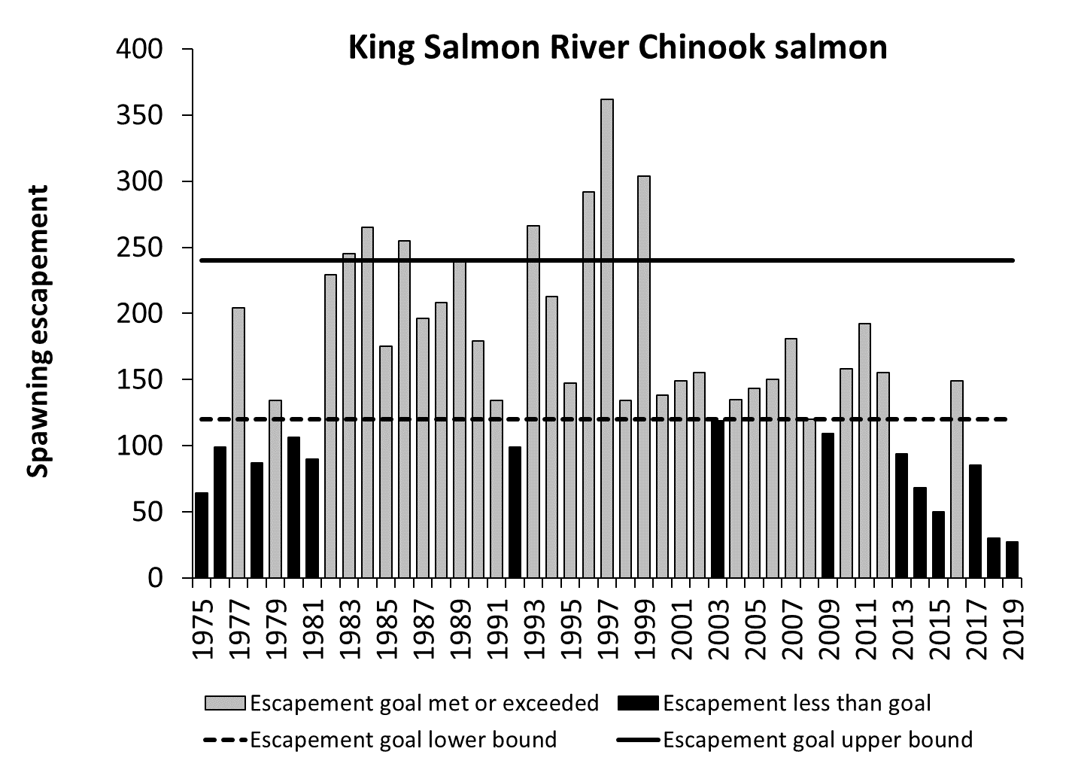

Appendix Figure A7.–Estimated King Salmon River Chinook salmon escapements, 1975–2019, and biological escapement goal range of 120–240 large spawners.

Appendix A8.–Taku River Chinook salmon.

The Taku River is a transboundary glacial system that supports an outside-rearing stock of Chinook salmon. The Taku River originates in British Columbia and drains over 17,000 square kilometers before its terminus at Taku Inlet, approximately 40 km northeast of Juneau. Wild smolt were coded-wire-tagged from 1976 to 1981 and from 1993 to present. Total escapement was estimated from mark–recapture studies conducted from 1989 to 1990, 1995 to 1998, 2000 to 2012, and 2014 to 2019. In all other years expanded index counts using helicopter surveys were used to estimate escapement. Concurrent mark–recapture estimates and index survey counts were used to estimate the peak index count expansion factor of 5.2.

**Escapement Goals and Stock Status:** Prior to 1999, several system-wide or index goals were developed based on limited data. In 1999, an escapement goal range of 30,000 to 55,000 large spawners was established based on a stock-recruit analysis that maximized smolt production. The current biological escapement goal range of 19,000 to 36,000 large spawners was established in 2009, based on a stock-recruit analysis by McPherson et al. (2010).

Starting in 2005, during years of surplus Chinook salmon production to the Taku River, directed commercial and liberalized sport fisheries for Chinook salmon were prosecuted in the marine waters in District 11 near Juneau and inriver in Canada. In years of directed fishing, total harvest rates averaged about 40%. In other years, harvest rates average only about 20%, and most harvest occurs in the late winter and spring commercial troll fisheries (mid-March through June), commercial drift gillnet and sport fisheries in District 11 near Juneau, and in Canadian inriver gillnet and Aboriginal fisheries. Due to conservation concerns fisheries known to intercept Taku River Chinook salmon were restricted in 2018 and 2019 and the harvest rate was reduced to 1% and 3%, respectively. This stock has shown a decline in productivity in recent years due to reduced marine survivals and it is unlikely that directed fisheries will be prosecuted until conditions improve. From 2015 to 2019, escapements were below the escapement goal range in 4 years (Appendix Figure A8), and harvest rates averaged 11%.

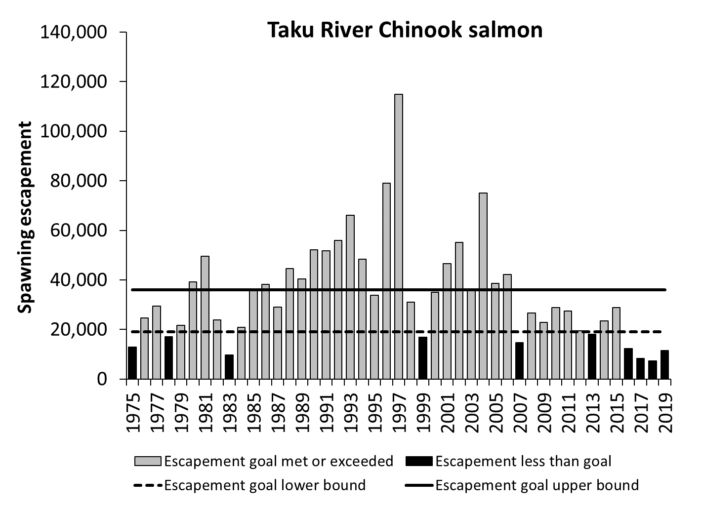

Appendix Figure A8.–Estimated Taku River Chinook salmon escapements, 1975–2019, and biological escapement goal range of 19,000–36,000 large spawners.

Appendix A9.–Chilkat River Chinook salmon.

The Chilkat River is a glacial system located near Haines, Alaska, which supports a mostly inside-rearing stock of Chinook salmon. This stock is targeted in a relatively small terminal marine sport fishery in Chilkat Inlet and is also harvested incidentally in mixed stock sport, and commercial drift gillnet and troll fisheries, primarily in northern Southeast Alaska. The Chilkat stock is also harvested incidentally in Chilkat Inlet and Chilkat River subsistence fisheries. Lynn Canal fisheries that harvest this stock are managed according to the *Lynn Canal and Chilkat River King Salmon Fishery Management Plan* (5 AAC 33.384) to achieve escapements within the escapement goal range. Escapements are based on estimates of large spawner abundance from a mark–recapture program conducted annually since 1991. Escapement data are relatively precise, with CVs for annual escapements averaging 14% since 1991. From 1975 to 1992, aerial survey counts were conducted on two small clear-water tributaries. Radio telemetry studies conducted in 1991 and 1992, however, showed that survey counts were not representative of escapement in the entire drainage and the surveys were discontinued. Smolts have been coded-wire-tagged at relatively high rates (8–10%) since 1999; additional wild-stock tagging occurred in three prior years.

**Escapement Goals and Stock Status:** In 1981, ADF&G established an escapement goal of 2,000 large fish, based on the assumed fraction of the escapement represented by survey counts (now discontinued). The current biological escapement goal range of 1,750 to 3,500 large spawners was established in 2003, based on a stock-recruit analysis by Ericksen and McPherson (2004). In 2003, the Board of Fisheries also adopted an inriver goal of 1,850 to 3,600 large fish (5 AAC 33.384) to account for incidental harvest in the Chilkat River subsistence sockeye salmon fishery. The Chilkat River stock, like other Chinook salmon stocks in Alaska, has recently experienced a decline in productivity. Coded wire tag information suggests harvest rates have been low, at about 24% for recent brood years. From 2015 to 2019, escapements were below the escapement goal range in 3 years (Appendix Figure A9), and harvest rates averaged 11%.

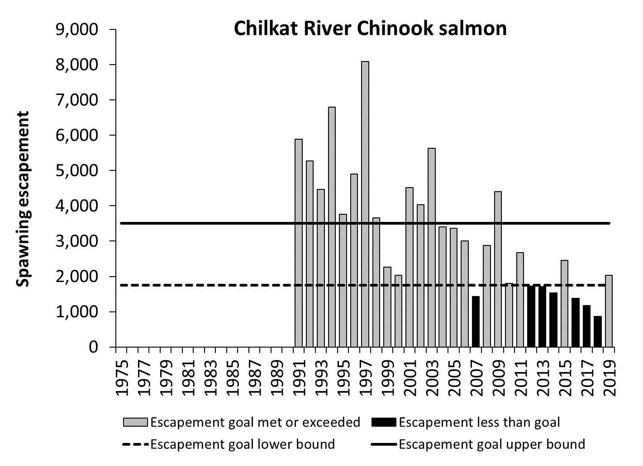

Appendix Figure A9.–Chilkat River Chinook salmon escapements (mark–recapture estimates), 1991–2019, and biological escapement goal range of 1,750–3,500 large spawners.

Appendix A10.–Alsek and Klukshu river Chinook salmon.

The Alsek River is a transboundary glacial system that originates in southwestern Yukon and northwestern British Columbia and flows into the Gulf of Alaska approximately80 km southeast of Yakutat. This river supports an outside-rearing stock of Chinook salmon. Since 1976, the principle means of indexing escapement has been through a weir operated at the Klukshu River, one of 51 tributaries of the Tatshenshini River, the principal salmon-producing branch of the Alsek River. Mark–recapture studies of total escapement in the Alsek River were conducted from 1998 to 2004. Concurrent mark–recapture estimates and measures of inriver run (weir counts plus any downstream harvest in the Klukshu River) were used to estimate the Klukshu inriver run expansion factor of 4.0.

**Escapement Goals and Stock Status:** In 1998, a biological escapement goal of 1,100 to 2,300 Chinook salmon was established for the Klukshu River (McPherson et al. 1998). Unlike other Chinook salmon escapement goals in Southeast Alaska which are germane only to large fish, both the Alsek and Klukshu goals includes 2-ocean (4-year old) aged fish. In 2013, the goal was revised to a biological escapement goal of 800 to 1,200 fish for the Klukshu River, with a corresponding drainagewide Alsek River biological escapement goal of 3,500 to 5,300 fish based on run-reconstruction and stock-recruit analysis (Bernard and Jones 2010; TTC 2014). Because the drainagewide escapement is a simple linear expansion of the Klukshu River escapement and for consistency with other index systems in Southeast Alaska that report total drainagewide escapements, the drainagewide Alsek River escapement goal is the preferred escapement goal performance metric and the Klukshu River goal was eliminated during the 2017/2018 Board of Fisheries cycle (Heinl et al. 2017).

Directed Canadian sport and Aboriginal fisheries occur in various upriver sections of the Alsek River. In the U.S., some fish are caught as bycatch in the commercial set gillnet sockeye salmon and subsistence fisheries that take place in the lower river and at Dry Bay. The Alsek River stock, like other Chinook salmon stocks in Alaska, has recently experienced a decline in productivity. Harvest rates for this stock are some of the lowest observed for a wild Chinook salmon stock and have averaged only about 12% since 1976. From 2015 to 2019, escapements in the Alsek River were below the escapement goal range in 2 years (Appendix Figures A10), and harvest rates averaged 6%.

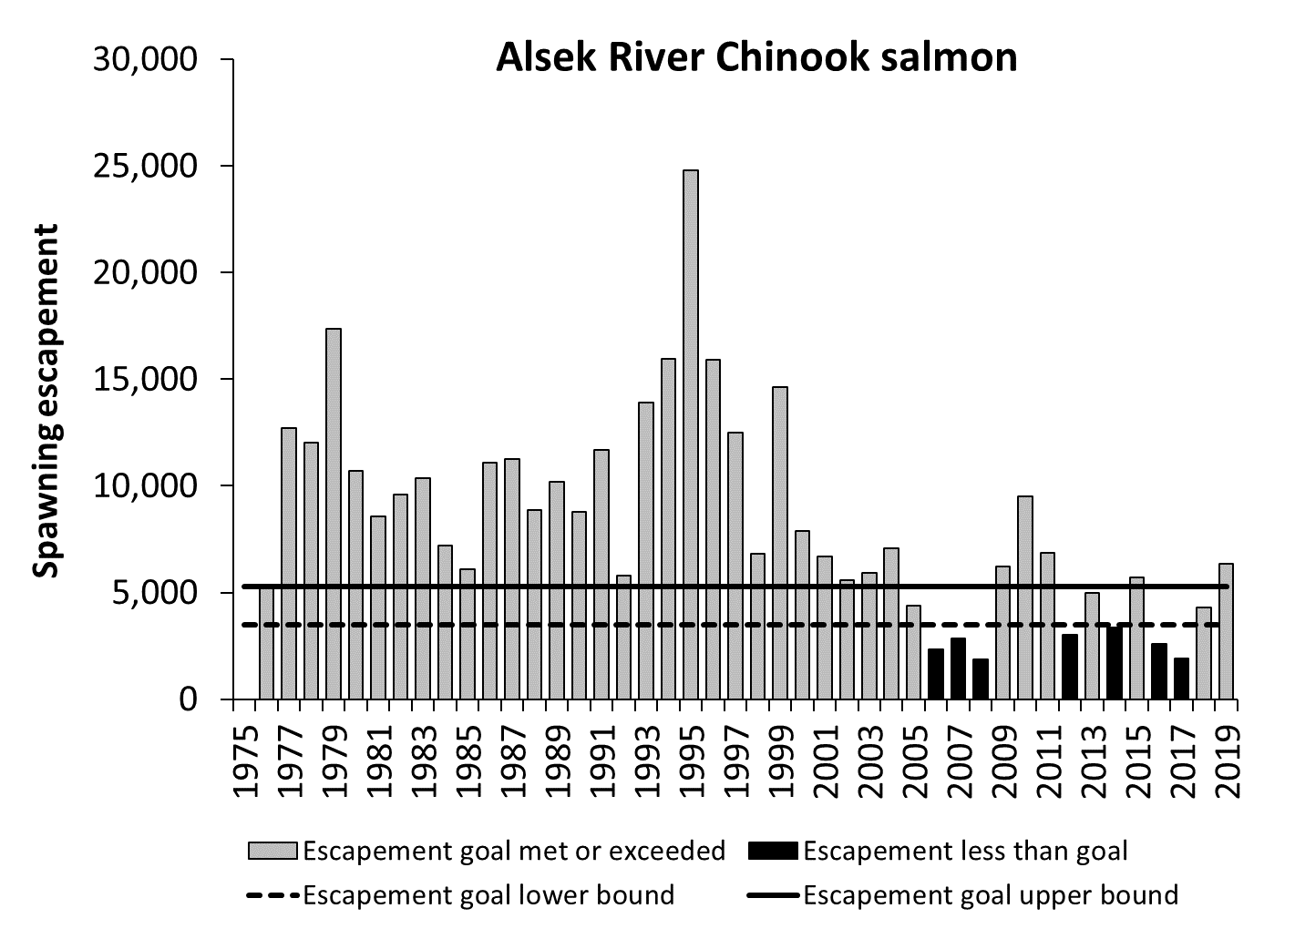

Appendix Figure A10.–Estimated Alsek River Chinook salmon escapements, 1976–2019, and biological escapement goal range of 3,500–5,300 fish.

Appendix A11.–Situk River Chinook salmon.

The Situk River is a clearwater system located near Yakutat, Alaska, that supports an outside-rearing stock of Chinook salmon. Situk-origin Chinook salmon are harvested primarily in directed sport, commercial, and subsistence fisheries located inriver, in the Situk-Ahrnklin inlet, and in nearby surf waters. Fisheries that target this stock are managed according to the *Situk-Ahrnklin Inlet and Lost River King Salmon Fisheries Management Plan* (5 AAC 30.365) to achieve escapements within the escapement goal range. Escapements are based on weir counts minus upstream sport fishery harvests, which are estimated from an on-site creel survey and a post-season mail-out survey. The weir has been operated annually since 1976 and was also operated from 1928 to 1955.

**Escapement Goals and Stock Status:** In 1991, ADF&G established an escapement goal of 600 large spawners, based on stock-recruit analysis, and in 1997 the escapement goal was revised to a range of 500 to 1,000 large spawners (McPherson et al. 2003). A new biological escapement goal range of 450 to 1,050 large spawners was established in 2003 using a more robust dataset and an updated stock-recruit analysis (McPherson et al. 2005). The Situk River stock, like other Chinook salmon stocks in Alaska, has recently experienced a decline in productivity. Sport fishery regulations and harvests have been significantly restricted, with partial (above weir) or total closures since 2008. Terminal net fishery harvests for commercial and subsistence fisheries were also curtailed beginning in 2008, but retention of Chinook salmon incidentally harvested in net fisheries continued until 2011. Significant management actions have been taken since 2011, and all inlet net fisheries have been closed to the retention of Chinook salmon unless it was apparent the lower bound of the escapement goal would be met (Zeiser and Woods 2016). Total annual terminal harvest rates for all gear groups combined averaged about 60% from 1990 to 2003; however, harvest rates have been substantially lower since 2004. From 2015 to 2019, escapements were below the escapement goal range in 3 years (Appendix Figure A11), and harvest rates averaged 3%.

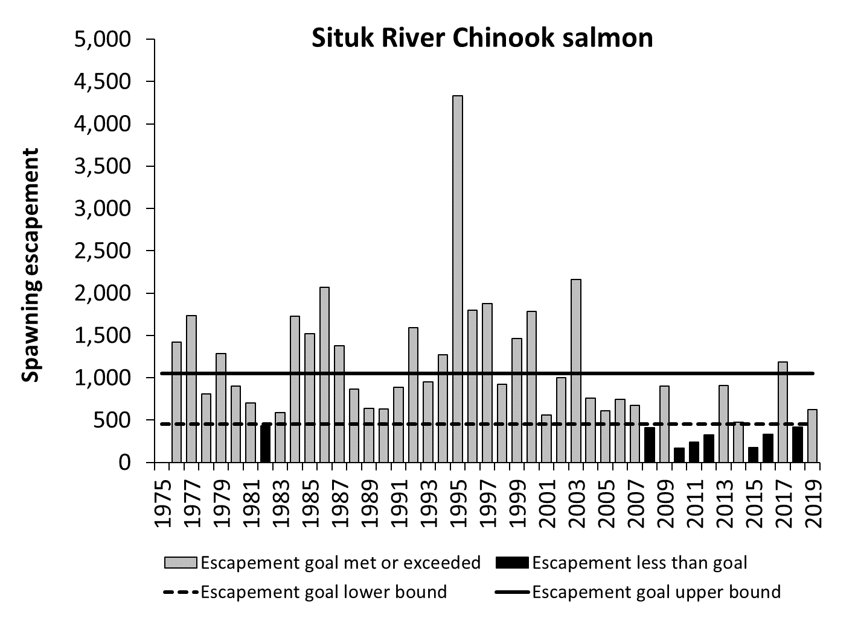

Appendix Figure A11.–Situk River Chinook salmon escapements (weir counts), 1976–2019, and biological escapement goal range of 450–1,050 large spawners.

# Appendix B. Sockeye Salmon Escapement Goal Performance

Appendix B1.–Situk River sockeye salmon.

The Situk River is located on the Yakutat forelands, approximately 15 km southeast of Yakutat, Alaska. The river flows into the Situk-Ahrnklin Inlet, the site of the oldest and, historically, most productive set gillnet fishery in the Yakutat area (Woods and Zeiser 2010). Sockeye salmon escapements have been enumerated annually at an adult counting weir on the Situk River since 1976.

**Escapement Goals and Stock Status:** Prior to 1987, ADF&G managed the Situk-Ahrnklin Inlet fisheries to achieve a Situk River escapement of 80,000–100,000 sockeye salmon. An escapement goal range of 40,000–55,000 sockeye salmon was established in 1987 based on preliminary stock-recruit analysis (McPherson et al. 1987). The escapement goal was revised in 1995 to a biological escapement goal range of 30,000–70,000 sockeye salmon based on a stock-recruit analysis by Clark et al. (1995a), and the goal remained unchanged following an updated analysis by Clark et al. (2002). From 2015 to 2019, escapements were below the escapement goal range in 1 of 5 years (Appendix Figure B1).



Appendix Figure B1.–Situk River sockeye salmon escapement (weir counts), 1976–2019, and biological escapement goal range of 30,000–70,000 fish.

Appendix B2.–Klukshu (Alsek) River sockeye salmon.

The Alsek River is a large transboundary river located on the mainland, approximately 80 km southeast of Yakutat, Alaska. Alsek River sockeye salmon are harvested primarily in U.S. commercial set gillnet fisheries in Dry Bay, at the mouth of the Alsek River, and in Canadian recreational and traditional aboriginal fisheries that take place primarily in the upper Tatshenshini drainage. Escapements to the Klukshu River, a major sockeye salmon-producing tributary, have been enumerated annually since 1976 at an adult counting weir just upstream of the confluence of the Klukshu and Tatshenshini rivers. The Klukshu weir is the principle tool for monitoring sockeye salmon stocks in the Alsek River (TTC 2014).

**Escapement Goals and Stock Status**: In 1984, the Transboundary Technical Committee of the Pacific Salmon Commission established an interim Alsek River drainage escapement goal range of 33,000–58,000 sockeye salmon, of which 12,000–35,000 were expected to enter the Klukshu River (TTC 1990). In 2000, a biological escapement goal of 7,500–15,000 sockeye salmon was established for the Klukshu River, based on a stock-recruit analysis (Clark and Etherton 2000). In 2013, the Klukshu River goal was revised to biological escapement goal range of 7,500–11,000 fish, and a drainagewide biological escapement goal range of 24,000–33,500 fish was established for the Alsek River, based on a run-reconstruction and stock-recruit analysis (Eggers and Bernard 2011; TTC 2014). In 2018, however, the department recommended eliminating the Alsek River sockeye salmon goal (Heinl et al. 2017) due to lack of timely escapement information with which to measure performance and based on management considerations, which continue to be focused on meeting the escapement goal for the Klukshu River (TTC 2019). From 2015 to 2019, Klukshu River spawning escapements were below the escapement goal range in 3 of 5 years (Appendix Figure B2).



Appendix Figure B2.–Klukshu River sockeye salmon escapement (weir counts adjusted for upstream removals), 1976–2019, and biological escapement goal range of 7,500–11,000 spawners.

Appendix B3.–East Alsek River sockeye salmon.

The East Alsek River is located on the Alsek River flood plain approximately 90 km southeast of Yakutat, Alaska. The East Alsek River was historically a distributary channel of the Alsek River but is now fed solely by groundwater and has no direct connection to the Alsek River (Smith et al. 2006). The adjacent Doame River is a clear water system with two lakes, located just east of the East Alsek River. The Doame once entered the Gulf of Alaska directly, but a 1966 earthquake caused the river to flow west and empty into the East Alsek River (Clark et al. 2003). Sockeye salmon are harvested in the District 182-20 commercial set gillnet fishery in the East Alsek River lagoon below the confluence of the two rivers. Sockeye salmon escapements have been assessed through aerial surveys since the early 1970s.

**Escapement Goals and Stock Status:** The East Alsek River run has undergone dramatic response to environmental changes over the past century due to rapid post-glacial uplift of the Alsek River flood plain: colonization of the river by sockeye salmon in the early 1900s, population explosion in the 1970s–1980s, and population decline due to deteriorating spawning habitat in the 1990s, which was thought to be the result of increased sedimentation and growth of aquatic vegetation (Smith et al. 2006; Faber 2008). In 1995, ADF&G established a biological escapement goal range of 26,000–57,000 sockeye salmon counted on peak aerial surveys in the East Alsek-Doame rivers combined, based on a stock-recruit analysis (Clark et al. 1995b). From 1999 to 2002, escapements dropped below the escapement goal range and the commercial fishery was closed. In 2003, the escapement goal was revised downward to a biological escapement goal range of 13,000–26,000 sockeye salmon (Clark et al. 2003). In 2018, the escapement goal was revised to a sustainable escapement goal range of 9,000–24,000 fish counted on a peak survey in the East Alsek River (not including Doame River counts), based on the 5th and 65th percentiles of 1999–2016 survey counts, the period that best encompassed years of decreased production in the East Alsek River (Heinl et al. 2017). Doame River counts were removed from the analysis, because that run is thought to be substantially smaller and earlier in run timing than the East Alsek River run (Clark et al. 2003), and because management decisions in the fishery are based on abundance in the East Alsek River. From 2015 to 2019, peak survey counts were within or above the escapement goal range in each year (Appendix Figure B3).



Appendix Figure B3.–East Alsek River sockeye salmon escapement index (peak aerial survey counts), 1972–2019, and recommended sustainable escapement goal range of 9,000–24,000 fish.

Appendix B4.–Chilkoot Lake sockeye salmon.

Chilkoot Lake is a glacial system located on the mainland, approximately 13 km northwest of Haines, Alaska. The Chilkoot drainage supports one of the larger runs of sockeye salmon in the region, which is harvested primarily in the District 15 Lynn Canal commercial drift gillnet fishery and in a subsistence fishery in Lutak Inlet. Escapements have been enumerated annually at an adult counting weir in the Chilkoot River, below the outlet of the lake, since 1976.

**Escapement Goals and Stock Status:** This stock was managed for informal escapement goals of 80,000–100,000 sockeye salmon starting in 1976, and 60,000–80,000 sockeye salmon starting in 1981 (McPherson 1990). In 1990, ADF&G established a biological escapement goal range of 50,500–91,500 sockeye salmon divided into separate goals for early- and late-runs, based on a stock-recruit analysis (McPherson 1990). The run underwent an extended downturn in production in the 1990s related to changes in the lake rearing environment, which is glacially turbid; very warm summers increased the silt load in the lake, which greatly reduced zooplankton abundance (Eggers et al. 2009b). An extremely low weir count in 1995 prompted ADF&G to verify weir counts with mark–recapture studies, which were conducted in 12 years between 1996 and 2011 (Bachman et al. 2014). Mark–recapture estimates were greater than weir counts, consistent with the idea that weir counts likely under-represented total escapement, but differences between the two estimates were not consistent enough to calibrate weir counts. Geiger et al. (2005) recommended maintaining essentially the same escapement goal range, 50,000–90,000 sockeye salmon, but reclassified the goal as a sustainable escapement goal. In 2009, the escapement goal was changed to a sustainable escapement goal range of 38,000–86,000 sockeye salmon based on an updated stock-recruit analysis (Eggers et al. 2008, 2009b). The goal was considered a sustainable goal, rather than a biological goal, due to uncertainty in weir counts. Recent reviews (Brenner et al. 2018; and in this report) suggested the escapement goal should remain unchanged until returns from the very large brood year 2019 escapement can be incorporated into the analysis. From 2015 to 2019, escapements were within or above the escapement goal range in each year (Appendix Figure B4).



Appendix Figure B4.–Chilkoot Lake sockeye salmon escapement (weir counts), 1976–2019, and sustainable escapement goal range of 38,000–86,000 fish.

Appendix B5.–Chilkat Lake sockeye salmon.

Chilkat Lake is located in the Chilkat River drainage, approximately 43 river km upstream from the city of Haines, Alaska. The lake supports one of the region’s larger sockeye salmon runs, which is harvested primarily in the District 15 Lynn Canal commercial drift gillnet fishery. Escapements have been variously estimated through weir counts (1967–1995, 1999–2007), mark–recapture estimates (1994–2016), and dual-frequency identification sonar (DIDSON), which has been used as the primary assessment method since 2008 (Eggers et al. 2010; Bednarski et al. 2017).

**Escapement Goals and Stock Status:** Prior to 1990, the Chilkat Lake sockeye salmon run was managed for informal escapement goals of 60,000–70,000 fish (1976–1980) and 70,000–90,000 fish (1981–1989) (Bergander et al. 1988). In 1990, ADF&G established a biological escapement goal range of 52,000–106,000 sockeye salmon (with separate goals for early and late runs), based on a stock-recruit analysis (McPherson 1990). Later efforts to update the escapement goal were hindered by concerns regarding accuracy of weir counts and lake stocking of sockeye salmon fry in the 1990s, which at the time caused severe declines in zooplankton populations (Geiger et al. 2005). In 2006, the existing goal was converted into mark–recapture units and revised to a sustainable escapement goal range of 80,000–200,000 sockeye salmon (Geiger et al. 2005). In 2009, the goal was revised to the current biological escapement goal range of 70,000–150,000 sockeye salmon, based on an auto-regressive stock-recruit model with weir counts scaled to mark–recapture estimates and a fry plant term to account for bias due to added production from fry stocking (Eggers et al. 2008, 2010).

Following comprehensive review of historical stock assessment data (Bednarski et al. 2017), the escapement goal analysis was updated using age-structured state-space stock-recruit models to better account for multiple overlapping methods of escapement enumeration and missing data (Miller and Heinl 2018). DIDSON escapement counts were treated as the ‘true’ counts and weir counts and mark–recapture estimates of escapement were treated as indices of escapement in the state-space models. Resulting parameter estimates from this analysis were very similar to those estimated by Eggers et al. (2010). The probability of achieving 90% of maximum sustained yield (MSY) over the entire current escapement goal range was estimated to average 65% and was maximized (near 84% probability) at the spawning escapement estimated to provide MSY (98,000 fish). These probabilities improved to 82% and 94%, respectively, with respect to achieving 80% of MSY (Miller and Heinl 2018). As a result, the escapement goal review committee recommended maintaining the current biological escapement goal of 70,000–150,000 sockeye salmon counted with the DIDSON system at the Chilkat Lake weir site (Heinl et al. 2017). From 2015 to 2019, escapements were within or above the escapement goal range in each year (Appendix Figure B5).



Appendix Figure B5.–Estimated Chilkat Lake sockeye salmon escapements, 1976–2019, and biological escapement goal range of 70,000–150,000 fish. Expanded DIDSON counts are shown as columns, 2008–2019; escapements estimated from model outputs (posterior medians and 95% credibility intervals) are shown as data points, 1976–2016.

Appendix B6.–Redoubt Lake sockeye salmon.

Redoubt Lake is located on Baranof Island, approximately 19 km south of Sitka, Alaska. Redoubt Lake sockeye salmon are harvested primarily in terminal subsistence and sport fisheries and, to a lesser extent, mixed stock commercial fisheries in Sitka Sound. Sockeye salmon escapements have been enumerated annually at an adult counting weir at the outlet of the lake in all but one year since 1982 (the USDA Forest Service has operated the weir since the mid-1990s).

**Escapement Goals and Stock Status:** In 2003, ADF&G recommended a biological escapement goal range of 10,000–25,000 sockeye salmon based on a stock-recruit analysis (Geiger 2003). In 2003, the Board of Fisheries adopted a management plan for Redoubt Lake and set an optimal escapement goal range of 7,000–25,000 sockeye salmon (5 AAC 01.760 *Redoubt Bay and Lake Sockeye Salmon Fisheries Management Plan*). The management plan provides guidelines for allocation of Redoubt Lake sockeye salmon between subsistence, sport, and commercial fisheries based on projected inseason run strength. Redoubt Lake was intensively fertilized during most years when stock-recruit observations were made (1984–1987 and 1990–1995). Lake fertilization was discontinued from 1996 to 1998, but a less intensive fertilization program has been conducted annually by the USDA Forest Service since 1999. An attempt to assess the effect of the lake fertilization project on freshwater production and adult recruitment of sockeye salmon was limited by lack of data from non-fertilized years (Beauchamp and Overman 2004). All but three brood years since 1982 (1987, 1995, 1996) experienced some level of lake fertilization. The Southeast Alaska escapement goal review committee recommended no changes to the current biological escapement goal following an updated escapement goal analysis (in this report). From 2015 to 2019, escapements were within or above the escapement goal range in each year (Appendix Figure B6).



Appendix Figure B6.–Redoubt Lake sockeye salmon escapement (weir counts), 1982–2019, and optimal escapement goal range of 7,000–25,000 fish. (The weir was not operated in 1998.)

Appendix B7.–Taku River sockeye salmon.

The Taku River is a large transboundary river located on the mainland, approximately 30 km northeast of Juneau, Alaska. Taku River sockeye salmon are harvested primarily in Alaska commercial drift gillnet fisheries in District 11 and Canadian inriver fisheries. Harvests have been estimated through postseason run-reconstruction analysis by the Transboundary Technical Committee of the Pacific Salmon Commission (PSC). Sockeye salmon escapements have been estimated through joint U.S./Canada mark–recapture studies conducted annually since 1984.

**Escapement Goals and Stock Status:** In 1985, the Transboundary Technical Committee established an escapement goal range of 71,000–80,000 sockeye salmon in Canadian spawning areas of the Taku River drainage. The goal was based on professional judgment and was long considered an “interim” goal (TTC 2014). In 2003, the department classified the goal as a sustainable escapement goal (Geiger et al. 2004). 04). Provisions of the 2019 Pacific Salmon Treaty called for development of a bilaterally approved maximum sustainable yield escapement goal to be established prior to the 2020 fishing season. A Taku River Sockeye Working Group was created to review the stock assessment program, update historical data, and conduct stock-recruit analysis of revised estimates of abundance (Pestal et al. 2020; Miller and Pestal 2020; also reviewed in this report). A biological escapement goal range of 40,000 to 75,000 wild sockeye salmon and a management objective of 58,000 fish (representing the midpoint of the escapement goal range) was adopted by the PSC Transboundary River Panel prior to the start of the 2020 fishing season (TTC 2020). From 2015 to 2019, estimated escapements were within or above the new biological escapement goal range each year (Appendix Figure B7).



Appendix Figure B7.–Estimated Taku River sockeye salmon escapements, 1984–2019, and biological escapement goal range of 40,000–75,000 fish. (A mark–recapture study was not conducted in 1986.)

Appendix B8.–Speel Lake sockeye salmon.

Speel Lake is located on mainland Alaska, in the Speel Arm of Port Snettisham, approximately 50 km southeast of Juneau, Alaska. Speel Lake sockeye salmon are harvested in traditional mixed stock commercial drift gillnet fisheries in District 11 and in terminal hatchery fisheries in Speel Arm. Escapements have been enumerated annually at an adult counting weir at the outlet of the lake in all but two years since 1983 (the weir has been operated by Douglas Island Pink and Chum, Inc. since 1996). Weir counts during most of the 1980s and 1990s underestimated the escapement, however, due to early removal of the weir. Speel Lake harvests have been estimated annually in conjunction with U.S./Canada stock identification programs to allocate harvests in the District 11 drift gillnet fisheries.

**Escapement Goals and Stock Status:** The Speel Lake sockeye salmon run was managed for informal escapement goals of 10,000 fish in the 1980s, then 5,000 fish starting in 1992. In 2003, ADF&G established a biological escapement goal range of 4,000–13,000 sockeye salmon, the range of escapements estimated to provide for greater than 80% of maximum sustained yield (Riffe and Clark 2003). Riffe and Clark (2003) recommended the Speel Lake weir continue to be operated through late September to ensure complete enumeration of the escapement and recommended the escapement goal be reviewed once sufficient new information had been collected. Heinl et al. (2014b) reviewed and updated Speel Lake sockeye salmon stock assessment information and updated the stock-recruit analysis. As a result, the goal was changed to a sustainable escapement goal range of 4,000–9,000 fish, based on the range of escapements estimated to provide for 70–80% of maximum sustained yield. A recent review (in this report) suggests the escapement goal should remain unchanged. From 2015 to 2019, escapements were below the escapement goal range in 1 of 5 years (Appendix Figure B8).



Appendix Figure B8.–Estimated Speel Lake sockeye salmon escapements (expanded weir counts 1984–2001 and weir counts 1983, 2002–2019), 1983–2019, and sustainable escapement goal range of 4,000–9,000 fish. (The weir was not operated in 1993 or 1994.)

Appendix B9.–Mainstem Stikine River sockeye salmon.

The Stikine River is a large transboundary river located on the mainland, approximately 15 km north of Wrangell, Alaska. The mainstem Stikine stock includes all Stikine River sockeye salmon populations aside from wild and hatchery runs at Tahltan and Tuya lakes (TTC 2014). Mainstem Stikine sockeye salmon are harvested primarily in Alaska commercial drift gillnet fisheries in districts 6 and 8 and in Canadian inriver fisheries. Harvests and escapements have been estimated through postseason run-reconstruction analysis of fishery data by the Transboundary Technical Committee of the Pacific Salmon Commission.

**Escapement Goals and Stock Status:** In 1987, the Transboundary Technical Committee established an interim escapement goal range of 20,000–40,000 sockeye salmon for mainstem Stikine stocks, based on professional judgment (TTC 1990, 1993). This goal has not been updated and ADF&G considered the goal to be a sustainable escapement goal in 2003 (Geiger et al. 2004). From 2015 to 2019, estimated escapements were below the escapement goal range in 2 of 5 years (Appendix Figure B9).



Appendix Figure B9.–Mainstem Stikine River sockeye salmon escapement (run-reconstruction estimates), 1979–2019, and sustainable escapement goal range of 20,000–40,000 fish.

Appendix B10.–Tahltan Lake sockeye salmon.

Tahltan Lake is the largest producer of sockeye salmon in the transboundary Stikine River drainage. The lake is located in Canada, approximately 170 km north of Wrangell, Alaska. Tahltan sockeye salmon are harvested primarily in Alaska commercial drift gillnet fisheries in Districts 6 and 8 and in Canadian inriver fisheries. Sockeye salmon escapements have been enumerated annually at an adult counting weir at the outlet of the lake since 1959.

**Escapement Goals and Stock Status:** In 1987, the Transboundary Technical Committee of the Pacific Salmon Commission established an interim Tahltan Lake escapement goal of 30,000 sockeye salmon (TTC 1990). In 1993, the committee revised the escapement goal to a range of 18,000–30,000 sockeye salmon (TTC 1993; Humphreys et al. 1994). ADF&G considered the goal to be a biological escapement goal in 2003 (Geiger et al. 2004). The escapement goal represents a mix of naturally spawning fish and a maximum of approximately 4,000 fish used for hatchery broodstock for stocking into Tahltan and Tuya lakes under the bilateral enhancement program specified in the Pacific Salmon Treaty. Sockeye salmon production has fluctuated dramatically over time. From 2015 to 2019, escapements were within or above the escapement goal range in each year (Appendix Figure B10).



Appendix Figure B10.–Tahltan Lake sockeye salmon escapement (weir counts), 1979–2019, and biological escapement goal range of 18,000–30,000 fish.

Appendix B11.–Hugh Smith Lake sockeye salmon.

Hugh Smith Lake is located on the mainland, approximately 65 km southeast of Ketchikan, Alaska. Hugh Smith sockeye salmon are harvested in mixed stock commercial net fisheries throughout the Northern Boundary area of Alaska and Canada. Sockeye salmon escapements have been enumerated annually at an adult counting weir at the outlet of the lake since 1980.

**Escapement Goals and Stock Status:** An escapement goal range of 15,000–35,000 sockeye salmon was established for Hugh Smith Lake in the early 1990s, based on professional judgment. The current optimal escapement goal range of 8,000–18,000 fish was established by the Board of Fisheries in 2003, based on escapement goal analyses outlined in Geiger et al. (2003); the goal includes spawning salmon of both wild and hatchery origin (5 AAC 33.390). Escapements were below goal for 5 consecutive years 1998–2002 (Appendix Figure B16), and the stock was formally designated as a stock of management concern by the Board of Fisheries in 2003 (Geiger et al. 2005). The board adopted an action plan that included fishery restrictions to reduce harvests in nearby District 1 commercial drift gillnet and purse seine fisheries. Various stocking projects were conducted at the lake in most years 1986–2003, most of which were thought to be unsuccessful (Geiger et al. 2003); however, large numbers of adults from the last pre-smolt stocking project returned from 2003 to 2007, and escapements exceeded the upper bound of the escapement goal range in each of those years. As a result of improved escapements, the Hugh Smith Lake sockeye salmon run was removed from stock of concern status in 2006 (Geiger et al. 2005). Escapements have generally improved from low levels observed in the 1990s. From 2015 to 2019, escapements were below the escapement goal range in 2 of 5 years (Appendix Figure B11).



Appendix Figure B11.–Hugh Smith Lake sockeye salmon escapements (weir counts), 1980–2019, and optimal escapement goal range of 8,000–18,000 fish. The optimal escapement goal includes both wild and hatchery-stocked fish. Escapements from 2003 to 2007 are divided to show estimated wild and hatchery-stocked (white columns) fish. Estimates of the contributions of wild and hatchery-stocked fish are not available for years prior to 2003.

Appendix B12.–McDonald Lake sockeye salmon.

McDonald Lake, located on the mainland, approximately 65 km north of Ketchikan, Alaska, supports one of the largest runs of sockeye salmon in southern Southeast Alaska. McDonald Lake sockeye salmon are harvested in mixed stock commercial net fisheries throughout the Northern Boundary area of Alaska and Canada. McDonald Lake was the target of a lake fertilization enhancement project conducted from 1982 to 2004 (Johnson et al. 2005). Escapements have been estimated from calibrated foot survey counts conducted annually since 1980.

**Escapement Goals and Stock Status:** In 1989, ADF&G established an informal McDonald Lake escapement goal of 85,000 sockeye salmon based on a euphotic volume habitat model (Burkett et al. 1989). In 1993, the goal was revised to a range of 65,000–85,000 sockeye salmon based on an undocumented stock-recruit analysis; the goal was considered a biological escapement goal in 2003 (Geiger et al. 2004). In 2006, the escapement goal was changed to a sustainable escapement goal range of 70,000–100,000 sockeye salmon based on a simple yield analysis (Johnson et al. 2005). The goal was revised again to the current sustainable escapement goal range of 55,000–120,000 fish in 2009, based on a stock-recruit analysis of recalibrated escapement estimates and assumed average commercial harvest rate of 41% (Eggers et al. 2009a). The goal was considered a sustainable escapement goal due to limited information on harvest rates and uncertainty regarding the effects of lake fertilization on stock productivity. Poor recruitment starting in the late 1990s resulted in a downward trend in escapements, which fell below the escapement goal range in 5 of 7 years 2002–2008 (Appendix Figure B14). The stock was formally designated as a stock of management concern by the Board of Fisheries in 2009 (Bergmann et al. 2009). Escapements were within the escapement goal range for three consecutive years, 2010–2012, and the stock of concern designation was removed in 2012; however, escapements again fell below the escapement goal range in 4 of 5 years 2013–2017, and the stock was designated as a stock of management concern by the Board of Fisheries in 2018 (Walker et al. 2018). From 2015 to 2019, estimated escapements were below the escapement goal range in 4 of 5 years (Appendix Figure B12).



Appendix Figure B12.–McDonald Lake sockeye salmon escapements (expanded foot surveys), 1980–2019, and sustainable escapement goal range of 55,000–120,000 fish.

# Appendix C. Coho Salmon Escapement Goal Performance

Appendix C1.–Chilkat River coho salmon.

The Chilkat River, a large glacial system located near Haines, Alaska, supports one of the largest coho salmon runs in Southeast Alaska. The Chilkat River coho salmon run exhibits typical late migratory timing; however, the run also includes earlier segments that enter the river beginning in late August and early September and spawn primarily during October. Chilkat River coho salmon are harvested primarily in the northern Southeast Alaska troll fishery and the Lynn Canal drift gillnet fishery, with lesser exploitation rates by purse seine fisheries and marine sport fisheries. The Chilkat River sport fishery is one of the largest in Southeast Alaska and, along with freshwater subsistence harvest, also contributes towards fishing mortality (Elliott 2013). Coded wire tagging studies, conducted annually since 1999, have provided estimates of harvest, smolt production, and marine survival. Standardized foot survey index counts at four Chilkat River tributaries have been performed annually since 1987; total Chilkat River coho salmon escapement was also concurrently estimated from mark–recapture studies conducted in 1990, 1998, 2002, 2003, and 2005 (Elliott 2009, 2013). Comparison of index counts with the five mark-recapture estimates yielded a peak index count expansion factor of 33.6 (SE=6.5; Elliott 2009).

**Escapement Goals and Stock Status:** In 2006, a biological escapement goal range of 30,000–70,000 coho salmon was established for the Chilkat River, based on a stock-recruit analysis (Ericksen and Fleischman 2006). From 2015 to 2019, escapements were below the escapement goal range in 1 of 5 years (Appendix Figure C1). Total adult returns to the Berners and Chilkat rivers have been closely correlated (R2 = 0.86) over the 20-year period since full assessment of the Chilkat River stock was initiated. Both runs exhibited a marked decline beginning in 2005, and over the most recent five years the total Chilkat River coho salmon run has averaged about 45% lower than the long-term average. A major contributor towards recent below-average total runs is below-average smolt estimates leaving the Chilkat River drainage. Estimated smolt populations during outmigration years 2012–2018 averaged 786,000 compared to the 1999–2011 average of 1,325,000 Chilkat coho salmon smolt. Marine survival estimates for the smolt populations leaving the Chilkat River during the 2012–2018 time period have been average and highly variable, ranging from 4.3% (SE=1.4%) in return year 2016 to 18.1% (SE=3.7%) in return year 2014.



Appendix Figure C1.–Total estimated run size, harvest, and escapement of Chilkat River coho salmon, 1982–2019, and biological escapement goal range of 30,000–70,000 spawners. (Harvest estimates are not available for 1987–1999.)

Appendix C2.–Berners River coho salmon.

The Berners River is located in Berners Bay, Lynn Canal, approximately 65 km northwest of Juneau, Alaska. The Berners River is a compact system with concentrated, high-quality coho spawning and rearing habitat. Coded wire tagging studies of the Berners River coho salmon run have provided annual estimates of harvest, escapement, smolt production, marine survival, and age composition since 1982 (Shaul et al. 2017, 2019). As a result, the Berners River coho salmon run is an important indicator of the commercial troll exploitation rate on northern inside stocks and is used in inseason estimation of regional wild coho salmon abundance. It is a late run that typically increases in the outside troll harvest throughout August, primarily in the vicinity of Cross Sound and northward, peaks around 1 September, and continues to contribute to the troll harvest until late-September. Berners River coho salmon also contribute to the Lynn Canal drift gillnet fishery and, to a lesser extent, purse seine and marine and freshwater sport fisheries. Compressed timing of spawning, combined with the specific physical features of the Berners River drainage, make it possible to consistently observe and count a high proportion of the total escapement during foot and helicopter surveys in mid- to late October.

**Escapement Goals and Stock Status:** In 1994, ADF&G established a biological escapement goal range of 4,000–9,200 coho salmon for the Berners River, based on stock-recruit analysis of unexpanded peak survey counts (Clark et al. 1994). In 2018, the Berners River goal was revised to a biological escapement goal range of 3,600–8,100 coho salmon counted on a peak survey, based on updated stock-recruit analysis of the 1989–2010 brood years (Shaul et al. 2017). From 2015 to 2019, escapements were below the escapement goal range in 1 of 5 years (Appendix Figure C2). Similar to other coho salmon indicator stocks in Southeast Alaska (e.g., Auke Creek and Hugh Smith Lake), recent above average smolt production at the Berners River has been offset by poor marine survival rates. Over the five-year period 2014–2018, smolt production was 6% above average but marine survival rates decreased approximately 46% and total adult runs during 2015–2019 were 51% below the long-term average (Appendix Figure C2).



Appendix Figure C2.–Total estimated run size, harvest, and escapement of Berners River coho salmon, 1982–2019, and current biological escapement goal range of 3,600–8,100 fish counted on a peak survey. (Harvest estimates are not available for 1984).

Appendix C3.–Taku River coho salmon.

The Taku River is a transboundary system that originates in the Stikine plateau of northwestern British Columbia and terminates at Taku Inlet, approximately 30 km northeast of Juneau, Alaska. The Taku River is likely the largest coho salmon-producing system in the region, and it supports a diversity of run components. Early-run stocks that spawn in high interior tributaries are harvested incidentally in U.S. drift gillnet and Canadian inriver fisheries that target sockeye salmon. Fall-run stocks that spawn primarily in mainstem tributaries are harvested in U.S. drift gillnet and Canadian inriver fisheries that target coho salmon. All run components are harvested by the U.S. troll and sport fisheries. Joint U.S./Canada mark–recapture studies have provided inriver estimates of abundance since 1987 and coded wire tagging studies have provided estimates of harvest, smolt production, and marine survival since 1992 (Pestal and Johnston 2015; Williams et al. 2016). Results of a 1992 radio-telemetry study indicated that the inriver mark–recapture abundance estimate represented about 78% of the total Taku River drainage escapement, and as much as 22% of the total escapement spawned in Alaska below the U.S.-Canada border (Eiler et al. *unpublished*[2]).

**Escapement Goals and Stock Status:** In 1986, the Transboundary Technical Committee of the Pacific Salmon Commission established an interim Taku River escapement goal of 27,500–35,000 coho salmon, based on professional judgement (TTC 1986). Starting in 1999, the management intent of the U.S. was to ensure a minimum above-border run of 38,000 coho salmon until a maximum sustained yield escapement goal could be developed as outlined in the Pacific Salmon Treaty. In 2015, a biological escapement goal range of 50,000–90,000 coho salmon was established, based on a stock-recruit analysis of the 1987–2009 brood years (Pestal and Johnston 2015). From 2015 to 2019, escapements were within the escapement goal range in each year (Appendix Figure C3).



Appendix Figure C3.–Total estimated run size, harvest, and escapement of Taku River coho salmon, 1987–2019, and biological escapement goal range of 50,000–90,000 spawners. (Marine harvest estimates are not available for 1987–1991.)

Appendix C4.–Auke Creek coho salmon.

Auke Creek, located in Juneau, Alaska, supports a small run of coho salmon. Annual smolt and adult spawning populations have been precisely counted at a weir (operated by the National Marine Fisheries Service), and coded wire tagging studies have provided estimates of harvest, marine survival, and age composition since 1980 (Shaul et al. 2019). As a result of the high coded wire tagging rate (100%) on smolts and precise total accounting of returning adults, the Auke Creek stock is an important indicator of the commercial troll exploitation rate on northern inside stocks and is used in inseason estimation of regional wild coho salmon abundance. The Auke Creek stock has migratory characteristics similar to the nearby Berners and Chilkat rivers; however, because of its location outside the boundaries of major commercial drift gillnet fishing areas, it is subjected to slightly lower harvest rates than stocks that are also targeted in drift gillnet fisheries. Rearing habitat in the Auke Creek drainage is dominated by the environment of Auke Lake.

**Escapement Goals and Stock Status:** In 1994, ADF&G established a biological escapement goal range of 200–500 coho salmon at Auke Lake, based on a stock-recruit analysis (Clark et al. 1994). From 2015 to 2019, escapements were below the escapement goal range in 1 of 5 years (Appendix Figure C4). Similar to other coho salmon indicator stocks in Southeast Alaska (e.g., Berners River and Hugh Smith Lake), recent above average smolt production at Auke Creek has been offset by poor marine survival rates. Over the five-year period 2014–2018, smolt production was 14% above average but marine survival rates decreased approximately 57% and total adult runs during 2015–2019 declined by an average 58% (Appendix Figure C4).



Appendix Figure C4.–Total estimated run size, harvest, and escapement (weir counts) of Auke Creek coho salmon, 1980–2019, and biological escapement goal range of 200–500 spawners.

Appendix C5.–Hugh Smith Lake coho salmon.

Hugh Smith Lake is located on the mainland, approximately 65 km southeast of Ketchikan, Alaska. The Hugh Smith Lake coho salmon run is currently the only wild, coded wire tagged coho salmon indicator stock in southern Southeast Alaska. Coded wire tagging studies and weir counts have provided annual estimates of harvest, escapement, smolt production, marine survival, and age composition since 1982 (Shaul et al. 2009, 2019). Thus, the Hugh Smith Lake coho salmon run is an important indicator of the commercial troll exploitation rate on southern inside stocks and is used in inseason estimation of regional wild coho salmon abundance. Returning adults are exposed to a broad array of troll, net, and sport fisheries from northern Southeast Alaska to northern British Columbia, and average harvest rates are higher for Hugh Smith Lake coho salmon than for coho salmon indicator stocks in northern Southeast Alaska. Escapements are counted at a weir across the short lake outlet stream, and fish spawn in two inlet streams. Since rearing habitat in the inlet streams is limited, most juvenile coho salmon rear around wood and rock structure along the steep-sided lakeshore and in an extensive log jam at the lake outlet.

**Escapement Goals and Stock Status:** In 1994, ADF&G established a biological escapement goal range of 500–1,100 coho salmon at Hugh Smith Lake, based on a stock-recruit analysis (Clark et al. 1994). In 2009, the escapement goal was revised to a biological escapement goal range of 500–1,600 coho salmon, based on stock-recruit analysis of brood years 1982–2004 (Shaul et al. 2009). From 2015 to 2019, escapements were within the escapement goal range in each year (Appendix Figure C5). Similar to coho salmon indicator stocks in northern Southeast Alaska (e.g., Berners River and Auke Creek), recent above-average smolt production at Hugh Smith Lake has been offset by poor marine survival rates. Over the five-year period 2014–2018, smolt production was 14% above average but marine survival rates decreased approximately 50% and total adult runs during 2015–2019 declined by an average 44% (Appendix Figure C5).



Appendix Figure C5.–Total estimated run size, harvest, and escapement (weir counts) of Hugh Smith Lake coho salmon, 1982–2019, and biological escapement goal range of 500–1,600 spawners.

Appendix C6.–Montana and Peterson creeks coho salmon.

Coho salmon escapements along the Juneau road system have been monitored by multiple foot surveys conducted annually since 1981 (Clark 2005). Comparable peak escapement surveys have been consistently conducted in recent years on two streams, Montana and Peterson creeks.

**Escapement Goals and Stock Status:** In 1995, ADF&G established biological escapement goals for five Juneau area coho salmon stocks based on peak survey counts and stock-recruit analysis (Clark 1995b), including biological escapement goal ranges of 200–500 fish for Montana Creek and 100–350 fish for Peterson Creek. Biological escapement goals that were also established in 1995 for Steep, Jordan, and Switzer creeks were eliminated in 2006, and escapement goals for Montana and Peterson creeks were retained, since those runs can be actively managed for escapement goals (Clark 2005; Der Hovanisian and Geiger 2005). In 2006, escapement goals for Montana and Peterson creek were revised to sustainable escapement goal ranges of 400–1,200 fish for Montana Creek and 100–250 fish for Peterson Creek, as counted on peak foot surveys (Clark 2005). The goals were based on theoretical stock-recruit analysis; harvest rates were assumed to be similar to the coded wire tagged wild indicator stock at nearby Auke Creek, and a range of probable productivity values were examined to estimate escapement counts that would encompass 90% or more of maximum sustained yield (Clark 2005).

Escapements to Montana Creek have, to some degree (R2 = 0.51), tracked escapements in the Berners River, where returns and escapements have declined substantially since the early 2000s, due in about equal part to lower smolt production and marine survival. Escapements in Peterson Creek have been somewhat more variable, recently ranging from a record high count of 660 spawners in 2008 to a record low count of 20 spawners in 2017 (Appendix Figure C6). From 2015 to 2019, peak survey counts were below the escapement goal range in 1 of 5 years at Montana Creek and 2 of 5 years at Peterson Creek (a valid peak survey count was not obtained for Peterson Creek in 2019).



Appendix Figure C6.–Coho salmon escapement index counts (peak foot survey counts) and sustainable escapement goal ranges for two Juneau roadside streams, Montana Creek and Peterson Creek, 1981–2019. (A valid survey count was not obtained for Peterson Creek in 2019.)

Appendix C7.–Sitka Area coho salmon survey index.

The Sitka area coho salmon survey index consists of five small streams within and north of Sitka Sound that have been surveyed annually since 1982. Foot surveys are conducted at Starrigavan Creek, Sinitsin Creek, and the Nakwasina River, and snorkel surveys are conducted at St. John Baptist Head Creek and the Eagle River (Chadwick 2016). The largest (peak) survey count for each stream is summed with the others in the total index. Only peak survey counts that meet standards for timing, survey conditions, and completeness are included in the annual index, and missing counts are interpolated in order to maintain a comparable aggregate escapement index (Shaul et al. 2011).

**Escapement Goals and Stock Status:** In 2006, ADF&G established a biological escapement goal range of 400–800 coho salmon for the aggregate survey counts in the five Sitka area index streams (Shaul and Tydingco 2006). The goal was based on theoretical stock-recruit analysis that assumed marine survival and harvest rates of Sitka area stocks were similar to the coded wire tagged wild indicator stock at the nearby Nakwasina River, and productivity (smolts per spawner at maximum sustained yield) was assumed to be average compared to other coho salmon stocks that have been studied. Since 1982, escapement counts were within or exceeded the escapement goal range in every year except one (1987) and have exceeded the escapement goal range annually since 2000 (Appendix Figure C7).



Appendix Figure C7.–Aggregate peak coho salmon escapement survey counts and biological escapement goal range of 400–800 fish for five index streams in the Sitka area, 1982–2019.

Appendix C8.–Ketchikan Area coho salmon survey index.

The Ketchikan area coho salmon survey index consists of 14 streams in District 1that have been surveyed annually since 1987. Surveys are conducted by helicopter and are usually done separately in two circuits: the northern circuit includes tributaries of the Chickamin River (Indian River, Barrier Creek, King Creek, Choca Creek) and streams in Burroughs Bay, near the mouth of the Unuk River (Herman Creek, Grant Creek, Eulachon River, Klahini River), and the southern circuit includes the Carroll, Blossom, Keta, Marten, and Tombstone rivers and Humpback Creek. Two surveys of each stream are scheduled (contingent on favorable weather and water conditions): an early survey scheduled for 28 September–1 October and a later survey scheduled for 15–20 October. The largest (peak) survey count for each stream is summed with the others in the total index. Only peak survey counts that meet standards for timing, survey conditions, and completeness are included in the annual index, and missing counts are interpolated in order to maintain a comparable aggregate escapement index (Shaul et al. 2011).

**Escapement Goals and Stock Status:** In 2006, ADF&G established a biological escapement goal range of 4,250–8,500 coho salmon for the aggregate survey counts in the 14 Ketchikan area index streams (Shaul and Tydingco 2006). The goal was based on theoretical stock-recruit analysis that assumed marine survival and harvest rates of Ketchikan area stocks were similar to the coded wire tagged wild indicator stock at nearby Hugh Smith Lake, and productivity (smolts per spawner at maximum sustained yield) was assumed to be average compared to other coho salmon stocks that have been studied. Since 1987, escapement counts were within or exceeded the escapement goal range in every year but one (1990) (Appendix Figure C8).



Appendix Figure C8.–Aggregate peak coho salmon escapement survey counts and biological escapement goal range of 4,250–8,500 fish for 14 index streams in the Ketchikan area, 1987–2019.

Appendix C9.–Klawock River coho salmon.

The Klawock River is located on the west coast of Prince of Wales Island, near the town of Klawock, Alaska. In 1977–1978, the State of Alaska built a hatchery on the river, 300 m below Klawock Lake (Stopha 2016). The state operated the hatchery through the early 1990s, after which management of the hatchery was transferred to the Prince of Wales Hatchery Association (1996–2015), followed by the Southern Southeast Regional Aquaculture Association (since 2016). Hatchery-produced coho salmon (Klawock Lake broodstock) have been released annually in the lake, river, and estuary since 1980; over the past decade, the hatchery released an average 4.1 million coho smolt per year. A portion of the annual coho salmon escapement is allowed to pass into the lake to spawn naturally, the remainder is used for broodstock and cost recovery.

**Escapement Goals and Stock Status:** Prior to 2007, an informal, *maximum* escapement target of 6,000 coho salmon was established for the Klawock River (Der Hovanisian 2013). A sustainable escapement goal range of 4,000–9,000 coho salmon was established in 2007 (though the goal was not formally adopted until 2013; Der Hovanisian 2013; and see Appendix E in Munro and Volk 2014). The goal was based on smolt-per-spawner and theoretical stock-recruit analyses, because, although some Klawock River coho salmon run abundance and escapement data were available for 1999–2005, exploitation rate, marine survival rate, and age composition information was not available, and estimates from a wild coho salmon coded wire tagging study at nearby Chuck Creek were used as surrogates (Der Hovanisian 2013). The annual hatchery management plan[3] includes stipulations for the hatchery to operate the weir from early July through 30 November and includes a weekly escapement schedule with a target escapement of 6,500 coho salmon. Although “most of the run now comprises hatchery returns” (Stopha 2016), the purpose of the escapement schedule is to maintain the historical escapement timing of the run. Escapements were within or above the escapement goal range in all years since 1997 (Appendix Figure C9).



Appendix Figure C9.–Klawock River coho salmon escapement (weir counts), 1997–2019, and sustainable escapement goal range of 4,000–9,000 fish.

Appendix C10.–Yakutat Area coho salmon.

Yakutat area coho salmon stocks are harvested primarily in commercial set gillnet and sport fisheries that target runs to discrete systems, though commercial trollers fishing on mixed stocks off the coast also account for some of the harvest. Yakutat area escapements have been assessed through foot, boat, and aerial surveys. Although the data series starts in 1972, the quality and comparability of peak survey counts in the Yakutat area are somewhat lower than is the case in other areas of the Southeast Region. Most surveys have been conducted early in the run to support inseason management of the set gillnet fisheries. Comparable peak escapement surveys have been conducted relatively consistently in recent years at only three systems: the Lost, Situk, and Tsiu-Tsivat rivers.

**Escapement Goals and Stock Status:** Escapement goals based on peak survey counts and stock-recruit analysis were developed for seven Yakutat area coho salmon stocks in 1994 (Clark and Clark 1994), including biological escapement goal ranges of 2,200–6,500 fish for the Lost River, 3,300–9,800 fish for the Situk River, and 10,000–29,000 fish for the Tsiu-Tsivat rivers. Biological escapement goals that were also established in 1994 for the East Alsek/Doame, Akwe, Italio, and Kaliakh rivers were eliminated in 2006, due to lack of consistent survey effort at those locations (Der Hovanisian and Geiger 2005). In 2009, the Lost River goal was modified into a lower bound sustainable escapement goal of 2,200 coho salmon, following a geological shift that resulted in the Lost River draining into the Situk-Ahrnklin Lagoon instead of directly into the Gulf of Alaska (Shaul et al. 2008). This shift made it difficult to actively manage the commercial set gillnet fishery for a goal specific for the Lost River (Burkholder 2000).

The utility of peak survey counts in assessing historical coho salmon escapement in the Yakutat area is limited by decreasing survey effort near the peak of spawner abundance at the end of the fishery and by frequently deteriorating weather conditions after mid-September. Mark–recapture studies were conducted to estimate escapements of coho salmon in both the Situk (2004–2006) and Lost (2003–2004) rivers in hopes of providing a calibration for index counts; however, mark–recapture estimates were not consistent with index counts and meaningful expansion factors could not be estimated (Shaul et al. 2010). Index counts were substantially lower than total escapement in all years and accounted for minor and variable portions of total escapements. Subsequent escapement goal reviews of Yakutat area coho salmon stocks, therefore, have been based on the percentile method, because stock assessment information is limited primarily to maximum survey counts.

In 2015, the Lost River goal was revised to a sustainable escapement goal range of 1,400–4,200 coho salmon counted on a peak survey, based on the 15th and 75th percentiles of historical counts obtained in Tawah Creek, a primary tributary where the majority of historical survey counts were conducted, and the name of the goal was changed to Tawah Creek (Heinl et al. 2014a). In 2018, the Tsiu-Tsivat goal was changed to a sustainable escapement goal based on the 5th and 65th percentiles of historical survey counts; however, the target range remained 10,000–29,000 coho salmon (Heinl et al. 2017). Finally, a recent analysis (in this report) supports a recommendation to revise the Situk River goal to a sustainable escapement goal range of 3,800–9,600 coho salmon, based on the 25th and 75th pecentiles of historical survey counts.

Escapement indices in the Yakutat area show peaks in coho salmon abundance in the early to mid-1990s and in 2002, and relatively strong escapements in the Tsiu River since 2013 (Appendix Figure C10). From 2015 to 2019, peak survey counts were within or above Yakutat area escapement goal ranges in each year, with the exception of Tawah Creek in 2016.



Appendix Figure C10.–Peak coho salmon escapement survey counts in the Yakutat area, compared to current escapement goal ranges, 1972–2019. (Blank columns in time series indicate that peak survey counts were not available in those years.)

# Appendix D. Pink Salmon Escapement Goal Performance

Appendix D1.–Southern Southeast Subregion pink salmon.

The Southern Southeast Subregion comprises pink salmon stocks from Sumner Strait south to Dixon Entrance (districts 1–8) and includes a total of 366 pink salmon index streams.

**Escapement Goals and Stock Status:** The department has maintained an annual index of the pink salmon escapement in Southeast Alaska, generated from aerial survey observations, conducted at intervals during most of the migration period. Zadina et al. (2004) developed biological escapement goals for Southeast Alaska pink salmon based on the “tabular approach” described by Hilborn and Walters (1992); a yield analysis that is useful for setting escapement goals when the form of the stock recruit relationship is not known. Heinl et al. (2008) updated the goals in 2009 using the same yield analysis. This yield analysis has been updated on a tri-annual basis in conjunction with the Alaska Board of Fisheries regulatory cycle, but no goal changes have been recommended since 2009 (Piston and Heinl 2011a, 2014b, 2018, 2020a). The current biological escapement goal range for pink salmon in the Southern Southeast Subregion is 3.0–8.0 million index spawners, as measured by the sum of annual peak survey counts to the aggregate 366 index streams.

The harvest of pink salmon in the Southern Southeast Subregion averaged 19 million fish per year over the past decade, 2010–2019, which was down from an average harvest of 31 million in the 1990s (Piston and Heinl 2020a). The harvest of 53 million fish in 2013 was just below the all-time record harvest of 54 million fish set in 1996. From 2015 to 2019, escapement indices were within or above the escapement goal range in each year (Appendix Figure D1), and the escapement index of 14.4 million in 2013 was the highest since statehood.



Appendix Figure D1.–Southern Southeast Subregion pink salmon escapement index, 1960–2019, and biological escapement goal range of 3.0–8.0 million index fish.

Appendix D2.–Northern Southeast Inside Subregion pink salmon.

The Northern Southeast Inside Subregion comprises pink salmon stocks on inside waters of Southeast Alaska north of Sumner Strait (districts 9–15) and includes 295 pink salmon index streams.

**Escapement Goals and Stock Status:** The department has maintained an annual index of the pink salmon escapement in Southeast Alaska, generated from aerial survey observations, conducted at intervals during most of the migration period. Zadina et al. (2004) developed biological escapement goals for Southeast Alaska pink salmon based on the “tabular approach” described by Hilborn and Walters (1992); a yield analysis that is useful for setting escapement goals when the form of the stock recruit relationship is not known. Heinl et al. (2008) updated the goals in 2009 using the same yield analysis. This yield analysis has been updated on a tri-annual basis in conjunction with the Alaska Board of Fisheries regulatory cycle, but no goal changes have been recommended since 2009 (Piston and Heinl 2011a, 2014b, 2018, 2020a). The current biological escapement goal range for pink salmon in the Northern Southeast Inside Subregion is 2.5–6.0 million index spawners, as measured by the sum of annual peak survey counts to the aggregate 295 index streams.

Pink salmon runs to the Northern Southeast Inside Subregion developed an extreme odd-even cycle starting in 2006 (Appendix Figure D2), with some very high odd-year harvests, including the all-time record harvest of 40.6 million fish in 2011, and very low even-year harvests. In 2019, however, abundance of the odd-year run abruptly dropped to a very low level, similar to low abundance observed in recent even years. The harvest of pink salmon in the Northern Southeast Inside Subregion averaged 11.6 million fish per year over the past decade, 2010–2019 (Piston and Heinl 2020a), which was below the average harvest of 17.7 million fish during 1991–2005, but just above the average harvest of 9.0 million fish since 1960. Even-year harvests have averaged only 1.7 million fish since 2008, and harvests were less than 1.2 million fish in five of the past six even years. From 2015 to 2019, escapement indices were below the escapement goal range in 3 of 5 years (Appendix Figure D2).



Appendix Figure D2.–Northern Southeast Inside Subregion pink salmon escapement index, 1960–2019, and biological escapement goal range of 2.5–6.0 million index fish.

Appendix D3.–Northern Southeast Outside Subregion pink salmon.

The Northern Southeast Outside Subregion comprises pink salmon stocks along the outer coasts of Chichagof and Baranof islands (District 13, excluding Peril Straits and Hoonah Sound subdistricts 51–59, which are considered part of the Northern Southeast Inside Subregion), and includes 41 pink salmon index streams.

**Escapement Goals and Stock Status:** The department has maintained an annual index of the pink salmon escapement in Southeast Alaska, generated from aerial survey observations, conducted at intervals during most of the migration period. Zadina et al. (2004) developed biological escapement goals for Southeast Alaska pink salmon based on the “tabular approach” described by Hilborn and Walters (1992); a yield analysis that is useful for setting escapement goals when the form of the stock recruit relationship is not known. Heinl et al. (2008) updated the goals in 2009 using the same yield analysis. This yield analysis has been updated on a tri-annual basis in conjunction with the Alaska Board of Fisheries regulatory cycle, but no goal changes have been recommended since 2009 (Piston and Heinl 2011a, 2014b, 2018, 2020a). The current biological escapement goal range for pink salmon in the Northern Southeast Outside Subregion is 0.75–2.5 million index spawners, as measured by the sum of annual peak survey counts to the aggregate 41 index streams.

The harvest of pink salmon in the Northern Southeast Outside Subregion averaged 4.6 million fish per year over the past decade, 2010–2019, which was double the average harvest of 2.3 million fish in the 1990s and 2000s (Piston and Heinl 2020a). Record harvests of 7.1 and 11.2 million fish occurred in 2011 and 2013, respectively. The escapement index averaged 2.6 million over the past 10 years (2010–2019), an increase of 49% over the 1990s. From 2015 to 2019, escapement indices were within or above the escapement goal range in all years (and in all years since 1994; Appendix Figure D3).



Appendix Figure D3.–Northern Southeast Outside Subregion pink salmon escapement index, 1960–2019, and biological escapement goal range of 0.75–2.5 million index fish.

# Appendix E. Chum Salmon Escapement Goal Performance

Appendix E1.–Southern Southeast Subregion summer-run chum salmon.

The Southern Southeast Subregion includes 15 summer-run chum salmon index streams located on the islands and mainland of Southeast Alaska from Sumner Strait south to Dixon entrance.

**Escapement Goals and Stock Status:** The current lower bound sustainable escapement goal of 62,000 chum salmon counted on peak surveys to the aggregate set of index streams was established in 2015, based on the 25th percentile of historical escapement data (Piston and Heinl 2017). The goal is a lower bound sustainable escapement goal, rather than an escapement goal range, because summer-run chum salmon are harvested in mixed stock commercial fisheries and their escapements cannot be effectively managed to fall within a range. Escapement indices were at low levels during the mid-1960s to late 1970s, exhibited an increasing trend into the 1990s, and have generally remained above goal over the past two decades, with the exception of poor escapement years 2008–2010 and 2014. From 2015 to 2019, escapement indices were above the lower bound sustainable escapement goal in each year (Piston and Heinl 2020b; Appendix Figure E1).



Appendix Figure E1.–Southern Southeast Subregion summer-run chum salmon escapement index (peak aerial and foot surveys), 1960–2019, and lower bound sustainable escapement goal of 62,000 fish.

Appendix E2.–Northern Southeast Inside Subregion summer-run chum salmon.

The Northern Southeast Inside Subregion includes 63 summer-run chum salmon index streams located on the inside waters of Southeast Alaska north of Sumner Strait.

**Escapement Goals and Stock Status:** The current lower bound sustainable escapement goal of 107,000 chum salmon counted on peak surveys to the aggregate set of index streams was established in 2018, based on the 25th percentile of historical escapement data (Piston and Heinl 2017). The goal is a lower bound sustainable escapement goal, rather than an escapement goal range, because summer-run chum salmon are harvested in mixed stock commercial fisheries and their escapements cannot be effectively managed to fall within a range. Escapement indices were at high levels in the 1960s, then declined to low levels in the 1970s–1980s. The escapement index trended upward into the late 1990s, trended downward through 2010, and has fluctuated considerably since that time. From 2015 to 2019, escapement indices were below the lower bound sustainable escapement goal in 1 of 5 years (Piston and Heinl 2020b; Appendix Figure E2).



Appendix Figure E2.–Northern Southeast Inside Subregion summer-run chum salmon escapement index (peak aerial and foot surveys), 1960–2019, and lower bound sustainable escapement goal of 107,000 fish.

Appendix E3.–Northern Southeast Outside Subregion summer-run chum salmon.

The Northern Southeast Outside Subregion includes nine summer-run chum salmon index streams on the outside waters of Chichagof and Baranof islands in northern Southeast Alaska.

**Escapement Goals and Stock Status:** The current lower bound sustainable escapement goal of 25,000 chum salmon counted on peak surveys to the aggregate set of index streams was established in 2015, based on the 25th percentile of historical escapement data (Piston and Heinl 2017). The goal is a lower bound sustainable escapement goal, rather than a range, because summer-run chum salmon are harvested in mixed stock commercial fisheries and their escapements cannot be effectively managed to fall within a range. From 2015 to 2019, escapement indices were below the lower bound sustainable escapement goal in 2 of 5 years (Piston and Heinl 2020b; Appendix Figure E3).



Appendix Figure E3.–Northern Southeast Outside Subregion summer-run chum salmon escapement index (peak aerial and foot surveys), 1982–2019, and lower bound sustainable escapement goal of 25,000 fish.

Appendix E4.–Cholmondeley Sound fall-run chum salmon.

Disappearance and Lagoon creeks, located approximately 40 km west of Ketchikan, on Prince of Wales Island, are the two most productive fall-run chum salmon systems in Cholmondeley Sound. Cholmondeley Sound fall-run chum salmon support a terminal commercial purse seine fishery (statistical area 102-40) that has historically provided commercial fishermen with a valuable opportunity to extend the fishing season beyond the directed pink salmon purse seine season that typically ends in late August (Piston and Heinl 2014a). Escapements have been assessed annually through aerial surveys since 1980.

**Escapement Goals and Stock Status:** In 2009, ADF&G established a sustainable escapement goal range of 30,000–48,000 chum salmon counted on combined peak aerial surveys at Disappearance and Lagoon creeks, based on the 25th and 75th percentiles of historical escapement data (Eggers and Heinl 2008; Piston and Heinl 2017). From 2015 to 2019, escapement indices were below the sustainable escapement goal range in 1 of 5 years (Appendix Figure E4; Piston and Heinl 2020b).



Appendix Figure E4.–Cholmondeley Sound fall-run chum salmon escapement index (peak aerial surveys), 1980–2019, and sustainable escapement goal range of 30,000–48,000 fish.

Appendix E5.–Port Camden fall-run chum salmon.

Port Camden (Kuiu Island) fall-run chum salmon have been harvested in a terminal commercial purse seine fishery (statistical area 109-43) in years when run strength appeared adequate to provide a harvest of fish surplus to escapement needs. Management of the Port Camden stock is based on aerial surveys conducted annually since the early 1960s at each of the two primary fall-run chum salmon streams, Port Camden South Head Creek and Port Camden West Head Creek. Both are relatively short streams in terms of spawning habitat; chum salmon runs average slightly smaller in the west head creek and run timing is about 10–14 days later than in the south head creek (Eggers and Heinl 2008).

**Escapement Goals and Stock Status:** In 2009, ADF&G established a sustainable escapement goal range of 2,000–7,000 chum salmon counted on combined peak aerial surveys at Port Camden South Head and Port Camden West Head creeks, based on the 25th and 75th percentiles of historical escapement data (Eggers and Heinl 2008; Piston and Heinl 2017). From 2015 to 2019, escapement indices were below the sustainable escapement goal range in 1 of 5 years (Appendix Figure E5; Piston and Heinl 2020b).



Appendix Figure E5.–Port Camden fall-run chum salmon escapement index (peak aerial surveys), 1964–2019, and sustainable escapement goal range of 2,000–7,000 fish.

Appendix E6.–Security Bay fall-run chum salmon.

Security Bay (Kuiu Island) fall-run chum salmon have been harvested in a terminal commercial purse seine fishery (statistical area 109-45) in years when run strength appeared adequate to provide a harvest of fish surplus to escapement needs. Management of the Security Bay stock is based on aerial surveys at Salt Chuck Creek, which have been conducted annually since the early 1960s (Eggers and Heinl 2008).

**Escapement Goals and Stock Status:** In 2009, ADF&G established a sustainable escapement goal range of 5,000–15,000 chum salmon counted on a peak aerial survey at Salt Chuck Creek, based on the 25th and 75th percentiles of historical escapement data (Eggers and Heinl 2008; Piston and Heinl 2017). From 2015 to 2019, escapement indices were within or above the sustainable escapement goal range in each year (Appendix Figure E6; Piston and Heinl 2020b).



Appendix Figure E6.–Security Bay fall-run chum salmon escapement index (peak aerial surveys), 1964–2019, and sustainable escapement goal range of 5,000–15,000 fish.

Appendix E7.–Excursion River fall-run chum salmon.

Excursion Inlet fall-run chum salmon have been harvested in a terminal commercial purse seine fishery (statistical area 114-80) during years when run strength appeared adequate to provide a harvest of fish surplus to escapement needs. Escapements at the Excursion River (approximately 17 km northwest of Gustavus, Alaska), the primary chum salmon producing stream in Excursion Inlet, have been assessed annually through aerial surveys since 1960.

**Escapement Goals and Stock Status:** In 2009, ADF&G established a sustainable escapement goal range of 4,000–18,000 chum salmon counted on a peak aerial survey at Excursion River, based on the 25th and 75th percentiles of historical escapement data (Eggers and Heinl 2008; Piston and Heinl 2017). From 2015 to 2019, escapement indices were below the sustainable escapement goal range in 2 of 5 years (Appendix Figure E7; Piston and Heinl 2020b).



Appendix Figure E7.–Excursion River fall-run chum salmon escapement index (peak aerial surveys), 1964–2019, and sustainable escapement goal range of 4,000–18,000 fish.

Appendix E8.–Chilkat River fall-run chum salmon.

The Chilkat River drainage, near Haines, Alaska, supports the largest fall-run chum salmon population in the region (Halupka et al. 2000). Most spawning takes place in the mainstem and side channels of the Chilkat River and a major tributary, the Klehini River. Chilkat River fall-run chum salmon are primarily harvested in the Lynn Canal (District 15) commercial drift gillnet fishery, although they are likely also harvested to some degree in other mixed stock fisheries prior to reaching Lynn Canal. Escapements by age have been estimated through a fish wheel project operated by ADF&G on the river since 1994 (Bednarski et al. 2017). The department conducted in-river mark–recapture studies in 1990 and from 2002 to 2005 that were designed to estimate the spawning population of chum salmon and relate those estimates to the fish wheel catches and aerial surveys of the primary spawning areas. The cumulative fish wheel catch, which averaged 1.53% of total escapement, was used to estimate the total chum salmon escapement for years when mark–recapture estimates were not available.

**Escapement Goals and Stock Status:** In 2009, ADF&G established a sustainable escapement goal range of 75,000–170,000 fish or, equivalently, a fish wheel index catch of 1,125–2,550 fish, based on a stock-recruit analysis of the 1994–2002 brood years (Eggers and Heinl 2008). In 2015, the sustainable escapement goal was revised to a range of 75,000–250,000 fish, or, equivalently, a fish wheel index catch of 1,160–3,875 fish, based on an updated stock-recruit analysis of the 1994–2008 brood years (Piston and Heinl 2014a). The escapement goal represents the range of escapements estimated to provide 70–100% probability of achieving greater than 70% of maximum sustained yield. The goal is considered a sustainable escapement goal due to uncertainty in escapement estimates (Piston and Heinl 2014a). From 2015 to 2019, estimated escapements were within or above the escapement goal range in each year (Appendix Figure E8; no escapement estimate was available for 2018 due to extremely low water levels at the fish wheel site; Piston and Heinl 2020b).



Appendix Figure E8.–Chilkat River fall-run chum salmon escapements (expanded fish wheel counts), 1990–2019, and sustainable escapement goal range of 75,000–250,000 fish. (Escapement estimates are not available for 1991–1993 and 2018.)

1. Bue, B. G., and J. J. Hasbrouck. Escapement goal review of salmon stocks of Upper Cook Inlet. Alaska Department of Fish and Game, Report to the Alaska Board of Fisheries, November 2001 (and February 2002), Anchorage, unpublished document.
2. Eiler, J. H., M. M. Masuda, and H. R. Carlson. Stock composition, timing, and movement patterns of adult coho salmon in the Taku River Drainage, 1992. National Marine Fisheries Service report, Juneau.
3. 2020 Annual Management Plan, Southern Southeast Regional Aquaculture Association, unpublished document.

   http://www.adfg.alaska.gov/index.cfm?adfg=fishingHatcheriesPlanning.annual (Accessed 8/12/2020).